**Acceleration problems**

Canvas: These problems are now hosted in Canvas as a multiple-choice exercise. Do your work on paper, and then enter your answers in Canvas.

Video help: Watch the homework video posted next to this assignment.

Equations: You will be using the “Big Five” equations of linear motion:

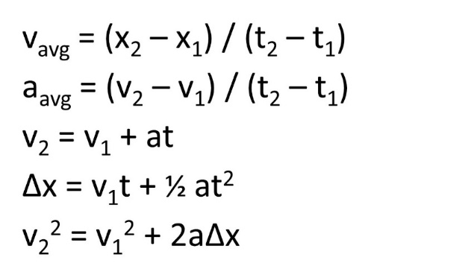

1. An auto manufacturer boasts that its newest sports car model goes from 0 to 60 mph in 5.00 seconds. There are 1609 meters per mile.
   1. What is the car’s acceleration in m/s2?
   2. How far does it travel in meters as it accelerates from 0.0 mi/h to 60.0 mi/h?
2. You are stuck on a two-lane road behind a truck traveling 64.4 km/h (40 mi/h). You pull into the oncoming lane to pass and immediately begin acceleration at 2.5 m/s2. After passing the truck, 6.10 s have elapsed. You stop acceleration and pull back into your lane. How far down the road did you travel (in meters) in the oncoming lane during the time interval? Hint: Use Big Five equation #4 for this one.

1. The Beretta Model 92S (the standard-issue U.S. army pistol) has a barrel 127 mm long. The bullets leave this barrel with a muzzle velocity of 335 m/s. There are 1000 mm per m.

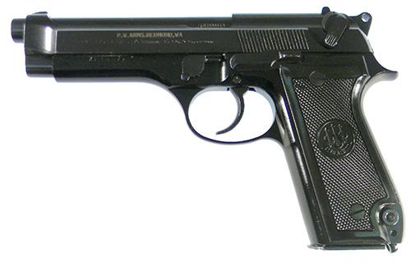

* 1. What is the average acceleration in m/s2 of the bullet while it is in the barrel?
  2. For how long in seconds is the bullet in the barrel?

For the next 3 questions, use 9.8 m/s2 as the acceleration of gravity:

1. A parachutist falls from a plane for 6.0 seconds before opening the parachute. How fast in m/s is he traveling when he opens his parachute?
2. A physics student drops a rock off of a cliff. If the rock takes 4.5 seconds to reach the bottom of the cliff, how tall is the cliff in meters?
3. A child throws a ball up in the air with an initial velocity of 4.9 m/s. What is the maximum height in m that the ball reaches?



*v*

1. (Ch. 2, problem #22) The graph shows the velocity of a motorcycle police officer plotted as a function of time. Find the instantaneous acceleration at the following times
   1. t = 3 s
   2. t = 7 s
   3. t = 11 s
2. (Ch. 2, problem #38) The reaction time of the average driver is about 0.7s. This is the time interval between recognizing danger and applying the brakes. If a car can slow down with an acceleration of 12.0 ft/s2, compute the total distance covered in coming to a stop after recognizing danger. Hint: Use ‘Big Five’ equation #5 above.
   1. From an initial velocity of 15.0 mi/h (in a school zone)
   2. From an initial velocity of 55.0 mi/h (on the highway)
3. (Ch. 2, problem #26) A little cat, Bella, walks along a straight line, which we shall call the x axis, with the positive direction to the right. As an observant scientist, you make measurements of her motion and construct a graph of the little feline’s velocity as a function of time.
   1. Find Bella’s velocity at
4. t = 4.0 s
5. t = 7.0 s
   1. What is her acceleration at
6. t = 3.0 s
7. t = 6.0 s
8. t = 7.0 s