**“Air in Classroom” problem**

Name and date submitted (3 pts):

Complete the work below by creating space in the document, and turn in by the due date. MUST SHOW WORK to get partial credit. *All of the concepts are taken from Ch. 3 in the BJU book.*

(10 questions, 5 points each, 50 points)

Problem 1: Calculate the weight of air in a classroom

The classroom shown below has dimensions of exactly 10.00 meters wide x 12.00 meters long x 3.00 meters high. (just assume it’s a simple cube, don’t worry about the ‘curve’ by the windows)

1. What do you think the air would weigh in this classroom, in pounds? Just take a good guess, there is no ‘wrong’ answer. _____________
2. Calculate the volume of air in the classroom in cubic meters (m3). Report your answer using the correct number of significant figures. Ignore the volume taken up by the students and the furniture. (hint: the volume is between 300 and 400 m3, and sig figs for multiplication are limited to the least # of sig figs in the numbers being multiplied)

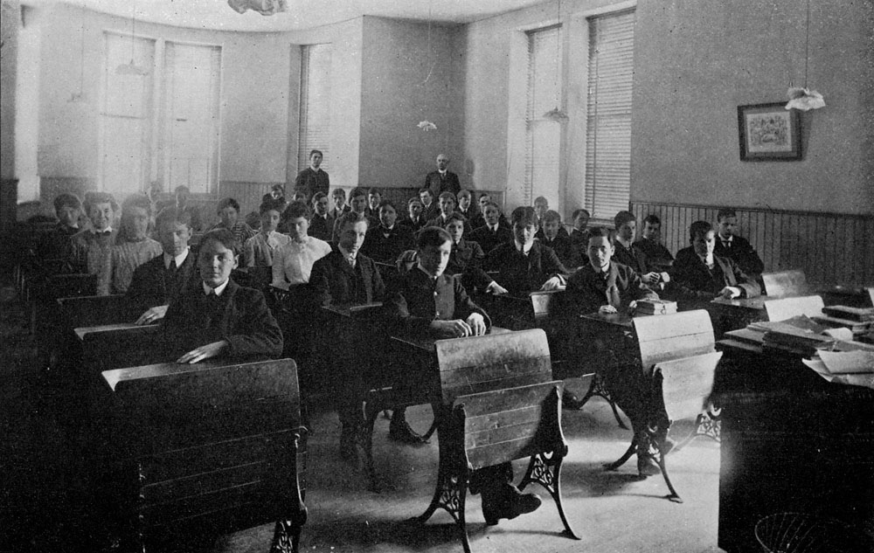

1. Use the density equation D = m/V (density equals mass over volume) to calculate the mass of the air in the room in kilograms. The density of air is 1.22 kg/m3. Report your answer with the correct significant figures. (Hint: between 400 and 450 kg)
2. How much does the air weigh in pounds? Convert the kilograms in #3 to pounds. Use the conversion factor of 2.20 lbs/kg. Use the correct significant figures. (hint: between 900 and 1,000 lbs.)
3. How close was your guess on page 1? Are you surprised?

Problem 2: Steel spheres

In problem 1 you calculated the volume of the classroom in m3. Now you will calculate how many steel spheres you can pack in this space.

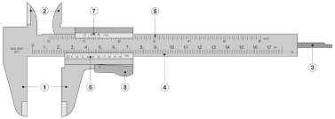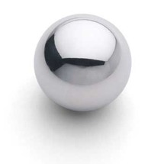

1. Using the calipers shown, you carefully measure the diameter of the steel sphere at 3.00 cm (0.0300 m). Using the formula Vsphere = 4/3 πr3, compute the volume of the sphere in m3. Note you will need to convert the diameter to radius to use the formula. Use the correct sig figs and scientific notation. (hint: answer is between 1.00 – 2.00 x 10-5 m3)
2. Guess how many spheres will fit in the classroom. There is no wrong answer. ____________
3. Use the formula (#spheres = Vroom/Vsphere) to compute the number of spheres that can be packed into the classroom. Use scientific notation, and the correct sig figs. (hint: answer is between 25-30 million, but use scientific notation).
4. Technically speaking, this was a simplification because we did not consider the ‘void space’ in between the balls, in other words the empty space in between them, which probably averages about 35% (so 65% balls, 35% air). To include the ‘void space’ in your calculation, modify your formula as follows: (#spheres = Vroom/Vsphere * 0.650)

Taking into account void space between spheres, how many can you pack into the classroom? (hint: between 15-20 million, but use scientific notation and correct sig figs)

How close was your guess in #7?

1. Density: The density of steel is 8,050. kg/m3. Using the volume of each sphere in m3 which you calculated above, compute the mass in kg of each steel sphere. Use the density formula D = m/v. (hint: between 0.100-0.120 kg)