Ch. 1: Thought Questions
Name and date submitted (3 pts):
Instructions: Create space in the document below, and type or write your answers. Turn in your completed work as an email attachment.
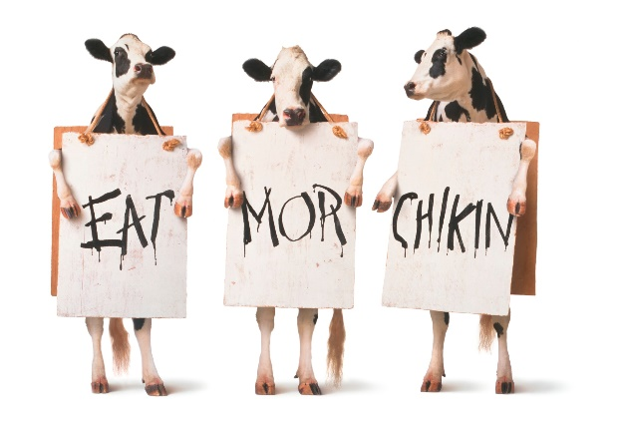
(10 questions, 5 pts each, 50 points)
- Chick-fil-A’s “Eat Mor Chikin” advertising campaign features three cows holding signs. If consumers began eating more chicken and less beef, would the cattle population increase or decrease? Think carefully about this and explain from an economics standpoint. The answer might not be obvious.

- Insatiability means never being satisfied. How can you achieve victory over insatiability in your own life? You may answer this from a variety of perspectives including the Bible, but I’m looking for a well thought-out answer.

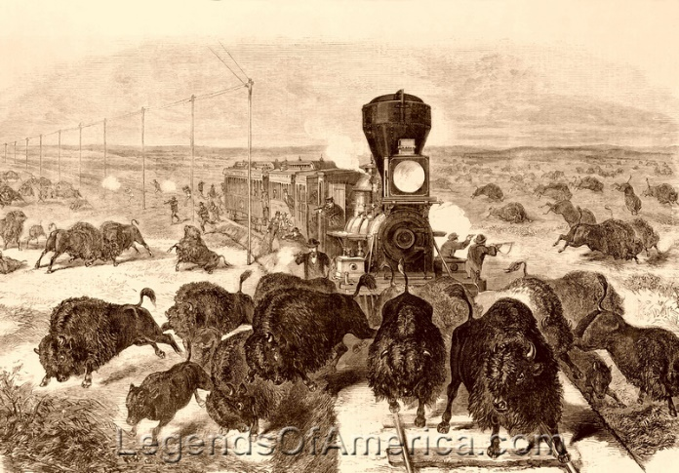
- Two centuries ago, there were more buffalo than cattle in the United States. Even though millions of cattle are butchered for beef consumption each year, the cattle population continues to grow while the buffalo are virtually extinct. Why is this? Explain this from an economics perspective.

- 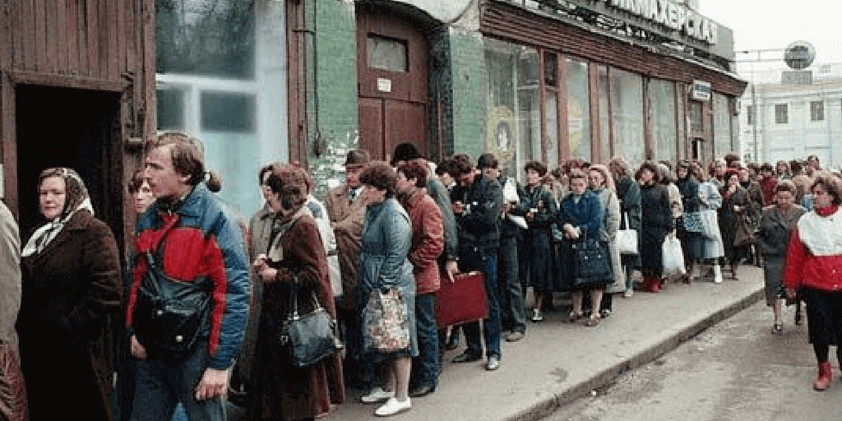Unintended consequences:
In a “command economy” like the former Soviet Union (a communist country), the government will set artificially low prices on many basic necessities such as potatoes.
Let’s say the dictator says, “From now on, the price of potatoes shall not exceed 10 cents a pound.” As a result, a smaller quantity of potatoes is grown by farmers, and customers either cannot obtain them or the have to wait in long lines to buy the potatoes that are available. Question: Does this sort of government price policy help or harm consumers in the long run? Why or why not? Give this some thought… there may be more than one way to answer the question.

- Easy cost-benefit analysis: You must choose between going to bed at your regular time or staying up late to study for a test. List the opportunity costs and opportunity benefits of both decisions:
Opp’y benefits Opp’y costs
Go to bed
Stay up late

- Greed and exploitation: Evaluate this statement: “People in business get ahead by exploiting their customers.” Elaborate. Think about it for a while and explain why or why not.

- Does a 60-year-old tree farmer have an incentive to plant and care for Douglas fir trees that will not reach optimal cutting size for another 50 years? Think carefully about this – the answer may not be obvious.

- During the last three decades, entrepreneurs like Steve Jobs (Apple), Sam Walton (Wal-Mart), and Jeff Bezos (Amazon.com) have earned billions of dollars. Do you think the average American is better or worse off as the result of the economic activities of these individuals? Explain your response.

- Good intentions: Suppose that in an effort to help low-skill workers the government raises the minimum wage to $50 per hour.

- Can you think of any unintended secondary effects that will result from this action? There would be several. Think about it and explain...

- Will all low-skill workers be helped by the minimum wage law? Think about this carefully….

- Good intentions and unintended consequences: Should the United States attempt to reduce all air and water pollution to zero? Why or why not? Give this some careful thought…

