Inorganic Chemistry questions
Name and date submitted (3 pts):
Create space in the Word document below, and write or type your answers. Turn in your completed work by the due date.
(10 questions, 100 points possible; plus extra credit question)
- Using the “Main chemical elements in the body” handout which is posted near this homework assignment, fill in the missing information in the table below. Each line should have 3 pieces of information. There are 11 elements.

Element | Symbol | % of total body mass
Oxygen
 | H
Sulfur |  | 0.25%
 | Fe
Carbon
 | N | 3.2%
 | Ca
Phosphorus
 | Na
 | Mg | 0.1%
Potassium

- Water:
  - What makes the water molecule “polar”? Use the correct chemistry terms.

  - Why does ‘being polar’ make water an excellent solvent in living organisms? Explain using chemistry terms.

  - Define “hydrophillic”

  - Define “hydrophobic”

  - Explain why water tends to stabilize temperature. In other words, the oceans stabilize the earth’s surface temperature, and the water-content in your body helps stabilize your body temperature…. HOW/WHY is that so? Explain using the correct terms given in your book.

  - You are mostly water: why don’t you literally evaporate the minute you walk outside on a scorching hot day? Related question: why don’t all the trees and grass evaporate on a hot day?

  - Explain the phrase, “water is cohesive”. Use chemistry terms.

  - What is “surface tension”?

  - What is “adhesion”?

  - How does water go up a tree? Your book has the answer. Use the correct terms.

- In a hurry one day, you merely rinse your lunch dishes with water. As you are drying your salad bowl, you notice that it still has an oily film. Why was the water alone not effective in cleaning the bowl? Explain, using the correct chemical terms given in your book.

- Atomic structure:
  - Atoms are built out of protons, electrons, and neutrons. Complete the table

 | Mass | Charge | Where does it reside?
Proton | 1
Electron |  | -1 | Around the nucleus
Neutron

  - Define the term “matter”

  - Define the term “element”

  - Choose the best answer: Single atoms combine to form (ions, molecules, isotopes, photons)

  - Carbon has an “atomic number” of 6 and “atomic mass” of 12. Your book explains what these terms mean. Which of the following is true?
    - It has 6 protons, 12 electrons, and 0 neutrons
    - It has 6 protons, 6 electrons, and 6 neutrons
    - It has 6 protons, 6 electrons, and 12 neutrons
    - It has 6 protons, 12 electrons, and 6 neutrons

  - Oxygen has an “atomic number” of 8 and “atomic mass” of 16.
    - How many protons?
    - How many electrons?
    - How many neutrons?

  - Nitrogen-14:
    - How many protons?
    - How many electrons?
    - How many neutrons?

- Isotopes:
  - Carbon-12 and Carbon-14 are “isotopes” of the same element, Carbon. The term “isotopes” refers to different forms of the same element which have the same number of (protons/neutrons), but a different number of (protons/neutrons). Hint: this sentence is taken right out of your book.

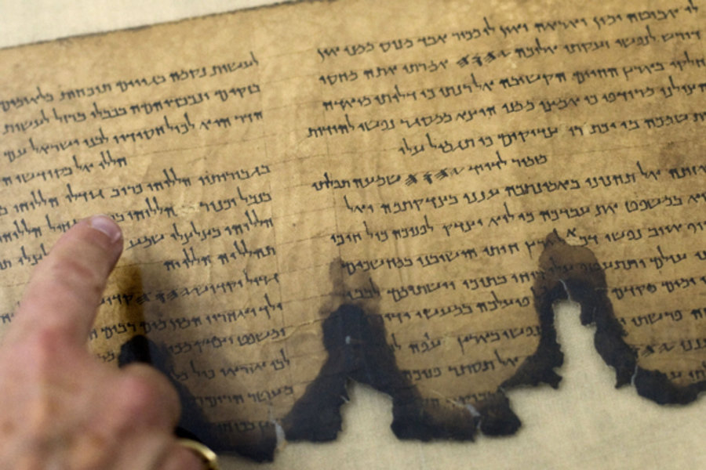
  - Carbon-14 is used to date certain artifacts that were once “living”, for example bones and plant material. The Dead Sea Scrolls, discovered in 1947, have been carbon dated to the time of the Roman occupation of Judea – approximately 100 b.c. to 100 a.d. Why is carbon-14 dating used to date a 2000 year-old scroll?

- Chemical bonding:
  - Atoms bond together to form molecules because
    - They are magnetically attracted to one another, and seek to lower their potential energy
    - They want to “fill” their outermost shells with electrons, usually 8 in number, also known as the octet rule
    - They seek to “give away” all their outermost electrons in order to lower their potential energy
    - They either donate or accept electrons in order to arrive at “6” outermost electrons, also known as the “rule of six”

  - A neutral atom has the same number of protons and e_________.

  - When an atom does not contain equal numbers of protons and electrons, it is called an _______.

  - An atom which has lost one or more electrons will have a positive net charge, and is called a c__________.

  - An atom which has gained one or more electrons will have a negative net charge, and is called an a_________.

  - Define “ionic bond”. Use correct chemistry terms.

  - Define “covalent bond”. Use correct chemistry terms.

  - Define “polar covalent bond”. Use correct terms.

  - Define “hydrogen bond”. Use correct terms.

  - Define “van der Waals” interactions. Use correct terms.

  - Na⁺¹ is a sodium atom which has (gained/lost) one electron.

  - Cl⁻¹ is a chlorine atom which has (gained/lost) one electron.

- pH scale:
  - The pH scale ranges from ________ to __________.

  - A pH measurement of < 7.0 is (acidic/basic)

  - A pH measurement of > 7.0 is (acidic/basic)

  - A change of one unit on the pH scale represents a change in pH by a factor of (10, 100, 1000)

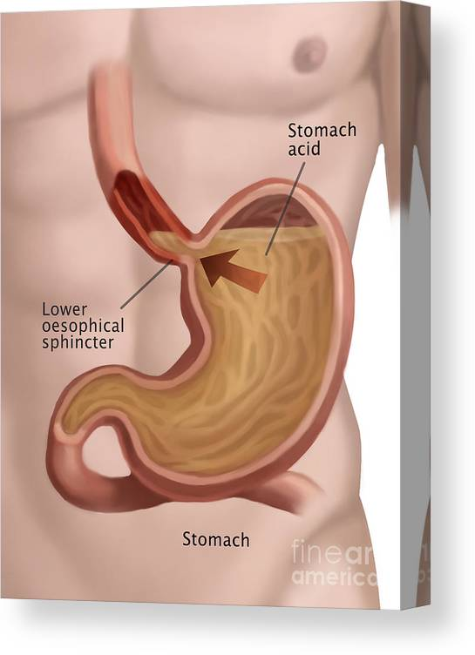
  - Pure water which is perfectly neutral has a pH of ______.

  - The blood in your veins has a pH of ________, making it slightly (acidic/basic).

  - The pH of stomach acid (gastric juice) is ___________, making it very (acidic/basic).

  - The pH of urine is ___________, making it slightly (acidic/basic).

- Acids and bases:
  - Acids donate H⁺ ions, which are otherwise known as _________.

  - Give the chemical formula for these acids
    - Hydrochloric acid (stomach acid) Example: HCl
    - Acetic acid (vinegar)
    - Citric acid (fruit juice)
    - Sulfuric acid (battery acid)
    - Oxalic acid (found in plants)
    - Formic acid (ant venom)

  - Bases donate OH⁻ ions, which are otherwise known as __________.

  - Give the chemical formula for these bases
    - Sodium hydroxide (caustic soda, or lye) Example: NaOH
    - Calcium hydroxide (lime water)
    - Ammonium hydroxide (household ‘ammonia’)

- Buffers:
  - How do buffers (like bicarbonate, or phosphate) maintain the body’s pH in a narrow range? Use correct chemistry terms found in your book.

- pH scale: Jake is three years old and as a result of a “stomach bug” has been vomiting for about 24 hours. His blood pH is 7.65. What does this mean? (re-read the section in your book covering pH; and/or refer to the “pH scale & pH values” handout posted near this homework assignment)
- His blood is slightly acidic
- His blood is slightly alkaline
- His blood is highly acidic
- His blood is within the normal range

Extra credit (up to 10 points)
In question #1, you described eleven (11) chemical elements in the body. Choose any one of the eleven; do Internet research and explain how the body obtains that element, and what function that element performs in the body (what does it do, chemically speaking?). Include pictures and diagrams, chemical equations, and any other information which helps explain its source & function in the body. I’m looking for about ½ page of information.

