Inorganic Chemistry questions (for Biology)
Name and date submitted (3 pts):
Create space in the Word document below, and write or type your answers. Turn in your completed work by the due date.
(20 questions, 100 points possible)
- Structure of atoms
  - What is an atom?

  - What is the nucleus of an atom

  - What is a proton

  - What is a neutron

  - What is an electron

- Ions, molecules, and compounds
  - What is an ion?

  - What is a molecule?

  - What is a compound?

- Atomic number
  - What determines the atomic number of an atom?

  - What determines the mass number of an atom

  - What is meant by “isotope”

- Atomic mass
  - What is meant by “atomic mass”?

  - Compare the size of an electron to the size of a proton or neutron

- State the 1) atomic number, and 2) atomic mass of the following elements. Your book will have a Periodic Table in the chapter, and you can look these up on the Periodic Table.
  - Hydrogen

  - Carbon

  - Nitrogen

  - Oxygen

- Covalent bonds: Describe how a covalent bond is formed between atoms

- Ionic bonds: Describe how an ionic bond is formed between atoms

- Hydrogen bonds: Describe how a hydrogen bond is formed between atoms

- Water:
  - What makes the water molecule “polar”? Use the correct chemistry terms.

  - Why does ‘being polar’ make water an excellent solvent in living organisms? Explain using chemistry terms.

  - Define “hydrophillic”

  - Define “hydrophobic”

  - Explain why water tends to stabilize temperature. In other words, the oceans stabilize the earth’s surface temperature, and the water-content in your body helps stabilize your body temperature…. HOW/WHY is that so? Explain using the correct terms given in your book.

  - Explain the phrase, “water is cohesive”. Use chemistry terms.

  - What is “surface tension”?

  - What is “adhesion”?

  - How does water go up a tree? Use the correct terms.

- In a hurry one day, you merely rinse your lunch dishes with water. As you are drying your salad bowl, you notice that it still has an oily film. Why was the water alone not effective in cleaning the bowl? Explain, using the correct chemical terms given in your book.

- Solutions, colloids, and suspensions: Sally mixes up a batch of pancake batter, then stirs in some chocolate chips. As she is waiting for the first few pancakes to cook, she notices the chocolate chips sinking to the bottom of the clear glass mixing bowl. The chocolate-chip batter is an example of a
- Solvent
- Solute
- Solution
- Suspension

- Atomic structure:
  - Atoms are built out of protons, electrons, and neutrons. Complete the table

 | Mass | Charge | Where does it reside?
Proton | 1
Electron |  | -1 | Around the nucleus
Neutron

  - Define the term “matter”

  - Define the term “element”

  - Choose the best answer: Single atoms combine to form (ions, molecules, isotopes, photons)

  - Carbon has an “atomic number” of 6 and “atomic mass” of 12. Your book explains what these terms mean. Which of the following is true?
    - It has 6 protons, 12 electrons, and 0 neutrons
    - It has 6 protons, 6 electrons, and 6 neutrons
    - It has 6 protons, 6 electrons, and 12 neutrons
    - It has 6 protons, 12 electrons, and 6 neutrons

  - Oxygen has an “atomic number” of 8 and “atomic mass” of 16.
    - How many protons?

    - How many electrons?

    - How many neutrons?

  - Nitrogen-14:
    - How many protons?

    - How many electrons?

    - How many neutrons?

- Isotopes: Carbon-12 and Carbon-14 are “isotopes” of the same element, Carbon. The term “isotopes” refers to different forms of the same element which have the same number of (protons/neutrons), but a different number of (protons/neutrons).

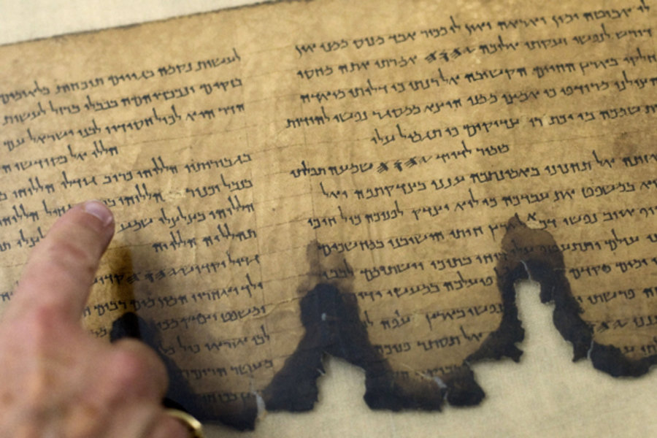
- Dating of ancient documents: Carbon-14 is used to date certain artifacts that were once “living”, for example bones and plant material. The Dead Sea Scrolls, discovered in 1947, have been carbon dated to the time of the Roman occupation of Judea – approximately 100 b.c. to 100 a.d. Why can carbon-14 dating be used to date a 2000 year-old scroll? Note I’m not asking “how can”, I’m asking “why can”. What’s going on with it? Why can C14 dating techniques give a meaningful result with the Dead Sea Scrolls dating problem?

- Chemical bonding:
  - Atoms bond together to form molecules because
    - They are magnetically attracted to one another, and seek to lower their potential energy
    - They want to “fill” their outermost shells with electrons, usually 8 in number, also known as the octet rule
    - They seek to “give away” all their outermost electrons in order to lower their potential energy
    - They either donate or accept electrons in order to arrive at “6” outermost electrons, also known as the “rule of six”

  - A neutral atom has the same number of protons and e_________.

  - When an atom does not contain equal numbers of protons and electrons, it is called an _______.

  - An atom which has lost one or more electrons will have a positive net charge, and is called a c__________.

  - An atom which has gained one or more electrons will have a negative net charge, and is called an a_________.

  - Na⁺¹ is a sodium atom which has (gained/lost) one electron.

  - Cl⁻¹ is a chlorine atom which has (gained/lost) one electron.

- pH scale:
  - The pH scale ranges from ________ to __________.

  - A pH measurement of < 7.0 is (acidic/basic)

  - A pH measurement of > 7.0 is (acidic/basic)

  - A change of one unit on the pH scale represents a change in pH by a factor of (10, 100, 1000)

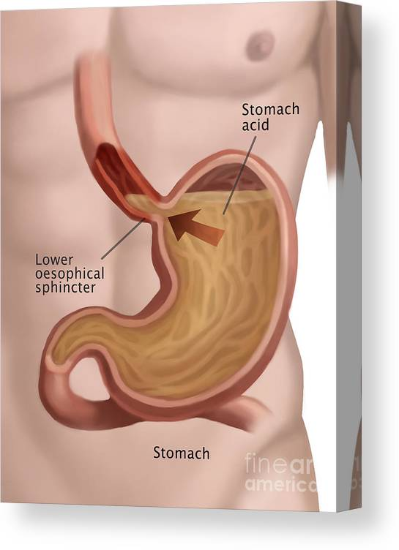
  - Pure water which is perfectly neutral has a pH of ______.

  - The blood in your veins has a pH of ________, making it slightly (acidic/basic).

  - The pH of stomach acid (gastric juice) is ___________, making it very (acidic/basic).

  - The pH of urine is ___________, making it slightly (acidic/basic).

- Acids and bases:
  - Acids donate H⁺ ions, which are otherwise known as _________.

  - Give the chemical formula for these acids
    - Hydrochloric acid (stomach acid) Example: HCl
    - Acetic acid (vinegar)
    - Citric acid (fruit juice)
    - Sulfuric acid (battery acid)
    - Oxalic acid (found in plants)
    - Formic acid (ant venom)

  - Bases donate OH⁻ ions, which are otherwise known as __________.

  - Give the chemical formula for these bases
    - Sodium hydroxide (caustic soda, or lye) Example: NaOH
    - Calcium hydroxide (lime water)
    - Ammonium hydroxide (household ‘ammonia’)

- Buffers: How do buffers (like bicarbonate, or phosphate) maintain the body’s pH in a narrow range? Use correct chemistry terms found in your book.

- pH scale: Jake is three years old and as a result of a “stomach bug” has been vomiting for about 24 hours. His blood pH is 7.65. What does this mean?
- His blood is slightly acidic
- His blood is slightly alkaline
- His blood is highly acidic
- His blood is within the normal range

- Your book lists the main chemical elements in the body (probably in a table in the chapter). If it doesn’t list them, then do Internet research on “essential elements in the body”. Choose any one of the elements, and do some research and explain 1) how the body obtains that element, and 2) what function that element performs in the body (what does it do, chemically speaking?). Include pictures and diagrams, chemical equations, and any other information which helps explain its source & function in the body. I’m looking for about ½ page of information.

