1. Introduction to the Human Body homework questions
Instructions
Name and date submitted (3 pts):
Create space in the Word document below, and write or type your answers. Turn in your completed work as an email attachment. Check your class emails for the due date.
(10 questions, 100 points possible)
- Define the following terms
- anatomy
- physiology Training new surgeons, circa 1890
- 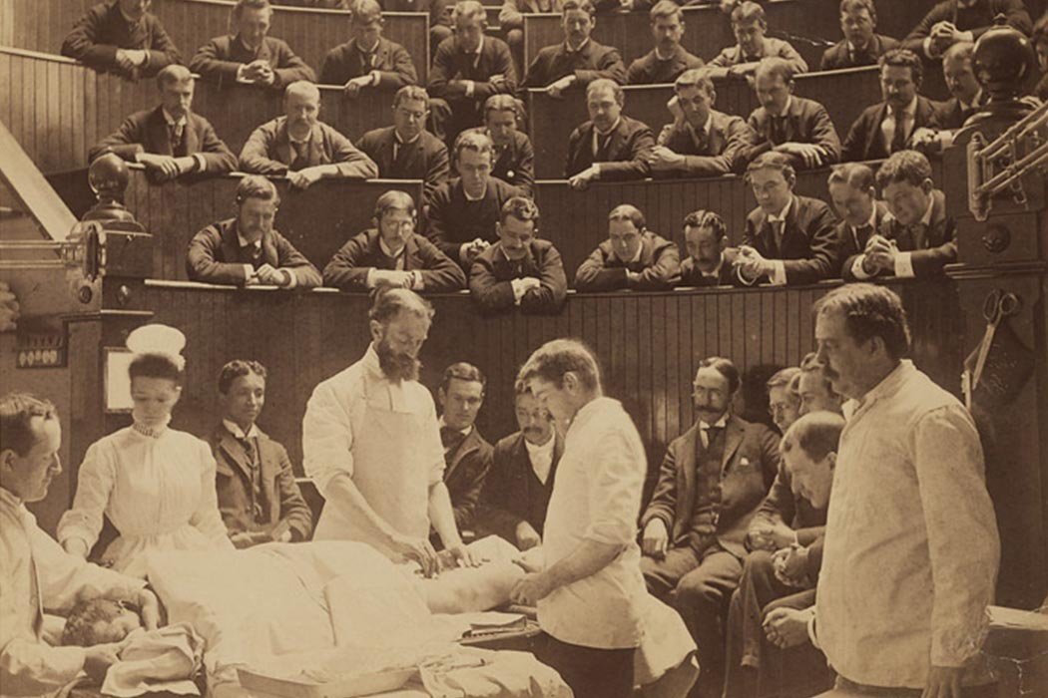metabolism
- homeostasis

- Levels of structural organization
List the six (6) levels of structural organization stated in the book, with a 2-3 sentence definition of each one IN YOUR OWN WORDS.

- Complete the table below by filling in the correct body system for each structure. Some answers are given. Refer to table 1.2 in your book.

Structure Body system
Brain nervous system
Lymph vessels
Trachea (windpipe)
Kidneys
Small intestines
Stomach digestive system
Femur (leg bone)
Sweat glands
Spinal cord
Blood vessels
Hair integumentary system
Testes
Lungs
Arteries
Pancreas
Thyroid gland
Ovaries female reproductive system
Red blood cells
Fingernails
Urinary bladder
Lymph nodes

- Which body systems help eliminate wastes? Think about this carefully – there are several! List each one and give a short explanation.

- What structures are in the Thoracic cavity? (p. 17). List at least 5.

- What structures are in the Abdominal cavity (p. 18). List at least 5.

- What is the diaphragm muscle, and what is its purpose? (p. 17) Give a complete answer.

- Directional terms (exhibit 1.1 and figure 1.6). Based on the usage of the underlined directional terms, describe the meaning of the following sentences. In other words, restate each sentence without using the underlined terms:
- EXAMPLE: In the leg, the knee joint is proximal to the ankle joint, but distal to the hip joint. ANSWER: …the knee joint is closer to the trunk than the ankle joint is, but farther from the trunk than the hip joint is.
- In the skin, the epidermis is superficial to the dermis.
- In the abdominal cavity, the stomach is superior to the small intestine, but inferior to the liver.
- In the thoracic cage, the ribs are lateral to the sternum (breastbone).
- In the arm, the humerus (arm bone) is proximal to the ulna (forearm), but distal to the scapula (shoulder blade).
- In the “anatomical position”, the radius is lateral to the ulna.

- Body Planes: Carefully sketch a zucchini (a type of squash) in all its glory. You may use separate paper. Then imagine that you took a sharp knife and sliced 3 zucchinis: one in the Transverse plane, one in the Frontal plane, and one in the Sagittal plane. (Refer to figures 1.7 & 1.8 in the book). Then make a sketch of each section and label it, in addition to your whole-zucchini sketch. You will have 4 sketches total.

- Complete the “Label the body cavities worksheet” which is posted near this assignment. Attach the completed worksheet.

