Measurements and Sig Figs lab handout (Air problem)
Name and date submitted (3 pts):
(13 questions, 5 pts each, 65 points total)
Problem 1: Calculate the weight of air in the laboratory
- Guess what the air in this laboratory weighs, in approximate pounds _____________

- Calculate the volume of the laboratory (the garage-lab in this case) in cubic meters (m³). Report your answer using the correct number of significant figures. (sig figs for multiplication are limited to the least # of sig figs in the numbers being multiplied)
Sketch it:

Calculate it:

- Use the density equation D = m/V to calculate the mass of the air in the room in kilograms. The density of air is 1.22 kg/m³. Report your answer with the correct significant figures.

- How much does the air weigh in pounds? Convert the kilograms in the last question to pounds. Use the conversion factor of 2.20 lbs/kg. Use the correct significant figures.

- How close was your original guess? Calculate the percent error, with the correct sig figs.
% error = $\frac{\left|measured-calculated\right|}{measured}$ , then convert to a percentage

Problem 2: Steel spheres
In problem 1 you calculated the volume of the laboratory in m³. Now you will calculate how many steel spheres you can pack in this space.
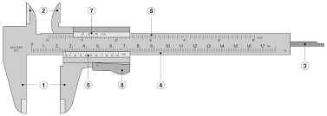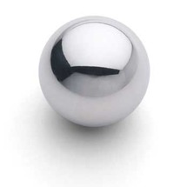

- Guess how many spheres will fit in the classroom. There is no wrong answer. ____________

- Using the Vernier caliper provided, measure the diameter of the steel sphere in cm. Report your answer to the nearest 1/100th of a cm. (for example 2.25 cm)

- Using the formula V_{sphere} = 4/3 πr³, compute the volume of the sphere in m³. Use the correct sig figs and scientific notation.

- Use the formula (#spheres = V_{room}/V_{sphere}) to compute the number of spheres that can be packed into the classroom, using a “void space” of 35.0%. Use scientific notation, and the correct sig figs.
Be sure to use a “void space” of 35.0% in your calculation. In other words, assume 35.0% of the volume of tightly-packed balls is air.

- How close was your original guess? Calculate the percent error, with the correct sig figs.
% error = $\frac{\left|measured-calculated\right|}{measured}$ , then convert to a percentage

Problem 3: Mass and density

- Mass of each sphere: Look up the density of steel in kg/m³. Using the volume of each sphere in m³ which you calculated above, compute the mass in kg of each steel sphere. Use the density formula D = m/v. Use the correct Sig Figs.

- Using a gram-scale, measure the mass of a single sphere in kg. _______________.

- How close was your calculated mass to the actual mass? Calculate your % error: _______________
% error = $\frac{\left|measured-calculated\right|}{measured}$ , then convert to a percentage

