Measurement lab
Lab Report
Complete a lab report and turn in by the due date. Use the format in the “lab notebook requirements” handout. Your lab report should be around 2 pages for this lab. I will grade and return at the next class, and then you can staple or attach it in your lab notebook.
Since this was our first lab, here is a recap of the lab to refresh your memory:
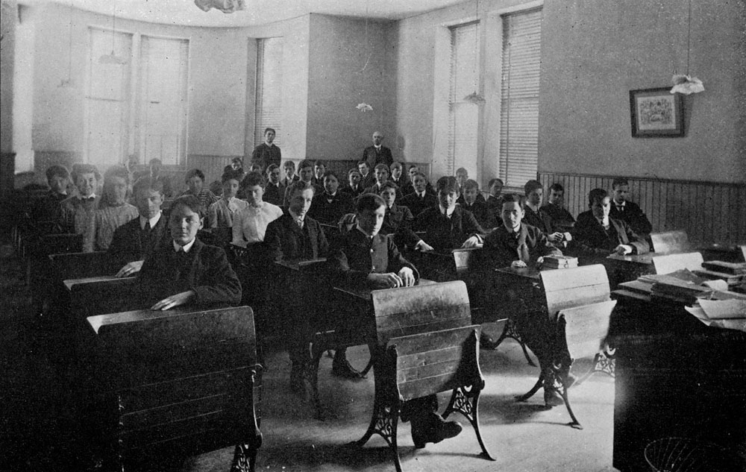In this lab exercise, we calculated 1) the ‘weight of the air in the classroom’, and 2) the number of steel spheres which could be packed into the classroom.
First, we measured the room dimensions and calculated the volume of the air in the room using V = l x w x h. The volume was calculated in ‘cubic meters’, or m³.
Then, we looked up the density of air (1.22 kg/m³) and used the density equation D = m/V to calculate the mass of the air in the room. Then we converted the mass of the air to the weight of the air using the conversion factor, 1 kg = 2.2 lbs. At that point, we had the “weight of air in the classroom”.
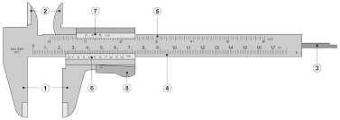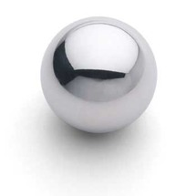After that, we calculated the volume of a 1-½” diameter steel sphere using the equation V_{sphere} = 4/3 πr³. We measured the precise diameter of the sphere using a Vernier Caliper, and divided that by ‘2’ to get the radius of the sphere. Then we were able to use the above equation to calculate its volume in m³.
Once we knew the volume of the sphere in cubic meters, m³, we then divided the volume of the room by the volume of the sphere, V_{room}/V_{sphere} , to calculate the “number of steel spheres which could fit in the classroom”. As I pointed out, this was a simplification because we did not consider the ‘void space’ of the balls, in other words the empty space in between them, which probably averages about 35% (65% balls, 35% air). If you include the ‘void space’ in your calculations below, I will award extra credit for that.

