Background
In class we discussed the dramatic pictures below. The 13-story, Lotus Riverside Apartment Building, in Shanghai, China, is a spectacular example of a major foundation failure.

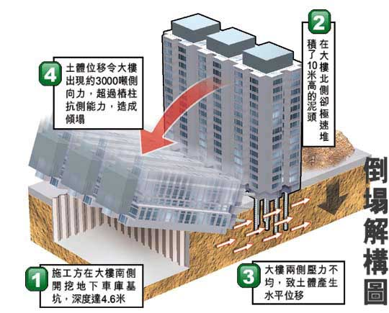
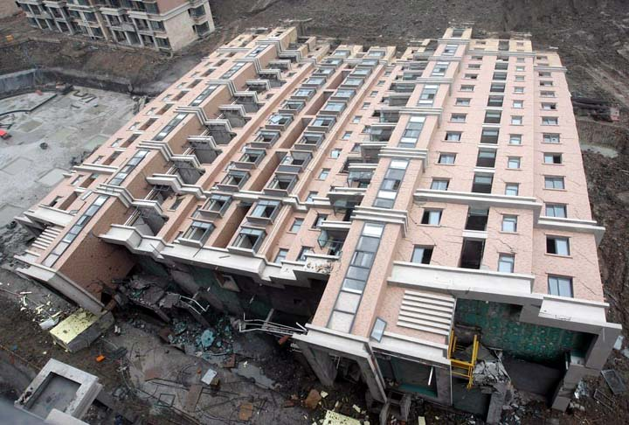

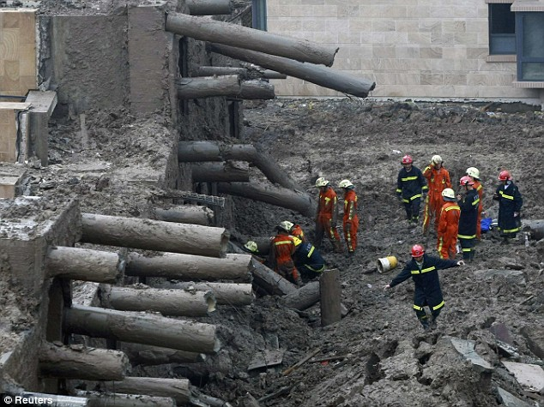
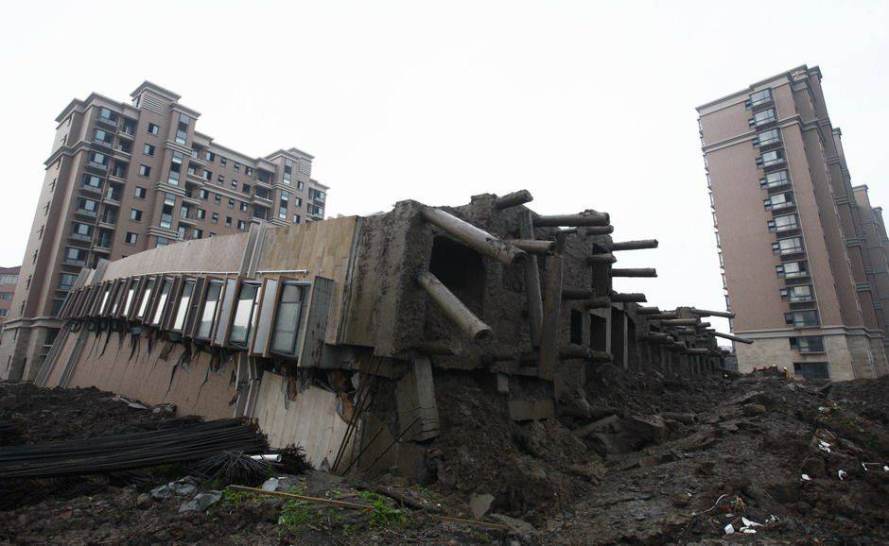

Your assignment
Your employer is designing a new high-rise building in Shanghai, China – near the above site.

Write a memo to your project team, explaining the causes and conditions which led up to the Lotus Riverside disaster, so you can avoid a similar disaster with your new project.

Address the memo to your team members, explaining the causes, mistakes, misjudgments, miscalculations, and soil conditions which led to the Lotus Riverside apartment building tipping over.

Your team needs to know how to avoid a similar collapse! Your memo should stick with the facts, use a lot of bullets, and make use of drawings or pictures. I expect around 2 pages, typed, including several pictures/diagrams. Arrange the diagrams and narrative into an easy-to-follow Memo. Use your own words – no cut-and-paste allowed!

Tips: there is a lot of information on this disaster on the Internet.

SAMPLE

Interoffice Memorandum
To: Shanghai Project Team (Liu, Jack, Sally, Fred, Hector, Wang, etc etc)
From: Your name
Subject: Lessons from the Lotus Riverside collapse
“Hi everyone. Liu has asked me to research the circumstances leading to the Lotus Riverside incident, so we can review our foundation design and construction sequencing plan. Here is a summary of what happened at the Lotus project site and what we can learn from it (then go on to explain what happened, including the causes, mistakes, miscalculations, alleged corruption, etc – and then explain to your team how to prevent the same thing from happening on your project)

Instructions
Do this assignment in a Word document and submit as an email attachment.
Grading: 60% technical content, 40% organized appearance

