California Electric Vehicles, Inc
Income Statement Analysis
Name and date submitted:
(15 questions, 47 points)
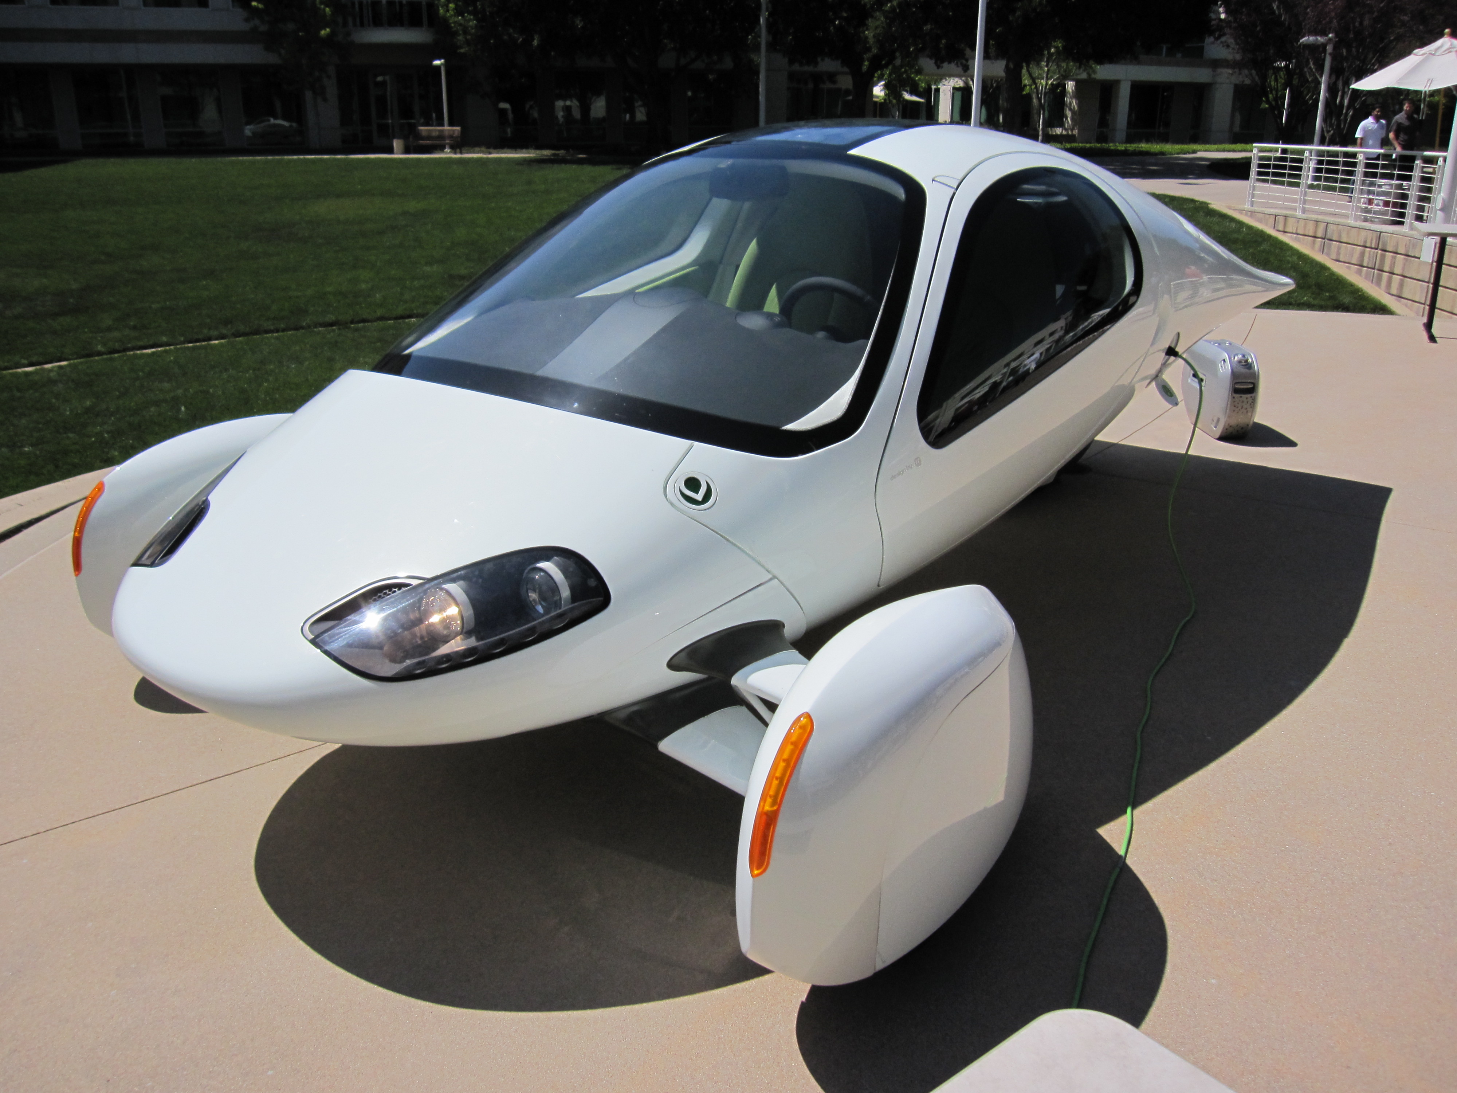Background
California Electric Vehicle, Inc. (CEV) is a startup company getting ready to launch an innovative, 3-wheel electric car for sale to the public. Their CEO, Billy McGilly, has *hired you* to look over their business plan, run the numbers, and offer suggestions. CEV has recently purchased a small factory to begin manufacturing the vehicles. Plans are underway to manufacture around 10 units the first year (to iron out all the bugs), and then slowly expand from there. Billy’s team is prepared to buy the necessary machinery to get started for around $1 million.
The firm’s Chief Financial Officer, Sally Smitherton, has prepared a “Projected Income Statement” for the new company, showing all the estimated numbers for the first (5) years of operation. Sally hands you a thumb drive containing the Income Statement, and remarks, “We are really looking forward to getting your feedback. OUR GOAL for this venture is to maximize our profit by the 5th year.” After spending a couple hours with the Vice President of Engineering and the Operations Manager, you head back to your office, confident you can assist them.
Instructions
Locate the CEV – Income Statement “template” which goes along with this assignment. Open the file in Excel or another Spreadsheet App.
For questions 1-10, create space below and type your answers. KEEP THE SAME NUMBERING!
- (1 pt) What is this company’s goal?

- ( 2 pts) Selling price
  - What is the estimated selling price, per vehicle, in year 1?

  - What is the estimated selling price, per vehicle, in year 5?

- (2 pts) Revenue: What is the projected revenue
  - During the 1st year of operation?

  - During the 5th year of operation?

- (2 pts) Cost of Goods Sold (COGS)
  - List the two categories in COGS

  - Which category represents the largest cost?

- (1 pts) (True/False) Gross Profit: The gross profit is projected to be ‘positive’ over the entire 5 years.

- (5 pts) Operating Expenses: List the 4 categories of operating expenses

  - Which is the largest operating expense listed?

- (4 pts) Fixed Assets and Depreciation
  - How much did they pay for the manufacturing plant?

  - How much in dollars is the annual (each year) depreciation expense for the plant?

  - How much are they expecting to pay for the manufacturing equipment?

  - How much in dollars is the annual (each year) depreciation expense for the equipment?

- (2 pts) Interest Expense
  - What is the annual (per year) interest expense, in dollars?

  - True/False: the interest expense changes from year to year

- (4 pts) Net Income after Taxes
  - State the net income in dollars in year 1

  - State the net income in dollars in year 5

  - True/False: Net Income steadily improves over the 5 year period

  - Profitability is achieved in which year? State the year.

For questions #10-13, you will need to modify the spreadsheet and turn it in – along with (2) graphs. There are SEVERAL graphing tutorials on YouTube if you need a refresher.
- (4 pts) Notice that the “Gross Profit %” line is blank. Using Excel (or other spreadsheet app), fill-in this line for all 5 years, showing Gross Profit as a percentage of Revenue. Example: In year 1, Gross Profit is $80,000 and Revenue is $250,000. You would then calculate Gross Profit % as 80,000/250,000 x 100, and show it as a percentage.

- (4 pts) Now do the same thing for all 5 years on the line called “Net Income %”.

Self-check: Now you should have a spreadsheet with Gross Profit % and Net Income % shown for all 5 years. You will turn-in this spreadsheet.
- (4 pts) Create an Excel graph showing “Revenue vs. Year”. In other words, graph the Projected Revenue over the 5 year period, showing Revenue on the Y-axis, and Year on the X-axis. Label the graph.

- (4 pts) Create a graph showing “Net Income (after taxes) vs. Year”. Label the graph.

Self-check: You have now created (2) graphs. I recommend using the graph style called “2D Line with markers”. You will turn these in, either as standalone files, or next to the Income Statement on the same spreadsheet.

- (4 pts) Optimization: Notice that by changing the Sales & Marketing percentage, you automatically change the Revenues from year to year. As a higher percentage is allocated to Sales & Marketing, the Revenue automatically grows faster, and vice versa (this would be expected with a car company!).

Sales & Marketing expense is initially set at 7% of Revenues. Complete columns #2-4 in the table below, by varying the Sales/Mktg percentage from 1% up to 10% as shown. (enter a different Sales & Mktg percentage on the Income Statement, and the Revenue will automatically change).
Sales & Mktg % | # of vehicles sold in year 5 | Revenue in year 5 | Net Income (after taxes) in year 5
1% | 493 | 14,800,000 | 761,000
2%
3%
4%
5%
6%
7%
8%
9%
10%

- (5 pts) You are now ready to give Sally Smitherton and her team an initial report (and a bill for your time!).
  - On the original income statement handed to you, when will the company “break even”? Which year?

  - On the original income statement, how much money in total will they lose until they start to break even? (add up all the losses up to the break-even point – hint: it’s between $1 million and $2 million)

  - On the original income statement, what net income percentage can they expect in year 5? (hint: it’s between 5-10%)

  - WHAT IS THE OPTIMUM LEVEL (between 1-10%) for Sales & Marketing as a percentage?

  - WHY is that the optimum level? (thing about the GOAL)

