11. Gene Expression (transcription & translation) homework questions
Name and date submitted (3 pts):
Using this handout as a TEMPLATE, create space in between questions below and write or type your answers. Turn in your completed work as an email attachment.
Refer to the chapter, and do Internet research as needed.
(20 questions, 100 points possible)
Table: the following table shows how each mRNA codon is translated into an amino acid in a growing polypeptide (protein molecule)
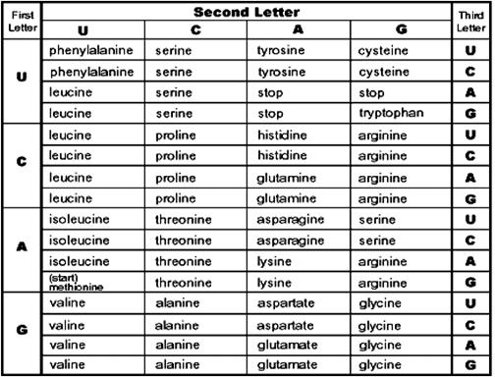
- What is the ‘central dogma’ or central idea about molecular biology?
  - The template strand of DNA makes complementary DNA, which then codes for proteins
  - mRNA makes tRNA, which moves to the ribosomes
  - DNA makes mRNA; mRNA gets translated into proteins
  - Codons get transcripted into proteins, which build the cell
- Codons are
  - Sequences of polypeptides
  - Sequences of four nucleotides on mRNA
  - Sequences of three amino acids
  - Sequences of three nucleotides on mRNA
- Amino acids are transported to the ribosome by
  - mRNA
  - tRNA
  - rRNA
  - mtDNA
- The formation of polypeptide chains is called
  - Translation
  - Transcription
  - Replication
  - Transformation
- True or False: Proteins are used primarily for growth and repair, not as energy sources.
- Transcribe and translate the following DNA sequence. In other words, list the bases that would result in the corresponding mRNA molecule, and then give the string of 6 amino acids produced by this portion of code.
3’ ATGGCCGGTTATTAAGCA 5’
- List the three types of RNA. Describe each and give its function.
- What are exons?
- What are introns?
- Indicate where the following processes take place: the nucleus, the cytoplasm, or on a ribosome.
- Transcription of a DNA molecule
- Reading of a mRNA molecule
- Lining up of a codon and an anticodon
- Replication of a DNA molecule
- Attachment of two amino acid molecules
- Attachment of an mRNA molecule to a ribosome
- Attachment of an amino acid to a tRNA molecule
- What are start codons and stop codons?
- The following is a sequence of bases on an mRNA molecule.
AUGUUCGUUAACGACCAAAUUUAA
Determine the sequence of amino acids in the section of a protein for which this mRNA would code.
- Other than the nucleus, where is DNA located in eukaryotic cells?
California Standards Test questions:
- A strand of mRNA containing the repeating sequence AAGAAGAAGAAG could code for which of the following amino acid sequences?
  - lys-arg-glu-lys
  - ser-ser-glu-glu
  - lys-arg-lys-arg
  - lys-lys-lys-lys
- 5’ ATCAGCGCTGGC 3’
The above sequence of DNA is part of a gene. How many amino acids are coded for by this segment?
  - 4
  - 8
  - 12
  - 20
- A scientist puts nucleotide chains of UUUUUU in a test tube under conditions allowing protein synthesis. Soon the test tube is full of polypeptide chains composed of only the amino acid phenylalanine. What does this experiment indicate?
  - The amino acid phenylalanine is composed of uracil.
  - UUU codes for the amino acid phenylalanine.
  - Protein synthesis doesn’t work easily in test tubes.
  - Most proteins contain only one type of amino acid.
- One human disease is caused by a change in one codon in a gene from GAA to GUA. This disease is the result of
  - A mutation
  - A meiosis error
  - Crossing over
  - Polyploidy
- Although there are only about 20 amino acids, many thousands of different types of proteins exist because the
  - Size of a given single amino acid can vary
  - Chemical composition of a given single amino acid can vary
  - Sequence and number of amino acids is different
  - Same amino acid can have many different properties
- The clear protein of an egg white becomes opaque and firm when cooked because the heat
  - Mutates the DNA
  - Turns the protein into carbohydrates
  - Stops protein formation
  - Denatures the protein structure
- A DNA base sequence is shown below:
ACAGTGC
How would the base sequence be coded on mRNA?
- TGTCACG
- GUGACAU
- UGUCACG
- CACUGUA

