Gold Recovery assignment
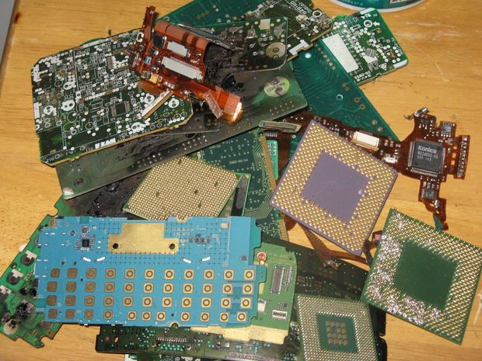
Include your name and date (3 pts)
(100 points possible)
Background
You have come across several truckloads of discarded electronic circuit boards which you suspect contain sizeable amounts of gold wiring and plating. They are destined for the landfill. You suddenly have a great business idea! How can you use chemistry and a bit of creativity to recover the valuable Gold?!

Instructions
- Do Internet research (search “recover gold from electronics” or “recover precious metals from circuit boards”, etc) and research the steps you would use to recover the gold, including the chemicals needed, tanks & vats, piping, pumps, etc.
- Prepare a professional-looking sketch of your “gold recovery system” which can handle, say, 3 large garbage-cans of electronics per day. You can use whatever materials and chemicals are necessary. You may use more than one sketch if needed to show what’s going on. On your sketches, label all the components, list all the chemicals used, and show the workflow using arrows.
YOUR REPORT MUST INCLUDE THE FOLLOWING. Points will be deducted if information is missing!
- Labeled sketch of the entire system. See above.
- How to separate the plastic and other waste
- How many, and what size, tanks or vats you need
- What chemicals you need. SHOW THE REACTIONS INVOLVED.
- How to separate and collect the gold in the tanks
- How to dispose of the waste

