11. Solutions homework problems
Name and date submitted (3 pts):
Instructions: Using this form as a template, create space in the document below and write or type your answers. Turn in your completed work as an email attachment.
(10 questions, 100 points possible)
Review questions
- Combined gas law:
The air in a car tire occupies 5.0 L at a pressure of 40 psi (pounds per square inch) and a temperature of 10.0 °C (a cold day). What will the pressure be in psi if the temperature increases to 26.0 °C (a hot day) and the volume increases slightly to 5.5 L?

- Ideal gas law:
  - How many moles of gas (don’t bother differentiating between O₂ and N₂) are contained in the car tire above?
  - How many molecules are contained in this many moles?
‘Solutions’ questions
Molarity = $\frac{mols of solute}{L of solution}$
- You have 0.5 L of 10M H₂SO₄ (10-molar sulfuric acid).
  - How would you use this to prepare 1.0 L of 5M H₂SO₄?
  - How would you use this to prepare 1.0 L of 1M H₂SO₄?

- Describe how you would prepare each of the following solutions?
  - 1.0 L of 0.50 M NaOH (0.50-molar caustic soda) from solid flakes of NaOH (you can buy caustic soda that way).
  - 1.0 L of 0.50 M NaOH from a 1.0 M NaOH stock solution sitting on a lab shelf.

- Freezing point depression: You want to melt the snow and ice on your sidewalk in Minneapolis, Minnesota. Which one of the following salts would best accomplish your task using the least amount? Explain why. You will find the information you need to answer this question in the book.
KCl, CaCl₂, CaSO₄, MgSO₄, or AgCl.
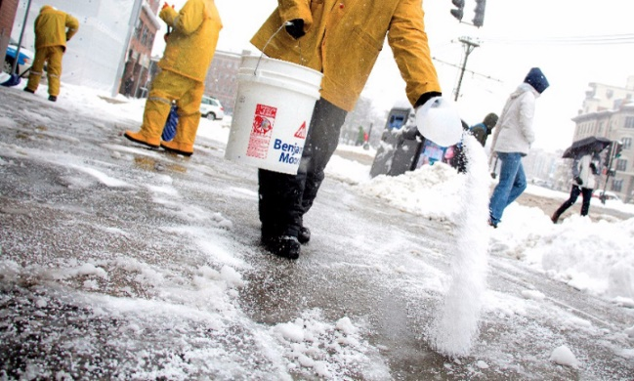

- Solution or chemical decomposition? During Chemistry lab, Sally places sucrose (table sugar) in a glass beaker, adds water, and stirs. As the table sugar disappears, she loudly proclaims that she has chemically broken down the sucrose into fructose and glucose. Is Sally’s chemical analysis correct? Research what these 3 sugars are - chemically speaking - and then explain why Sally is correct or incorrect.

- Electrical conductivity: If electrical leads (wires with clips on the end) are attached to the opposite sides of a crystal of table salt (NaCl), the salt crystal does not conduct electricity. Distilled water does not conduct electricity, either. Yet, if the sodium chloride crystal is dissolved in the distilled water, the resulting solution does conduct electricity. Use hand-drawn sketches at the molecular level of detail to describe why this occurs.

- You go into the laboratory to look for a squirt bottle containing acetone. You find two squirt bottles with different colored tops suggesting they are different liquids. Unfortunately, the labels have fallen off the squirt bottles. You have a terrible cold and you cannot tell by smell which one might be acetone, and you definitely don’t want to taste-test it, either. What simple (safe) test could you use to determine which liquid is acetone and which is water? How does this test tell you this information?

- Sea Ice: People have proposed towing icebergs to arid parts of the earth as a way to deliver freshwater. Explain why sea ice does not contain salts although it is formed by the freezing of ocean water. (ignore icebergs which are berthed from glaciers).
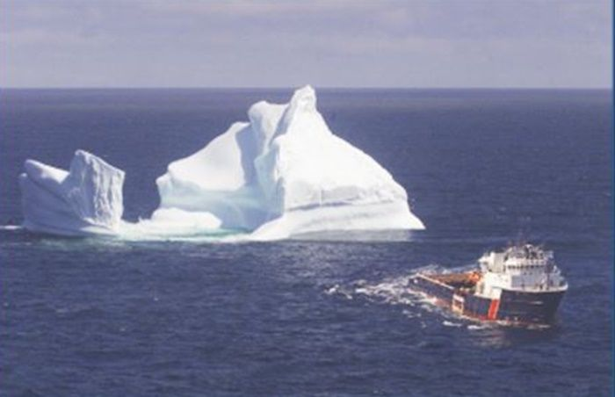

- Fresh drinking water: Assuming you could tow an iceberg to San Diego Harbor, how would you go about harvesting the freshwater from the ice in the giant iceberg? Think about what an iceberg is, and the physical & chemical challenges involved in this enterprise. List several challenges you would face - together with possible solutions – in bringing in the iceberg, breaking it up, and converting it to freshwater which could be stored on-shore – and doing so in a cost effective manner. Provide sketches as needed. There’s lots of information online.

