The U.S. Money Supply
Instructions: Create space below and type or write your answers to the following critical-thinking questions. When you are done, submit your work as an email attachment.
(4 questions, 100 points possible)
The questions will require Internet research. Give complete answers in your own words.
Fig. 1: The definitions of M1, M2, and M3
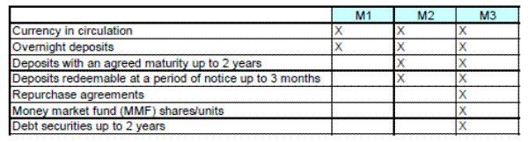
Question 1: Use this website http://www.tradingeconomics.com/united-states/money-supply-m1 to research the following. Be sure to use the correct units!
- What is the most current value for M1? In other words, how much currency is in circulation, including money in checking accounts?
- What is the most current value for M2? In other words, the total of M1 + savings accounts?

Fig. 2: The government has been printing money – lots of it recently.
Question 2: Do Internet research and explain what is meant by QE 1,2,3? Don’t just give me the names, explain what these are. Why did the U.S. government want to suddenly increase the money supply like this? What’s the story behind QE 1,2,3?
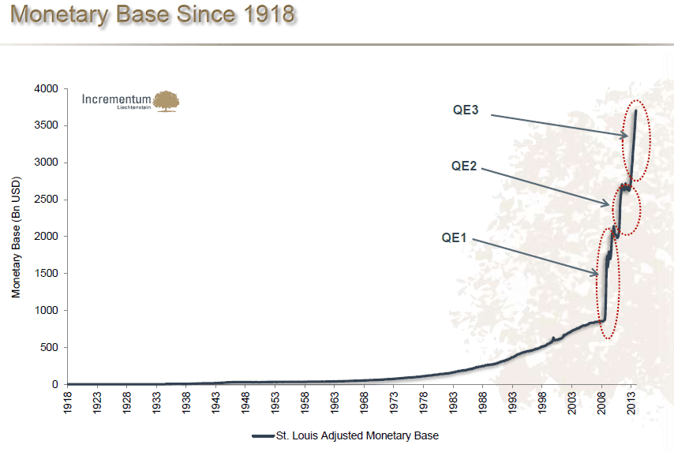

Fig. 3: The true value of the Dollar has been eroded. This is what “inflation” does.

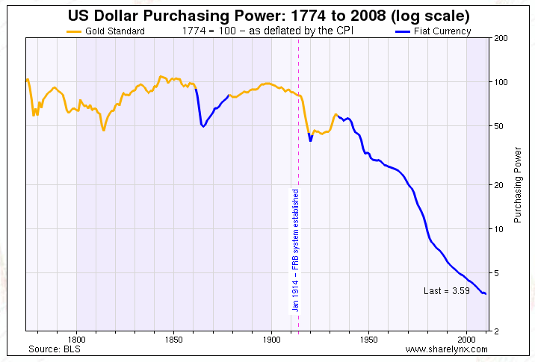
Question 3: What is this graph showing? What does it mean? What is meant by “purchasing power”? What’s going on?

Question 4: Who does inflation help? Who does it hurt? Do Internet research and think about it before answering.

