**11. Velocity & Acceleration homework problems (Physical Science)**

Name and date submitted (3 pts):

Instructions: Using this form as a template, create space in the document below and write or type your answers. Turn in your completed work as an email attachment.

(12 questions, 100 points possible).

Equations: v = $\frac{∆x}{t}$ = $\frac{(x2-x1)}{t}$ velocity formula

a = $\frac{∆v}{t}$ = $\frac{(v2-v1)}{t}$ acceleration formula

1. What is the opposite of acceleration?
2. Speed
3. Velocity
4. Deceleration
5. Motion
6. What is a suitable unit for speed?
7. m
8. m/s
9. s
10. m/s2
11. The symbol ∆ (delta) means
12. “change in”
13. “small”
14. “therefore”
15. “unknown”
16. Mary Keitany holds the women’s-only Marathon world record of 2 hours, 17 minutes, 1 second. A Marathon is 26.2 miles. Rounding off her time to 2 hours, 17 minutes, calculate her average velocity in miles per hour.



1. In metric units, a Marathon race is 42,195 meters. Using 2 hours, 17 minutes, 1 second as her official time, what was Mary Keitany’s average velocity expressed in meters per second?
2. How much time will it take for a person to walk the length of a football field (100 yards) at a constant speed of 5 ft/s?
3. 20 seconds
4. 33 seconds
5. 60 seconds
6. 166 seconds
7. A railroad freight yard switch engine on a straight track travels 1000 m to the end of the track, then back 600 m, then forward 300 m.
   1. What is the total distance travelled by the switch engine?
   2. If it took 10 minutes, 30 seconds, what was its average speed in m/s?
8. An object moves away from a motion detector with a constant speed. Which graph *best* represents the motion of the object?
9. Your thorium-powered family spacecraft can safely carry you and your loved ones on a sightseeing trip starting at your home, going directly to Miami, FL, then to Washington D.C., and then back to your home, at a speed of 20,000 miles per hour.
   1. Do Internet research (or use Google maps or Google Earth) to calculate the total distance travelled in miles.
   2. How much time in minutes was spent travelling? Ignore the time & distance spent accelerating & decelerating.
   3. 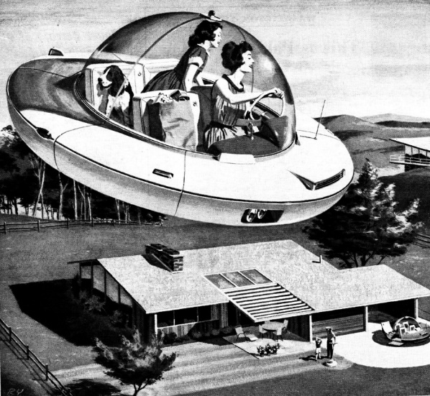More realistic scenario: assuming you can reach the top speed of 20,000 miles/hr by accelerating at the same rate as a fast sports car (a = 5 meters/s2), how long in minutes would it take you just to reach your top speed?
10. Leaping the river: A car comes to a bridge during a storm and finds the bridge washed out. The driver gets out to assess the situation and decides to leap the river with his car. The side the car is on is 21.3 m above the river, while the opposite side is a mere 1.80 m above the river. The river itself is a raging torrent 61.0 m wide. The driver calculates that the car needs to be travelling at a velocity of 30.5 m/s to land safely on the other side.
    1. Assuming the car can accelerate from a standstill at 5.3 m/s2 (a really fast car), how far back from the water’s edge must the driver begin his approach?
    2. How many seconds is the car directly over the water? Ignore air and wind resistance.
11. Don’t do this: A daring swimmer dives off a cliff with a running horizontal leap, as shown in the figure. Assuming he will reach the ledge in 1.4 s, what must his minimum speed be just as he leaves the top of the cliff so that he will clear the ledge?
12. Some students were test-driving a Ferrari as part of a school laboratory exercise. They found that the 1,370-kg car accelerated from 0 to 60 mi/hr (0 to 97.0 km/hr) in 2.7 seconds along a level stretch of track.
    1. Calculate the average acceleration in m/s2.
    2. What speed would it attain if it continued accelerating at that rate for an additional 2.7 seconds (5.4 s total)?

