12. Building Stonehenge assignment (Physical Science)
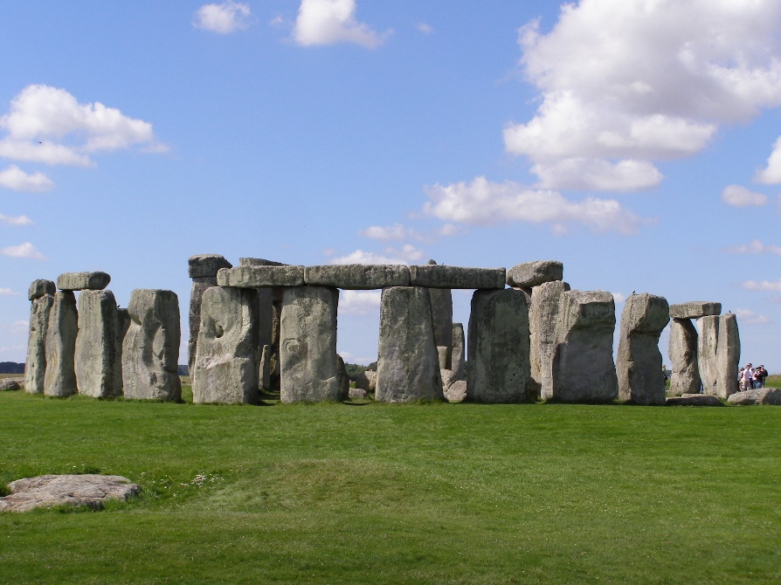
(100 points)
Background:
The idea from this chapter is that all complex machines are just a combination of one or more of the “Six Simple Machines”. The Six Simple Machines are 1) the lever (includes 1st 2nd 3rd class levers, wheelbarrows, crowbars, ratcheting mechanisms, etc), 2) inclined plane (wedges, ramps, fan blades, turbine blades), 3) pulley systems (includes single pulleys and block & tackle pulleys), 4) wheel & axle (includes gears, wheels, bearings, rollers), 5) the wedge, and 6) the screw (includes worm gears, Archimedes pumps, lifting jacks).
Assignment:
Do Internet research and brainstorm how the massive stone-monument at Stonehenge may have been built using only manpower & animal-power and Iron Age materials (500 B.C.). Do some thinking about how the huge stones could have been transported many miles, and then tipped up vertically around the circle, with heavy flat stones then lifted into place across the top of the vertical ones. The stones weigh between 5 and 20 tons each!
Complete the following:
- Prepare three (3) glorious sketches showing: 1) how the stones could have been transported 20 miles, 2) how they could have been tipped up into place, and 3) how the big flat stones across the top could have been lifted into place – using only timbers, stones, rope, iron tools, etc.
- In your (3) very-impressive sketches, show as many of the Six Simple Machines as you need. Label them. Indicate what’s going on. Explain if humans or animals are being used as the ‘motive force’ in each case.
TIPS: There’s lots and lots of information about STONEHENGE on the Internet! You can search “how was Stonehenge built” or “building Stonehenge”. Look at the ‘images’ to get ideas!

