Concentration weblab

Name and date:

Go to the weblab here: https://phet.colorado.edu/sims/html/concentration/latest/concentration_en.html
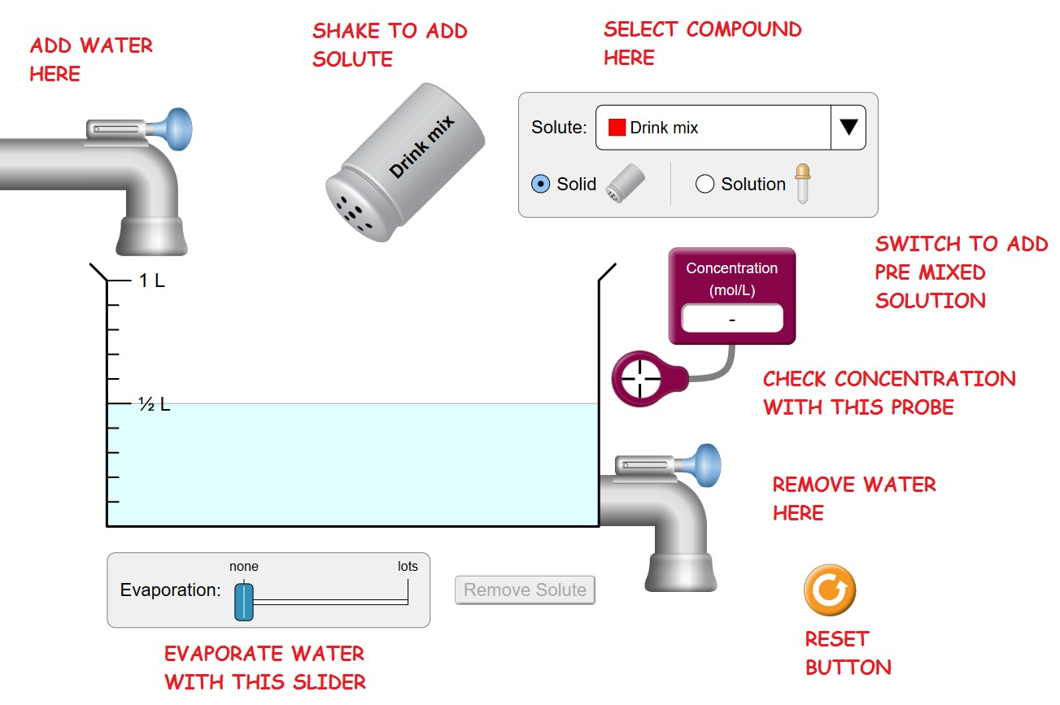

Answer all questions below. KEEP THE SAME LAYOUT AND NUMBERING!!!... or I won’t be able to grade it.
Part 1 – Introduction
Move the Concentration Probe into the liquid. Shake some drink mix into the water. Continue to add more.
- What happens to the concentration as more solute is added?

- What are the units of concentration on the meter?

- What happens to the color as more solute is added?

- Now add water from the faucet. What happens to the concentration as the quantity of water increases?

- Now remove water with the valve on the lower right. Does the concentration increase, decrease, or stay the same? Explain why.

- Now remove water with the Evaporation Slider Bar on the bottom. Does the concentration increase, decrease, or stay the same? Explain why.

Part 2 - Saturation
Press RESET. Switch the SOLUTE to Copper II Sulfate (CuSO₄).

- Move the Concentration Probe into the liquid. Add a bunch of CuSO₄ using the shaker. Can a saturated solution be created?

- How do you know when a saturated solution is created?

- What is the concentration in mol/L at saturation?

- Add more CuSO₄ solute. Does the concentration continue to go up, or does it stay the same? Explain why.

Part 3 – The Eyedropper
Press RESET. Switch to the eyedropper. Stay with copper II sulfate as the solute.

- Completely drain the water from the beaker. Squirt about ¼ L of CuSO₄ solution into the beaker. Using the concentration meter, what is the concentration of the solution in the eyedropper in mols/L?

Part 4 – Controlling the concentration
Press RESET. Select CuSO4 as the solute again.

- What is the molecular weight of CuSO₄ in g/mol? Hint: It’s between 150 and 170 g/mol. Answer ____________ g/mol

- Drain the water level down to 0.25 L. Then add enough CuSO₄ from the eyedropper to create a .5 Molar solution. What is the total volume in L? (Hint: it will be quite a bit more than 0.25 L)

- How many moles of CuSO₄ are now in the beaker? (Check: the answer is .25 mol, but you must show your work!)

- Predict the concentration in mols/L if you now were to top-off the beaker to 1 L with water from the faucet. Show your calculation, include units.

- Now actually add water up to the 1 L mark.
  - What is the concentration? (Check: it should be about .25 mol/L)

  - Was your calculation correct?

  - Fix your calculation if it wasn’t correct!

- Predict the concentration in mols/L if you were now to evaporate the solution from 1 L down to .75 L. Show your calculation.

- Now actually evaporate water until there is .75 liter of solution left in the beaker.
  - What is the concentration in mol/L? (Check: it should be about .33-.34 M)

  - How close was your prediction?

  - Fix your calculation if it wasn’t correct!

- From the concentration & volume, calculate the number of moles of solute in the solution at this point. Show your calculation, using (mol/L) x (L). (Check: it’s .25 mol, but show your work!)

- Predict the concentration and the moles of CuSO₄ solute if you were to add water up to the 1-L mark again. (Check: it’s .25 mol/L and .25 mol, but show your work!)

Now drain the beaker down to the ½-L mark. Be careful not to overshoot, or you will need to start over!

- Did the concentration go up, down, or stay the same? Explain why.

- Now calculate the number of moles of CuSO₄ solute still in the solution, using (mol/L) x (L). Show your calculation. (Check: it’s .125 mol, but show your work!)

- Predict the concentration if you were now to dilute the volume back up to 1 L with water. Show your calculation.

- Now actually add water from the faucet up to the 1-L mark.
  - What is the concentration in mol/L? (Check: it’s .125 M, but show your work)

  - How close was your prediction?

  - Fix it if it wasn’t correct!

Part 5 - Summary

- Adding solute to an unsaturated solution causes the concentration of the solution to: INCREASE /DECREASE/ REMAIN UNCHANGED.
- Adding solute to a saturated solution causes the concentration of the solution to: INCREASE /DECREASE/ REMAIN UNCHANGED.
- Adding pure water to a saturated solution will cause the concentration of the solution to: INCREASE /DECREASE/ REMAIN UNCHANGED.

- Evaporating water from an unsaturated solution causes the concentration of the solution to: INCREASE /DECREASE/ REMAIN UNCHANGED

- Evaporation acting on a saturated solution causes the concentration of the solution to: INCREASE /DECREASE/ REMAIN UNCHANGED.

