13. Fluid Mechanics homework problems (Physical Science)
Name and date submitted (3 pts):
Instructions: Using this form as a template, create space in the document below and write or type your answers. Turn in your completed work as an email attachment.
(15 questions, 100 points possible).
- T/F: Pressure: Fluid particles are always moving, bumping the container and causing pressure.
- T/F: Pascal’s Law states, “If you change the pressure in a confined fluid, that change is felt equally throughout all the fluid.”
- T/F: 1 Pascal is equal to 1 Newton of force over a square meter (N/m²)
- T/F: Archimedes’ Principle states, “A submerged or partially-submerged object is buoyed up by a force equal to the weight of the fluid it is displacing.”

- When you go deeper in the water, the pressure increases because
  - There is more salt in the water
  - There is more water on top of you
  - The water temperature gets colder
  - There are living organisms in the water

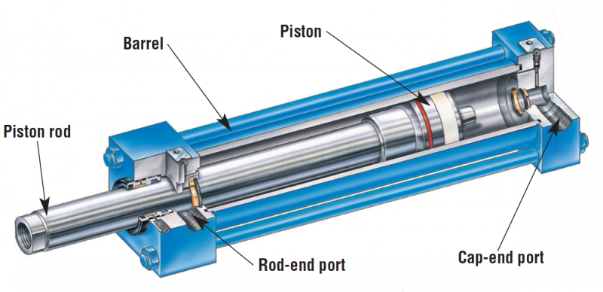
- In a certain hydraulic machine, the input piston has an area of 2 cm² and the output piston has an area of 32 cm². The output force will be ____________ the input force.
  - 16 times
  - 1/16 of
  - 32 times
  - 1/32 of

- The pascal is a unit of
- Pressure
- Force
- Mass
- Volume

- Pressure is
- Force
- Volume x force
- Force / area
- Force / volume

- Suitable units of pressure are
- Feet-pounds
- Pounds per square inch
- Newtons per square meter
- All of the above
- A & B only
- B & C only

- Suitable units for the flowrate of a fluid are
- Gallons per minute
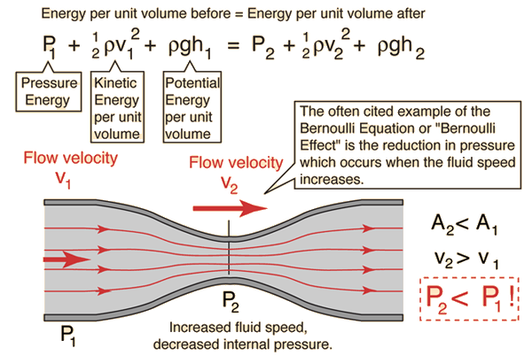
- m³ per second
- ft³/sec
- all of the above

- Bernoulli’s Principle states
- A fluid’s pressure increases as its speed increases
- A fluid’s pressure decreases as its speed increases
- A fluid’s volume increases as its pressure increases
- A fluid’s volume increases as its force increases

- When you compare the air pressure above the wing of a moving airplane to the air pressure below the wing,
- There will be less pressure above the wing
- There will be less pressure below the wing
- There will be equal pressure above and below the wing
- Not enough information to tell

- Steel ships float because within their hulls are large volumes of
- Water
- Ballast
- Air
- Insulation

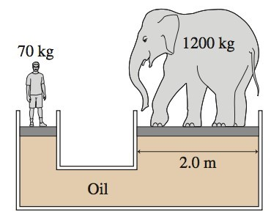
- In the figure, the man (who weighs 686 N) and elephant (which weighs 11,760 N) are at equilibrium (perfectly balanced). What is the diameter in meters of the platform the man is standing on?

- The small piston “A1” has a surface area of 2 in², and the large piston “A2” has a surface area of 100 in².

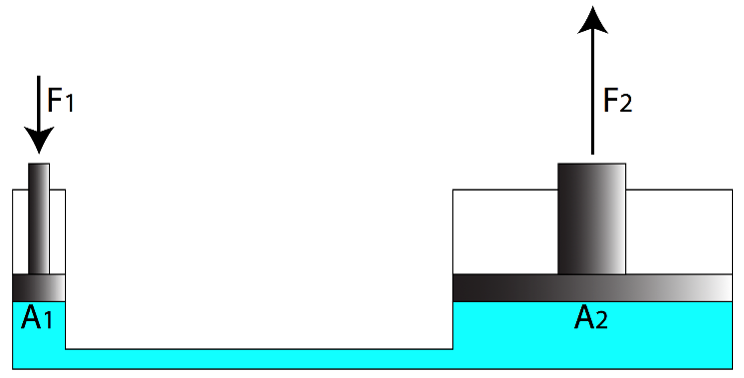
  - If you want to lift 1,000 lbs with piston A2, how much force do you need to apply to piston A1?

  - Using the same information, how far does piston A1 need to travel in order to move piston A2 a distance of 1 inch?

  - Using the same information, what is the ‘mechanical advantage’ of this hydraulic machine?

