Human Insulin report
Background
Insulin is a hormone (a protein signaling molecule) made in the Pancreas. Insulin’s function is to regulate glucose levels in the blood. Without Insulin, a life-threatening condition known as Diabetes Mellitus results. In this class we have already studied Diabetes and the role of Insulin in the body, so you should be somewhat familiar with the topic.
Historically, people with Diabetes did not live long. In 1921, Banting & Best showed that Insulin could be isolated and purified from a dog’s pancreas. This meant people could inject animal insulin as treatment for Diabetes. Over the ensuing years, improvements were made in the process, but you were still injecting Insulin derived from cows and pigs. This caused an immune response or allergic reaction in people, and so it was not ideal.
By the 1970’s, we had located the gene for Insulin in humans (on chromosome 11) and determined the exact amino-acid sequence of the Insulin molecule. In 1978, Genentech successfully copied (cloned) the human Insulin gene by splicing it into the E. Coli bacterial genome, and then used the E. Coli bacteria as a ‘factory’ to produce lots of the Insulin. In 1982, Ely Lilly received FDA approval for Humulin (artificially made human Insulin). This was the World’s first drug produced by recombinant-DNA (genetic engineering) methods! THIS IS WHAT WE ARE DOING in our E. coli bacterial transformation lab!... the so-called ‘pGLO’ or ‘GFP’ lab.
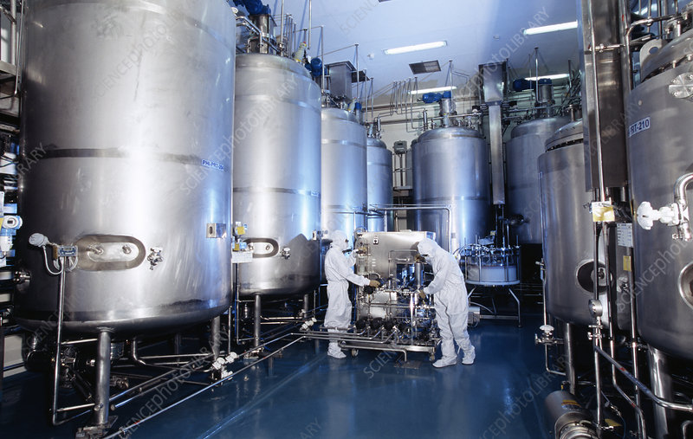
Bacteria is busy making human insulin while sloshing around in these tanks:

Assignment instructions
Do Internet research and prepare a 2-page report on the topic: “How Human Insulin is Made”. Be prepared to present your paper at a future class.
Length: I would like to see at least 2 pages. Respond to all 5 requirements, below.
Use bullet points together with short, informative sentences. Use lots of diagrams and graphics to convey information quickly.
Search terms: “how human insulin is made” “insulin recombinant dna methods” “genetic engineering of insulin” “history of insulin” and so forth.
50 points total.

REQUIREMENTS: Your paper must address all five of these:
- (10 pts) Give a brief history of Insulin production from animals. Use lots of dates and who-did-what.
- (10 pts) Show images of the Insulin protein itself, and what it looks like. You can show a picture of chromosome 11, with the Insulin gene identified somehow.
- (10 pts) Explain how we use ‘genetic engineering’ and ‘recombinant DNA’ methods to make human Insulin today.
- (10 pts) Show graphics/images of the process itself. How is it made? What does the process consist of? Go into each step a little bit… (this should constitute about 50% of your report)
- (10 pts) Any future drugs under development? Describe ‘analog Insulin’ or any other future drugs.

