Marketing Plan assignment
California Electric Vehicles, Inc.
Name and date submitted (3 pts):
Instructions: Create space in the TEMPLATE BELOW and write or type your complete responses. Turn in your completed work by the due date.
(10 questions, 100 points)
Before completing this assignment, go back and review Ch. 8 “Marketing Your Product”.
Narrative
It is now early 2023, and the original 3-wheel Electric Car concept is selling so well that the CEO of California Electric Vehicles, Inc., Billy McGilly, wants to launch a new product: an all-electric Truck! The company’s Board of Directors (Smithers, Callahan, Chang, and Columbo) backs the idea 100 percent!... and has asked McGilly to develop a preliminary Marketing Plan for the new project. The Vice President of Marketing, Bo Svenson, calls you in and asks if you’re available to develop a first-draft Marketing Plan as soon as possible, which incorporates the “Five Ps” of marketing. After some initial back-and-forth with Bo, you agree to take it on as your top priority, with a very generous hourly billing rate. (Don’t worry, you have since moved on from the CFO position - which was offered to Hans Spielman, the former Controller - so you have plenty of time to do this).
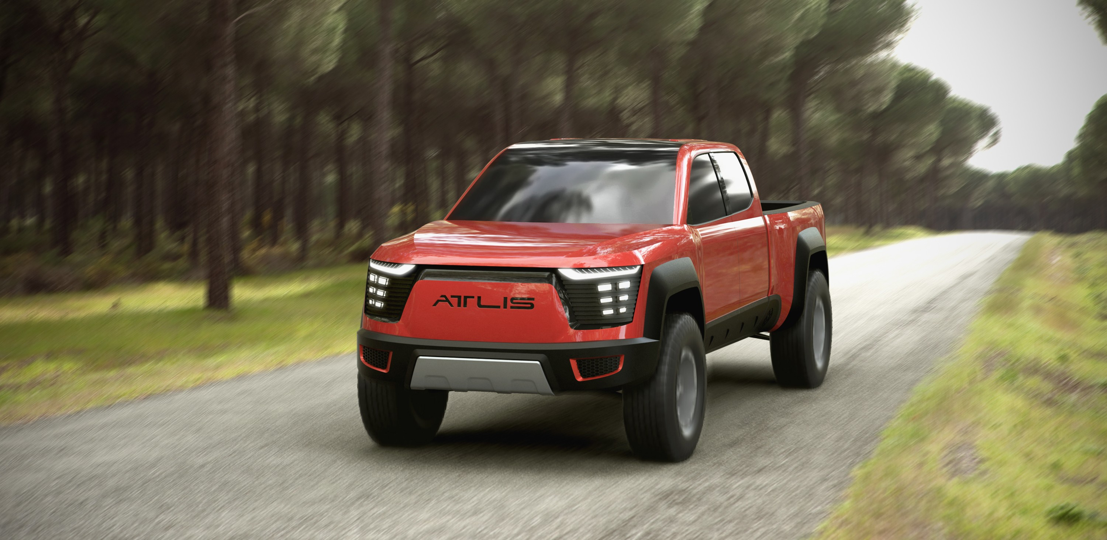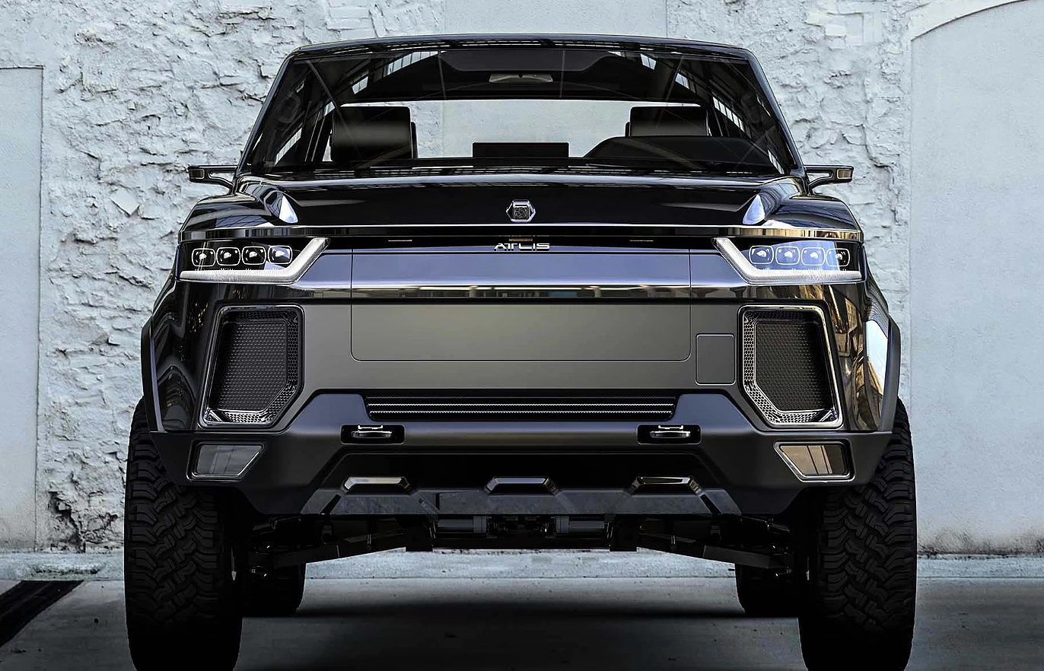

Instructions
Begin preparing a Marketing Plan for this new product (“E-Truck”) by answering the questions below. All of this was covered in Ch. 8 “Marketing Your Product”, so will probably need to review the chapter first.
You will need to make lots of assumptions. Use creative thinking! None of you will have the same approach. Some of you will view this as a “sports vehicle”, while others will view it as a “utility vehicle”. Some of you will position it as a “premium” product, while other will position it as a “value” product. You will find lots of ideas here https://www.startengine.com/atlis-motor-vehicles, but I want your independent, unique, input! Simply copying and pasting will not be allowed.

Unit cost analysis (covered in Ch. 10)
Selling price per unit (E-Truck) |  | $45,000
Manufacturing expenses:
Materials (47%) | $21, 150
Labor (21%) | $9,450
Manufacturing overhead (5%) | $2,250
Total cost of goods sold | $32,850 | $32,850
Gross Profit |  | $12,150
Less: Operating expenses (20%) |  | ($9,000)
Net Profit per unit |  | $3,150

5- Year Sales Forecast (E-Truck)
 | Yr. 1 | Yr. 2 | Yr. 3 | Yr. 4 | Yr. 5
E-Trucks sold (projected) | 10 | 50 | 250 | 1200 | 6000

‘E-Truck’ Marketing Plan
- Use the Atlis Motor Vehicle link for ideas! https://www.startengine.com/atlis-motor-vehicles
- Don’t just copy Atlis’ ideas; come up with your own ideas. You are marketing this vehicle.
- I want this to be YOUR marketing plan! (not a cut-and-paste of Atlis). They are paying you for your ideas!
- Use complete sentences.
- Use your own words!
(10 questions, 10 points each)
- Product Description
Describe the product (E-Truck) in glowing terms, using 3-4 sentences. Make it sound believable, but sort of rosy. Put your “sales hat” on.

- Value Proposition
Think about ‘brand’ and ‘attracting customers’ and ‘product positioning’! (all of these are covered at p. 215-216 in your book). What is E-Truck’s “value proposition” to consumers? Why should people buy it? What are the reasons they should buy it, instead of “brand-X”? What separates the E-Truck from its competitors? What is distinctive about this product? Get ideas from Atlis, but also make up some of your own! Use “creative thinking” here. At least 3-4 sentences.

Marketing Goals:
These are defined and discussed in detail on p. 212. I am looking for at least 3-4 well written sentences under each set of goals, below. Get your ideas from Atlis, but also make up stuff that sounds reasonable! Use creative thinking.

- Short-range goals

- Mid-range goals

- Long-range goals

Marketing strategy - “Five Ps”:
Cover the topics listed for the Five P’s on p. 213-214 in the book. If you need numbers, use the tables above to get your numbers! Use information from Atlis, and also make up your own strategies that sound reasonable and make sense to you. You are marketing this product. Describe a strategy which you think will work for a product like this!

- People

- Product

- Place

- Price

- Promotion

