The Business Cycle
Name and date submitted (3 pts):

Instructions: Create space and enter your answers in the Word document below. When you are done, submit your work as an email attachment by the due date.
(10 questions, 100 possible points).

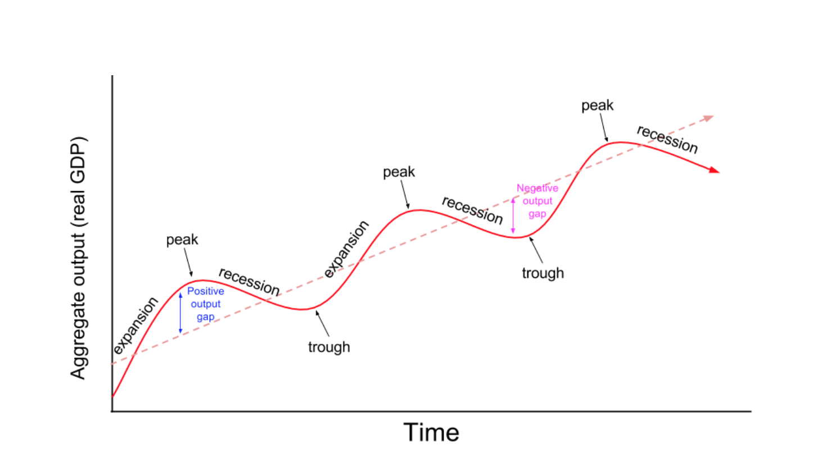
The four phases of the business cycle
- Describe the ‘expansion phase’ of the business cycle. What is it? What happens?

- When the economy reaches the ‘peak phase’, three factors typically prevent further growth. With each one, explain what is going on:
  - Limited raw materials

  - Limited labor

  - Limited financial capital

- What causes the ‘recession phase’ of the business cycle?

  - Why are big-ticket items affected first? What happens?

  - Why are smaller items affected? What happens?

- What are three characteristics of the ‘trough phase’?

Recession vs. Depression
“A recession is when your neighbor loses his job; a depression is when you lose yours.” President Harry Truman

“A recession is when your neighbor loses his job; a depression is when you lose yours. A recovery is when Jimmy Carter loses his!” Presidential-candidate Ronald Reagan, while running against President Carter in 1980 https://www.youtube.com/watch?v=0YDXmxfWM2o

- In quantitative terms, when does a “recession” officially become a “depression”? (quantitative means in terms of actual numbers or percentages…)

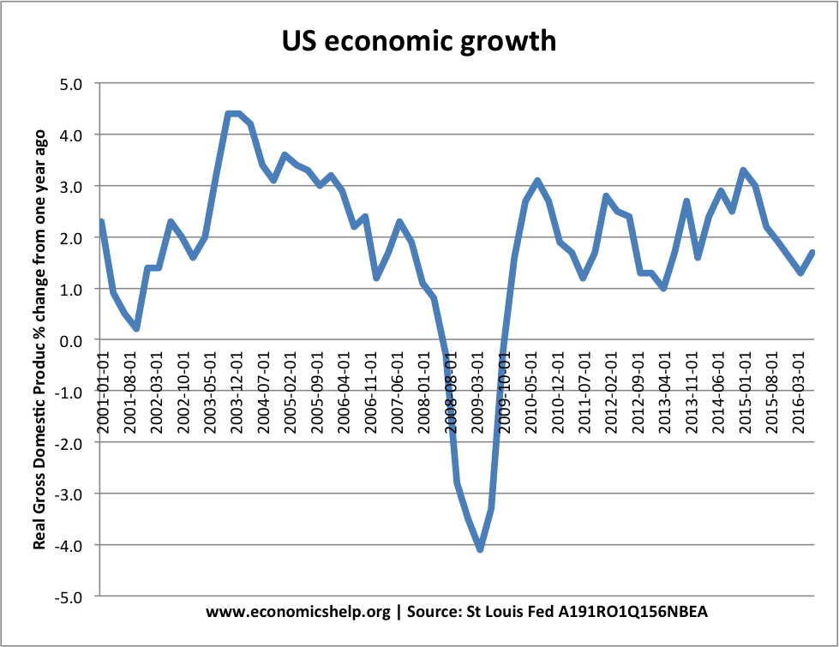

Business Cycles: 5 Theories
- There are many theories for the existence of business cycles. Your textbook describes five theories. With each, explain what is going on.

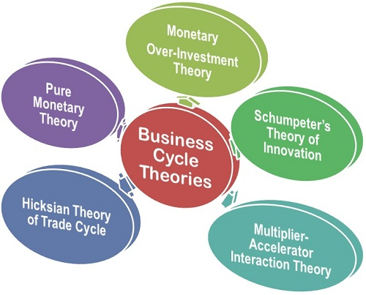
  - Sunspot theory

  - Psychological theory

  - Monetary theory

  - Technology theory

  - Political theory

Unemployment
- Civilian labor force
  - Currently, how many people make up the civilian labor force in the U.S.? https://fred.stlouisfed.org/series/CLF16OV

  - What is the current population of the U.S.? https://www.census.gov/popclock/

  - Calculate the percentage of the population which is in the labor force. Hint: [(labor force / total population) x 100]

- Unemployment rate
  - Exactly what is the current unemployment rate as a percentage? https://fred.stlouisfed.org/series/UNRATE

  - How high did the unemployment rate get during the 2009 recession? https://fred.stlouisfed.org/series/UNRATE

  - How high did it get during the 1982 recession? (see graph below)
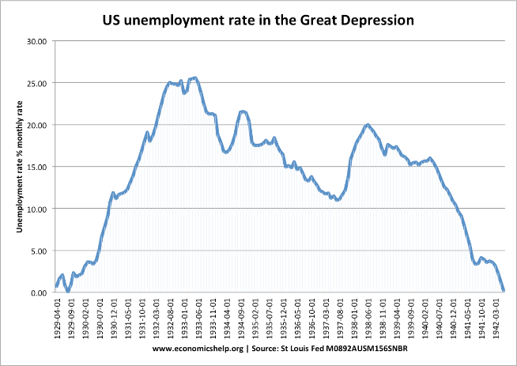

- Your textbook describes four kinds of unemployment. Explain what each one is.
  - Frictional unemployment

  - Structural unemployment

  - Seasonal unemployment

Minimum wage
- Analysis: What if tomorrow, California Governor Newsome signed into law, “From this point forward, California farms and businesses must pay a minimum wage of $50 per hour to all workers. Violators will face fines and/or imprisonment.”

Explain how this would affect the following groups of people:

  - A consumer buying fast food (Five-Guys, In-N-Out, etc)

  - A farmer growing lettuce

  - An employee-Barista at Starbucks Coffee

  - A consumer buying a new car from a car dealer

  - A poor person buying a loaf of bread at WalMart

  - A rich person buying a steak at Costco

  - A student paying for college

