**Coulomb’s Law weblab**

Name and date submitted:

Open the PhET “Coulomb’s Law” lab simulation <https://phet.colorado.edu/en/simulations/coulombs-law>

Select “Atomic Scale”.

Purpose: You are comparing the forces within an atom.

Instructions: Create space in the Word document below, and write or type your answers to the questions. YOU MUST SHOW YOUR WORK where it is required.

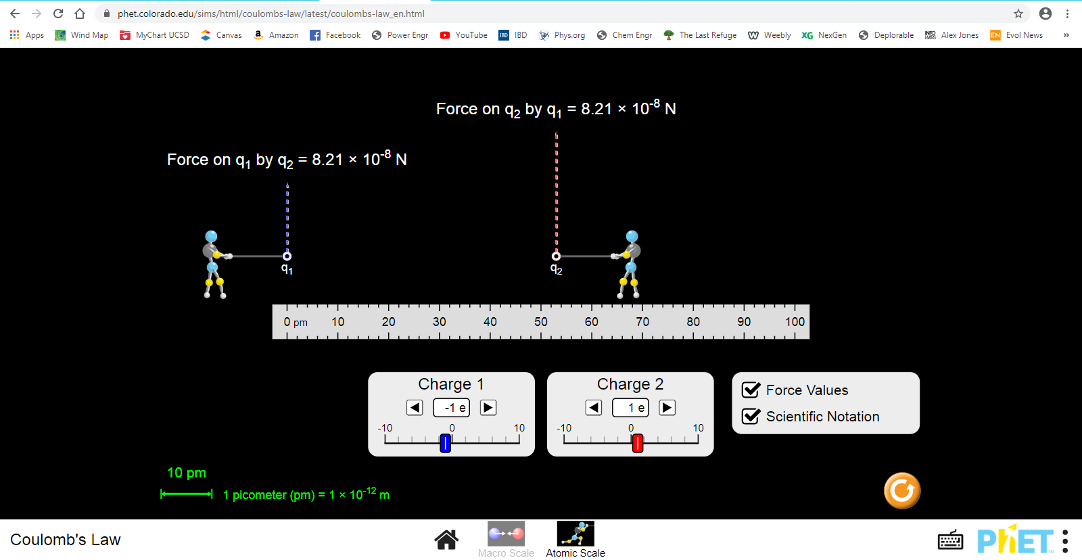(10 questions)

Equations: Coulomb’s Law: FE = k $\frac{q_{1}q_{2}}{r^{2}}$

1 C = 6 x 1018 electrons,

1 e = -1.6 x 10-19 Coulomb

1 p = +1.6 x 10-19 Coulomb

1. Using Coulomb’s Law, calculate the electrical repulsion between two protons in a nucleus if they are 1.00 x 10-15 m apart. (Hint: 200-300 N)
2. If you were holding these protons, do you think you could feel the effect of this force?
3. How many pounds would the force be? (Hint: 50-75 lbs)
4. Now using the PhET simulation by positioning the ‘atomic men’ and adjusting the charges, find the electrical attraction that a proton in a nucleus exerts on an orbiting electron if the two particles are 1.00 x 10-10 m apart. (Hint: 1.0-5.0 x 10-8 N)
5. If you were holding the electron, do you think you could feel the effect of this force?
6. Conclusion to the above: How do the forces in the nucleus of an atom compare with the forces that corral/confine the electrons?
7. Use the PhET simulation to determine the electrostatic attraction between the lone electron and lone proton in a Hydrogen atom. The electron orbits at a distance of 0.529 Angstroms (1 Angstrom is 10-10 m) from the nucleus. You will need to convert this to picometers to use the simulation. (Hint: 8.0-10.0 x 10-8 N)
8. Use Newton’s law of gravity FG = G $\frac{m_{1}m_{2}}{d^{2}}$ to compute the gravitational attraction in Newtons between the proton and electron above, using a distance of 0.529 x 10-10 m. You will need to look up the mass of a proton and electron, and the value for ‘G’, in the back of the book. (Hint: 1.00-2.00 x 10-47 N)
9. Conclusion to the above: How does gravitational force compare with electrostatic force? Try to be specific as to ‘order of magnitude’.
10. Two electrons and one proton are in the configuration shown below. Use the PhET simulation to determine the attractive forces between e1 and p, and e2 and p, and calculate the magnitude and direction of the net electrostatic force they will exert on the proton.

