Economist Thomas Sowell assignment
“Economic Facts and Fallacies”
Name and date (3 pts):
Dr. Thomas Sowell is a famous American Economist who has made a career out of challenging our societal assumptions and ideas on a wide range of topics. As any good Economist should, he first does lots of research and then uses statistics to back up his arguments. He grew up in poverty in New York City, dropped out of high school to support himself, was eventually educated at Harvard and University of Chicago, worked as an Economics professor at UCLA (and other places), and is currently a Fellow at the Hoover Institution. He has been a favorite go-to guest on various radio and TV programs and specials.
Instructions: Watch the video “Thomas Sowell – Fallacies of Race”, and respond to the questions below. https://www.youtube.com/watch?v=g6IJV_0p64s&t=290s. Submit your completed work by the due date.
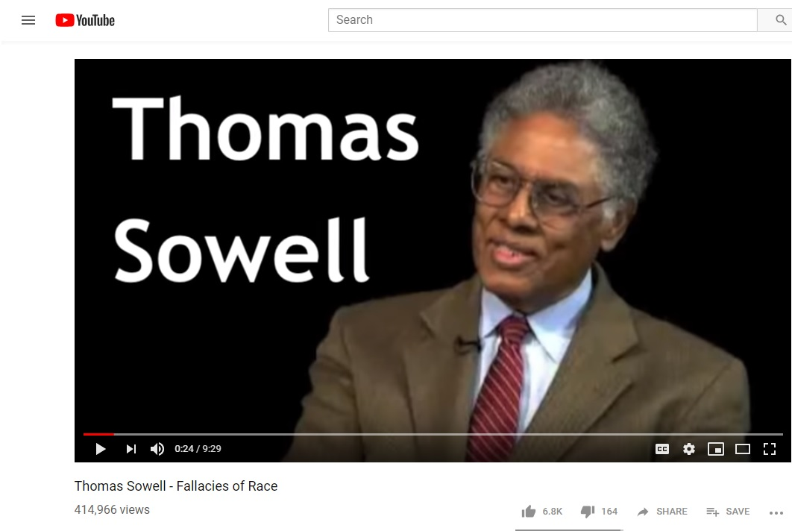(10 questions, 100 possible points)
- 0.00-0.22 Dr. Sowell is discussing his new book, “Economic Facts and Fallacies”.
  - What is meant by the word “fallacy”?
  - Restate his “gloomy observation” in this segment in your own words. What does he mean?
- 0.35-1.26 Slavery and racism
  - Summarize what is being discussed, and Dr. Sowell’s response to the question. Take some time and be specific.
  - What is meant by “Slav”? What is a “Slav”?
- 1.26-2:18 Slavery in the United States
  - Summarize what is being discussed, and Dr. Sowell’s response to the question. Go into detail.
  - How did slavery in Brazil differ from slavery in the U.S.? Explain….
- 2.18-2.40 Differences in Income
  - What is the question, and what is Dr. Sowell’s answer? Summarize in your own words.
- 2.40-3.26 Income
  - Again, summarize the question together with Sowell’s answer.
- 3.26-4.52 Fatherless families and slavery
  - A common argument you hear is that the breakdown of the African American family structure is a result of slavery. Again, summarize the question from the interviewer, as well as Sowell’s answer. Be sure to mention the statistics he’s using.
  - Why does Sowell believe the family breakdown started in the 1960’s? He gives several reasons. What was going on in the 1960’s? Summarize his argument.
- 4.52-5.35 Illegitimacy and race
  - What is ‘illegitimacy’?
  - What was the “Moynihan Report”? (it was a very famous report by Senator Moynihan of New York). I want to know what the gist of the report was. Just summarize it quickly. You will need to look this up….
  - What is meant by “welfare state”? Just summarize. You will need to look it up.
  - What is the question (starting around 5.10), and how does Sowell answer it? Try to be specific.
- 5.37-7.20 Racism vs. Discrimination
  - What is the question, and what is Dr. Sowell’s answer?
  - Sowell then uses black construction workers in the South as an example. Try to summarize this argument in your own words.
- 7.20-8.20 Free markets and discrimination
  - Summarize what is being discussed here.
  - According to Dr. Sowell, why does the “free market” offer the best hope for solving racial discrimination?
  - What is the example he gives from South Africa? Try to summarize in your own words.
- 8.20-9.20 Employment and discrimination
  - This is a continuation of the ‘free markets’ discussion. Summarize what is being discussed.

