Inflation homework questions
Name and date (3 pts):
Instructions: Create space in the document below, and type or write your answers. When you are done, submit your work as an email attachment.
(10 questions, 100 possible points).
Watch the short video “Milton Friedman – Understanding Inflation” posted in this Unit. Then answer questions 1-5 below.
- What is meant by the term “inflation”?

- What caused the inflation in the gold-mining example? Elaborate…

- What caused the inflation in the tobacco-leaf-money example? Go into some detail…

- In the tobacco-leaf example, what is meant by “Bad money drives out good money”…

- Summarize: What is the root cause of inflation? Explain…

Next questions: Do Internet research as needed

- A classic example of hyperinflation happened in Germany in the 1920’s.
  - What was the cause? What led up to this? You can search “Weimer Germany hyperinflation” or “Germany 1920’s hyperinflation”

  - Give some examples from that episode in history. The Internet is full of this sort of information, and your book also gives examples.

- Four groups of people harmed by inflation:
  - Why are the elderly usually hurt by inflation? Explain…

  - Why are creditors (lenders of money, i.e. Banks, Credit Unions, and Savings & Loans) hurt by inflation? Explain…

  - Why are savers (i.e. people with savings accounts) hurt by inflation? Explain….

  - Why are consumers (i.e. the general public) hurt by inflation? Explain….

- A person’s income in 2010 was $50,000. If inflation averages 3 percent per year, what does their income need to be in 2019 just to keep up with inflation?
Time Value of Money formula:

FV = PV (1 + r)^{t} FV = future value
PV = present value
r = inflation rate in decimal form
t = time, number of years

- Joe wins the lottery! He goes to collect his $1 million, but he’s told that he can’t have it all at once. Instead, the lottery officials say they’ll pay him $50,000 a year for the next 20 years. That’s okay, Joe thinks… $50,000 times 20 payments is still $1,000,000. Or is it?
Using the “Time Value of Money formula” above, and assuming an inflation rate of 3 percent per year, compute the present value (PV) of
  - the $50,000 payment to be received in year “10” (hint: set FV at $50,000, and solve for PV)

  - the $50,000 payment to be received in year “20”

  - Why would the state lottery want to spread out the payments? How does it benefit them?

- 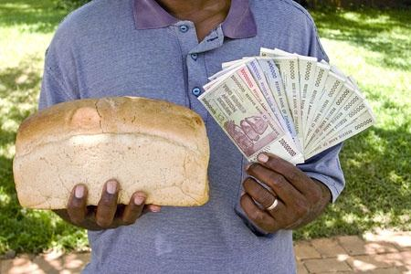A more recent case of hyperinflation occurred in the country of Zimbabwe. Do Internet research and write at least 2 paragraphs on the causes/reasons for the hyperinflation in that country. I’m looking for a well-written summary. You can start researching here, for example https://www.quora.com/What-happened-to-the-Zimbabwe-currency
