Inflation homework questions
Name and date (3 pts):
Instructions: Create space in the document below, and type or write your answers. When you are done, submit your work as an email attachment.
(16 questions, 3 points each)
Watch the short video “Milton Friedman – Understanding Inflation” posted in this Unit. Then answer questions 1-5 below.
- What is meant by the term “inflation”?

- What caused the inflation in the gold-mining example? Elaborate…

- What caused the inflation in the tobacco-leaf-money example? Go into some detail…

- In the tobacco-leaf example, what is meant by “Bad money drives out good money”…

- Summarize: What is the root cause of inflation? Explain…

Next questions: Do Internet research as needed

- A classic example of hyperinflation happened in Germany in the 1920’s.
  - What was the cause? What led up to this? You can search “Weimer Germany hyperinflation” or “Germany 1920’s hyperinflation”

  - Give some examples from that episode in history. The Internet is full of this sort of information, and your book also gives examples.

- Four groups of people harmed by inflation:
  - Why are the elderly usually hurt by inflation? Explain…

  - Why are creditors (lenders of money, i.e. Banks, Credit Unions, and Savings & Loans) hurt by inflation? Explain…

  - Why are savers (i.e. people with savings accounts) hurt by inflation? Explain….

  - Why are consumers (i.e. the general public) hurt by inflation? Explain….

- A person’s income in 2020 was $50,000. If inflation averages 3 percent per year, what does their income need to be in 2029 (9 years later) just to keep up with inflation?
  - $65,120
  - $65,240
  - $65,360
  - $65,480
Time Value of Money formula:

FV = PV (1 + r)^{t} FV = future value
PV = present value
r = inflation rate in decimal form
t = time, number of years

- Joe wins the lottery! He goes to collect his $1 million, but he’s told that he can’t have it all at once. Instead, the lottery officials say they’ll pay him $50,000 a year for the next 20 years. That’s okay, Joe thinks… $50,000 times 20 payments is still $1,000,000. Or is it?
Using the “Time Value of Money formula” above, and assuming an inflation rate of 3 percent per year, compute the present value (PV) of…
  - the $50,000 payment to be received in year “10” (hint: set FV at $50,000, and solve for PV)
Circle: $35,200, $36, 200, $37,200, $38,200

  - the $50,000 payment to be received in year “20”
Circle: $27,700, $28,700, $29,700, $30,700

  - Why would the state lottery want to spread out the payments? How does it benefit them?

- 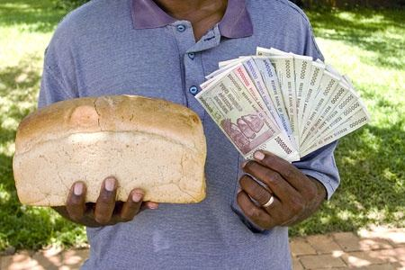A more recent case of hyperinflation occurred in the country of Zimbabwe. Do Internet research and write at least 2 paragraphs on the causes/reasons for the hyperinflation in that country. I’m looking for a well-written summary. You can start researching here, for example https://www.quora.com/What-happened-to-the-Zimbabwe-currency
