Reactions and Rates PhET WebLab

Name and date submitted (3 pts): _________________________

Instructions: Open the PhET “Reactions and Rates” lab (#1.07). You will need Java. It is a free download. It is an Oracle product, very well known, and safe. Download it here https://www.java.com/en/download/. Follow along with the instructions below, and scan your completed work and turn it in as a PDF attachment.

Chemical Kinetics (Rate of Reaction)
Reactions require three things:
- Collisions must occur
- Collisions must have the proper orientation
- Collisions must have sufficient speed (kinetic energy)

Assuming you have the above three, there are four (4) things that affect the rate of a reaction:

Concentration
We measure concentration in moles/L, also known as Molarity.
- More molecules = more collisions
- Collisions are necessary for reactions

Physical State
Smaller and better mixed = more collisions
- Solids can be ground and pulverized to increase surface area
- Liquids can be stirred

Temperature
Higher temperature increases the kinetic energy of molecules
Higher kinetic energy of reactants = more collisions, and more forceful collisions
- Need sufficient energy to react (Activation Energy)

Catalysts
Lower the activation energy of reactions
Lower activation energy = more molecules have sufficient kinetic energy to react
- Lower activation “hump” means more molecules can react

Single Collision Tab ***Hypothesis: collisions must have sufficient speed***
Pull back the knob. What happened? (Discuss with your partner(s) or to yourself)
Click the “Reload Launcher” button and expand the two windows on the right side of the program by clicking the “+” button for the Separation View and the Energy View. Now release the knob from various distances.
Indicate on the potential energy diagram when the reaction proceeds forward.

Potential Energy

Reaction Coordinate

Now click the Angled Shot option in the top right corner.
- Hypothesis: collisions must have the proper orientation
Try launching from a different angle or two.
Did the reaction proceed as before?

Why do you think this was the outcome despite having enough energy for the reaction to proceed?

***Hypothesis: Energy is conserved in a reaction. Potential energy contained within chemical bonds is converted into kinetic energy (1/2mv²) and vice versa***
Set the Choose a reaction option to the last preset chemical reaction that isn’t Design your own. (exothermic with no activation energy hump)
Now Change the Launcher Options back to Straight Shot and release the knob.
What happens to the translational speed of the molecules as the reaction goes forwards and backwards? (Hint: the effect will be easiest to observe at a low energy)
Please explain why this occurs.

Rate Experiments Tab ***Hypothesis: Increasing the concentration of reactants increases the speed of reaction***
Click on the “Rate Experiments” tab found at the top middle of the program window. Make sure “Select a Reaction” is set to the first reaction (endothermic with activation energy hump). Set Options (bottom right corner) to Strip. Increase the Initial Temperature (right side of window) until the Average Energy (green bar) is equal to the potential energy of the product
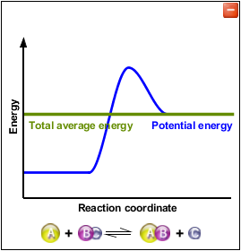
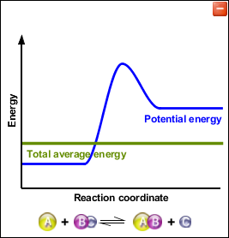

Set each reactant to 1.
How much time does it take to react?
(Stop if it has been 2 minutes or roughly 3000 seconds on the programs graph)

If no reaction occurred, stop the reaction after 2 minutes and increase reactant by 1. Repeat until the reaction occurs.
How many reactants had to be used?

Explain how this reaction took place below the activation energy?

Now start out with 5 of each reactant. Record how long it takes for 1 reaction to take place (The program counter will suffice).
Repeat the experiment for a total of 5 times. Then throw out the fastest and slowest time and average the remaining 3 experiments.
5 Reactants Each
Run 1:
Run 2:
Run 3:
Run 4:
Run 5:
Average:

Repeat this process for 10 reactants each and 15 reactants each.
Average:
Average:
10 Reactants Each
Run 1:
Run 2:
Run 3:
Run 4:
Run 5:
15 Reactants Each
Run 1: Run 2:
Run 3:
Run 4:
Run 5:

How did the rate of the reaction change?

