Single Collision Tab ***Hypothesis: collisions must have sufficient speed***
Pull back the knob. What happened? (Discuss with your partner(s) or to yourself)
Click the “Reload Launcher” button and expand the two windows on the right side of the program by clicking the “+” button for the Separation View and the Energy View. Now release the knob from various distances.
Indicate on the potential energy diagram when the reaction proceeds forward.
At any point above the activation energy.

Potential Energy

Reaction Coordinate

Now click the Angled Shot option in the top right corner.
- Hypothesis: collisions must have the proper orientation
Try launching from a different angle or two.
Did the reaction proceed as before?
No. The molecules collided, but they didn’t exchange the B component.

Why do you think this was the outcome despite having enough energy for the reaction to proceed?
The reaction didn’t proceed, because in order for the forward reaction to take place the reactants must have the correct orientation. In this case, A must hit B head on with the B-C bond for the reaction to work.

***Hypothesis: Energy is conserved in a reaction. Potential energy contained within chemical bonds is converted into kinetic energy (1/2mv²) and vice versa***
Set the Choose a reaction option to the last preset chemical reaction that isn’t Design your own. (exothermic with no activation energy hump)
Now Change the Launcher Options back to Straight Shot and release the knob.
What happens to the translational speed of the molecules as the reaction goes forwards and backwards? (Hint: the effect will be easiest to observe at a low energy)
Please explain why this occurs.
Since this particular example is an exothermic reaction that is essentially barrierless, the molecules increase in translation motion as the products are formed and slow down when the reactants are formed. This is due to the conservation of energy. When the reactants exist the majority of the energy is within the molecules as potential energy. When the products exists the difference in potential energy between the reactants and products (enthalpy of the reaction) is converted into kinetic energy resulting in an increase in speed.

This effect is exacerbated by the change in mass as well. C has much less mass than A and the speed (velocity) is dictated by $E_{kinetic}=\frac{1}{2}*\underline{m}ass*{\left(\underline{v}elocity\right)}^{2}$
Since the mass is less the velocity is more to equal the same amount of energy.

Rate Experiments Tab ***Hypothesis: Increasing the concentration of reactants increases the speed of reaction***
Click on the “Rate Experiments” tab found at the top middle of the program window. Make sure “Select a Reaction” is set to the first reaction (endothermic with activation energy hump). Set Options (bottom right corner) to Strip. Increase the Initial Temperature (right side of window) until the Average Energy (green bar) is equal to the potential energy of the product
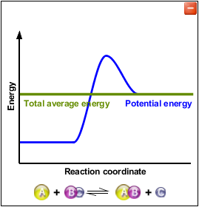
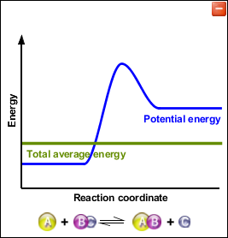

Set each reactant to 1.
How much time does it take to react?
(Stop if it has been 2 minutes or roughly 3000 seconds on the programs graph)
The reaction didn’t go forward. (Note: sometimes the reaction does happen in under 2 minutes even though it shouldn’t. The Single Collision tab works correctly, the Rate Experiments tab sometimes has this goof.)

If no reaction occurred, stop the reaction after 2 minutes and increase reactant by 1. Repeat until the reaction occurs.
How many reactants had to be used?
This will vary, most students are between 2 and 4 of each reactant (A and BC).

Explain how this reaction took place below the activation energy?
The green bar represents the average energy, and once there are more than one set of reactants, there is a chance that one set of reactants will be above the average energy while another is below the average energy. It is possible that the set of reactants above the average has sufficient energy to overcome the activation energy. As the number of reactants increase, so does the probability that one set will have sufficient energy. In reality, it’s a Boltzmann Distribution.

Now start out with 5 of each reactant. Record how long it takes for 1 reaction to take place (The program counter will suffice).
Repeat the experiment for a total of 5 times. Then throw out the fastest and slowest time and average the remaining 3 experiments.
5 Reactants Each
Run 1: Results will vary
Run 2:
Run 3:
Run 4:
Run 5:
Average: ~150 - 400

Repeat this process for 10 reactants each and 15 reactants each.
Average: ~ 30 - 100
Average: ~ 10 – 40 sec
10 Reactants Each
Run 1: Results will vary
Run 2:
Run 3:
Run 4:
Run 5:
15 Reactants Each
Run 1: Results will vary
Run 2:
Run 3:
Run 4:
Run 5:
The rate of the reaction increased as the number of reactants increased. This is due to an increase in concentrations. The additional molecules increase the number of collisions (allowing more opportunities for correct orientation collisions and a higher probability of a set of reactants to have enough energy to overcome the activation energy.
How did the rate of the reaction change?

