Digestive Tract - Structure and Function questions
Name and date submitted (3 pts):
Using this handout as a TEMPLATE, write or type your answers in the spaces provided.
(34 questions, 3 points each, 102 points)
Watch the video “The Digestive System”, posted in Unit 14 on the student portal. It can also be accessed here https://www.youtube.com/watch?v=goSC-1YvHVk
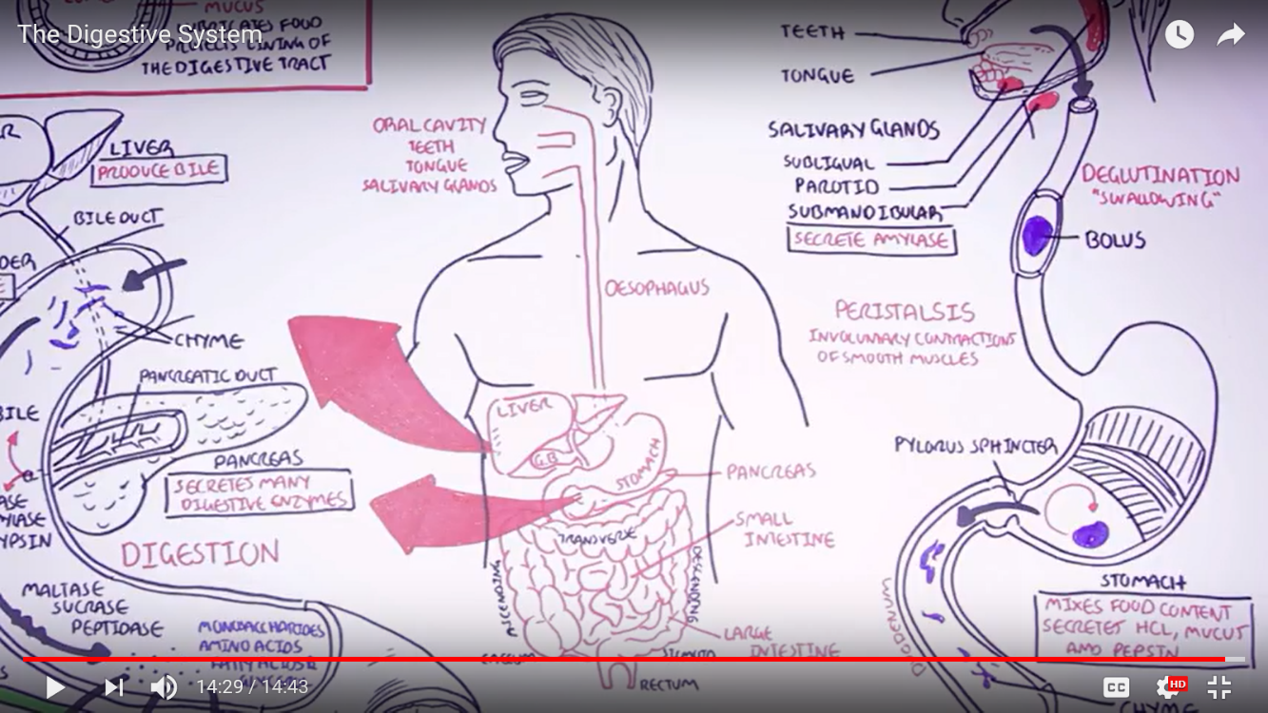

Questions:
- 0:14: What are the six (6) main organs which make up the human digestive tract?

- What are the six (6) “accessory organs”?

- 1:20: What are the three (3) main food types we need to digest?

- 1:50: List the three (3) main layers of the digestive tract AND state their purpose.

Layer | Purpose

- 3:05 The mouth
- What is the role/function of the teeth

- What is the role/function of the tongue

- What is the role/function of the salivary glands

- Name the three (3) salivary glands

- What does the enzyme ‘amylase’ do?

- 4:08 The esophagus
- What is the physiological term for ‘swallowing’?

- What is the food referred to in the esophagus?

- What process drives the food down the esophagus?

- 4:55 The stomach
- What is the basic function of the stomach?

- How many muscle layers does the stomach have?

- What three (3) substances do the stomach cells secrete?

- 5:35 The small intestine
- What is the name of the ‘valve’ located at the bottom of the stomach?

- What is the liquefied food is now called (after the stomach)?

- What are the three (3) sections of the small intestine called?

- True/False: Most of your food digestion takes place in the small intestine, not the stomach.

- 7:00 The liver and gallbladder
- The liver secretes a substance which has a critical role in digestion of fats (lipids). What is this substance called?

- What is the purpose of the gallbladder?

- 8:00 The pancreas
- The pancreas makes many digestive enzymes. How do these enzymes make their way to the small intestine?

- What are three (3) enzymes produced by the pancreas?

- 9:00 Back to the small intestine
- The cells lining the small intestine also produce enzymes. What are three (3) of these brush border enzymes?

- The food (chyme) is broken down into what four (4) types of smaller molecules?

- These four (4) smaller molecules are the building blocks of what three (3) substances in the body?

- How are monosaccharides and amino acids finally absorbed into the body?

- How are fatty acids absorbed into the body?

- What are villi? What do they do?

- 11:15 The large intestine
- What is another name for the large intestine?

- What are the six (6) parts of the large intestine?

- What is the role of the appendix?

- What is the role of the trillions of bacteria in the large intestine?

- True/False: the lining of the large intestine has a thick mucus layer located on top of the villi.

