Virtual Heart Surgery
Name and date submitted (3 pts):
Using this handout as a TEMPLATE, create space in between problems below and write or type your answers. Attach you completed work in Canvas as a Word or PDF file.
(10 questions, 100 points possible)

Virtual Heart Surgery
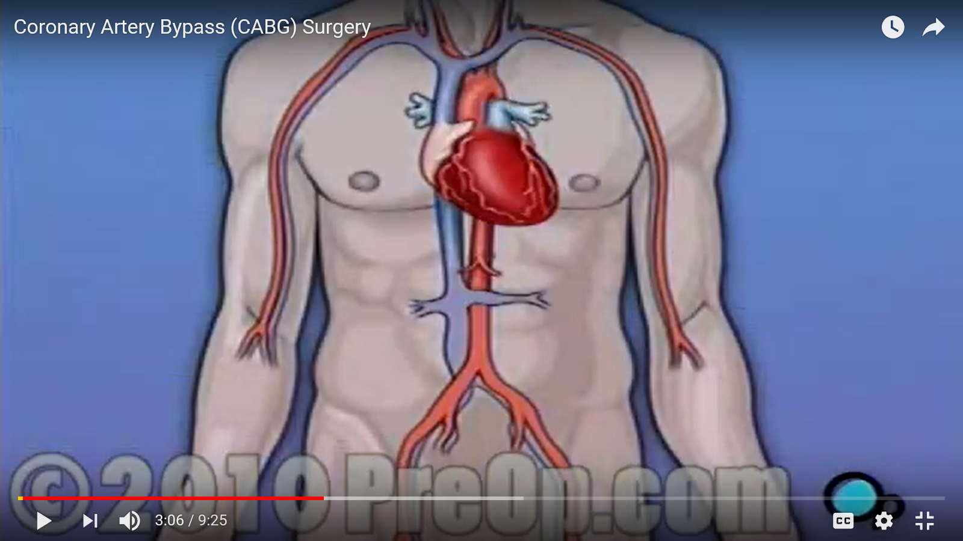
Watch this video before performing the virtual heart surgery. https://www.youtube.com/watch?v=WM_tcf5Ogy0

VIRTUAL HEART SURGERY
Go To: http://www.abc.net.au/science/lcs/heart.htm.. This App uses Adobe Flash Player, a safe and free download. https://get3.adobe.com/flashplayer/update/plugin/. Note: Your security settings have to be set to “allow” Flash Player. In your browser “settings” you may have it blocked. In that case, you will need to go to your Internet browser settings and “uncheck” that box, and/or select “always ask first”, or something similar.
Read the introduction; then click “Enter” to start the procedure.
HINT: you can choose “Intern, Surgeon, or Specialist”. They all do the same things during the procedure, but more clues are given to the Intern, etc. If you want a challenge, select Surgeon or Specialist.
RESOURCES: You will need to refer back to the “heart” chapter in your book, as well as do Internet research. The questions are not hard, but you will probably need to research some of them.
- Diagnosis
- What is the patient’s diagnosis?

- What are the coronary arteries? What do they do?

- How many coronary arteries do you have?

- Where do they originate?

- What is atherosclerosis? (Internet or your textbook). Try to summarize in your own words.

- What causes atherosclerosis?

- What is plaque? Try to be specific.

- What happens when your arteries are narrowed? Try to be specific.

- What would happen if your coronary arteries became completely obstructed? Don’t just say “you would die”. Use physiological terms and be specific.

- Anatomy: Click on the Anatomy button at the top left corner. Briefly describe what each of these does in your own words.
- Right atrium

- Right ventricle

- Left atrium

- Left ventricle

- Aorta

- Pulmonary arteries

- Sedative
- Research the drugs Midazolam & Versed - https://www.mayoclinic.org/drugs-supplements/midazolam-injection-route/description/drg-20064813 What do they do? Why are they used for surgery?

- Click on the “precautions” tab on the Mayo Clinic page above. What are the precautions for this drug (Midazolam and/or Versed)?

- Surgery team
- Describe the job of the perfusionist?

- Describe the job of the anesthetist?

HINT: watch the “brain” and “blood” monitors during surgery in case there is an emergency!
- Vein harvesting
- Where does the harvested vein come from?

- What is the function of the great saphenous vein? http://www.innerbody.com/image_cardov/card29-new.html

- Give at least two good reasons why the saphenous vein is used.

- Chest incision
- What major bone is cut open? Use the correct anatomical term, not “breast bone”.

- What is the function of the pericardium? Your book has a good description…

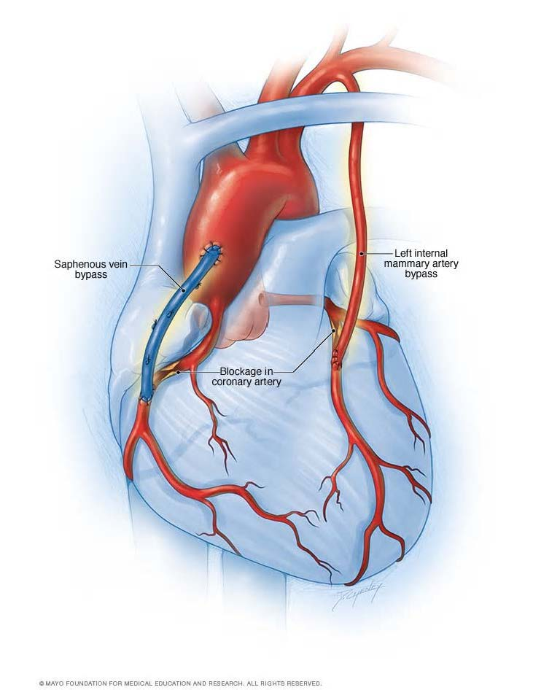

- Graft incision
- Where is this incision made? Study the picture above before making this incision.

- How does a pacemaker work? Requires Internet research.

- What does the protamine injection near the end of surgery do?

- Closing the chest. The virtual surgery asks you to stitch up the skin, but it doesn’t cover the actual sternum closure.
- This is the traditional wire method of closing the sternum. https://www.youtube.com/watch?v=sKcgkQ8hN3g Explain how this is done.

- This is an alternate method. https://www.youtube.com/watch?v=y7SYMy908ng Explain how this is done.

