Immune System & Disease questions (revised 2020)
Name and date submitted (3 pts):
Instructions: Using this handout as a template, create space and answer the questions below.
You will need to use your textbook and the Internet!
(20 questions, 100 points possible)
- Coronavirus: Read this article https://www.scientificamerican.com/article/heres-how-coronavirus-tests-work-and-who-offers-them/
  - Describe the “first step” in the test

  - Viral detection: Describe how the RT-PCR test makes thousands of copies of the virus’s RNA

  - Specifically what does the CDC-approved test “target”?

- Covid 19 test: How does this San Diego Biotech company’s test work? https://www.prnewswire.com/news-releases/mesa-biotech-receives-emergency-use-authorization-from-fda-for-a-30-minute-point-of-care-molecular-covid-19-test-301028687.html See if you can figure it out. Summarize in your own words. If you copy-and-paste, you will not get credit for any portion of this question.

- Coronavirus Antibody tests: Read this article, and summarize the pros and cons of infusing patients with the antibody-laden blood of those who have survived the infection. What is the basic mechanism, and what’s going on? (In your own words) See if you can figure it out. https://www.scientificamerican.com/article/how-blood-from-coronavirus-survivors-might-save-lives/

- What is meant by the term “pathogen”? List at least 5 common examples.

- What is meant by the term "barrier immunity"? List at least 5 external defenses of the human body.

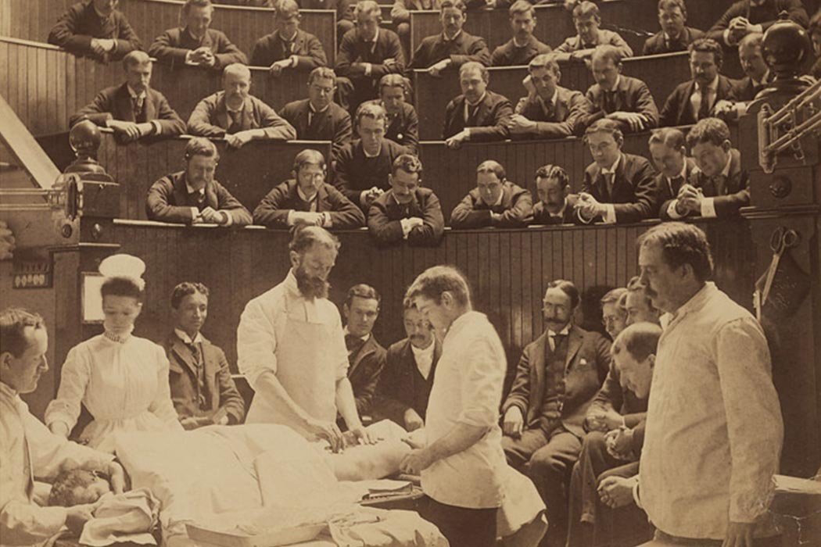
Training new surgeons, 1890

- Compare the “innate” and “adaptive” immune systems in the human body. You can ‘list’ the features of each if that’s easiest.

- In general, what do white blood cells (WBC’s) do? Where do they reside, and what is their overall function? I’m looking for 3-4 well written sentences.

- Lymphocytes: What is meant by the term “lymphocyte”?

- B-lymphocytes (B-cells) mature in the ________________.

- T-lymphocytes (T-cells) mature in the ________________.

- Inflammation: Why does your body initiate an “inflammatory response” to infection or trauma? What is your body is trying to accomplish by inflammation? What are some of the things going on? Use your textbook and the Internet. Your response to this question can be in the form of a ‘list’.

- Research and give the relative sizes of a Bacteriophage T4 virus, E. coli bacterium, red blood cell, and width of a human hair. Use the correct units.

- Viruses
  - What is a virus and how does it work? 3-4 well written sentences in your own words.

  - Is a virus a living organism? Why or why not?

  - How big is a typical virus? Report your answer in nanometers (i.e. billionths of a meter).

  - How do they attack? What is the basic mechanism by which they work? 3-4 well written sentences.

- Antigens
  - What is meant by the term “antigen”? Look it up in your book or research online, and then state in your own words.

  - Give at least 5 examples of antigens.

- Antibodies
  - Research and define the term “antibody”. Look it up in your book or research online. State it in your own words.

  - Where do antibodies ‘hang out’, and what do they do? In other words, what is their purpose, and how do they do it?

  - How does the antibody binding to an antigen end up fighting infection? This is a little complicated, but try to simplify it and state it in your own words.

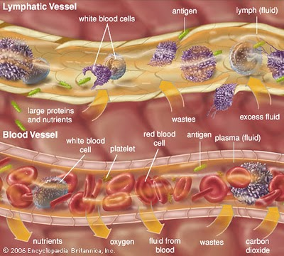
- Lymphatic system
  - List the main components of the lymphatic system. You can use the list in the book, I just want to make sure you to know what the lymphatic system consists of.

  - What is lymph fluid made of? What’s in it?

  - What is the purpose of lymph nodes? Try to be fairly specific.

  - What does the spleen do?

  - How does the lymph fluid eventually get back to the blood supply? In other words, how does it return back to the blood circulation? Be specific.

- Bacteria
  - How big is a typical bacterium? You can use E. coli as an example. Report your answer in microns (i.e. millionths of a meter). How does its size compare to that of a virus?

  - Is a bacterium a living organism? Why or why not?

  - A bacteria cell is a Prokaryotic cell. How does this differ from a Eukaryotic cell (plants and animals)? Compare the two types of cells. You can ‘list’ the differences if that’s easiest.

  - How can a foreign bacterium enter the body? List at least 5 ways.

- Vaccines
  - How does a vaccine work? What is the mechanism by which it works? 3-4 well-written sentences is enough.

- Smallpox virus
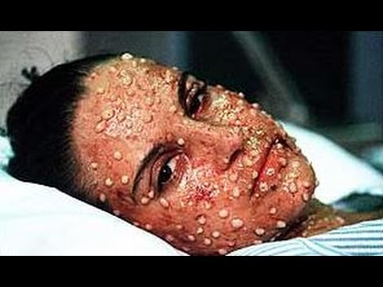
  - Look up Smallpox on the CDC website https://www.cdc.gov/smallpox/index.html. What are the Signs and Symptoms of Smallpox? (click on “Signs and Symptoms”) Please use your own words, do not cut & paste.

  - Click on “History of Smallpox”. Describe the process of variolation.

  - Summarize in your own words the development of vaccination by Edward Jenner.

  - Read the stories of Rahima Banu, Ali Maalin, and Janet Parker. Give an overview of their stories and how Smallpox was finally eradicated.

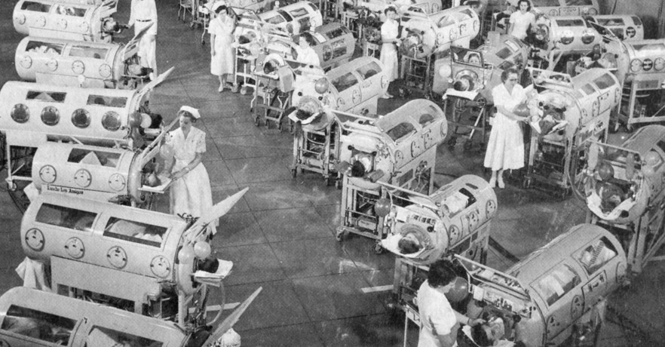
- Poliomyelitis (Polio)
  - What causes polio?

  - How does polio spread from person to person?

  - What are the symptoms and long-term effects?

  - How many cases are reported in the U.S. each year? How many are reported in the world each year? Research it and compare these numbers to, say, 50 years ago.

  - What is the mechanism by which poliovirus acts (its pathophysiology)? This is a complicated topic, but research it and do your best to summarize it in your own words.

  - The first effective polio vaccine was developed in 1952 by Jonas Salk. Give a short summary of how his vaccine was tested in the U.S. and what the results were.

