pH Scale PhET WebLab

Name and date submitted (3 pts):

Procedure:

* Go to phet.colorado.edu.
* Click on the *Chemistry* tab.
* Choose the *pH Scale* simulation.
* Click on *Run in HTML5*, then choose the *Micro* tab.
* Add battery acid, then use the bottom faucet to drain the tank until 0.1 L remains.

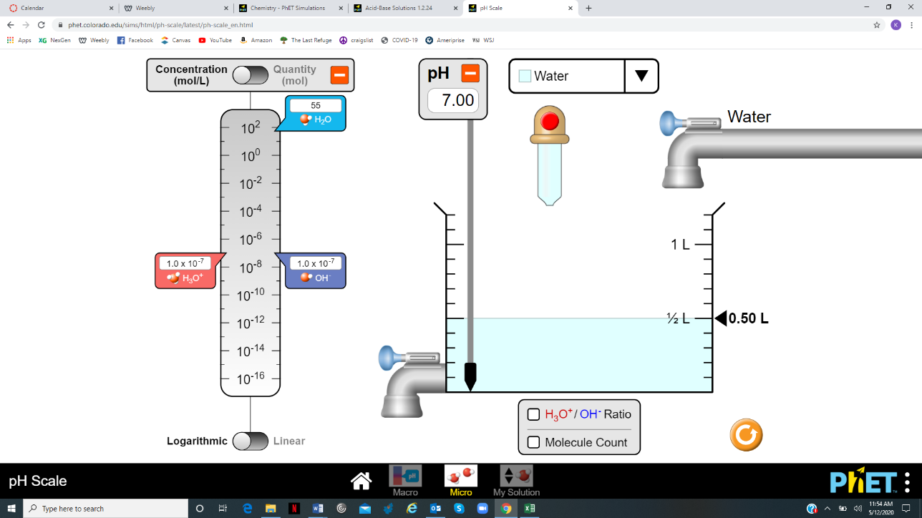

Step 1: 100% acid solution (1.00)

1. Record the pH of the solution

1. How many moles of H3O+ (hydronium) ions are present in each liter of the solution? In other words, state the Molarity in moles/L of H3O+ (Answer in scientific notation and decimal form).

1. How many moles of H3O+ ions are present in 0.1 L of the solution (the volume in the container at this point)?

Step 2: 10% acid solution (.10)  
  
Add water until there is 1 L of solution in the container. *Compared to the H3O+ in the battery acid, the H3O+ in the water is negligible.* So, we can consider the **amount of H3O+** in the diluted solution to be **unchanged** by the added water.

1. Since the amount of hydronium is essentially unchanged, how many moles of H3O+ ions are present in the liter of diluted solution?

1. Now state the new concentration of H3O+ ions, in moles per liter

1. What is the pH of the new diluted solution?
2. Explain why diluting the battery acid increased the pH by 1.

Step 3: 1% acid solution (.01)

Drain the 10% battery acid solution until 0.1 L remains. Be careful not to drain too much of the solution. If you drain too much, you will have to restart the experiment from the beginning.

Pour water into the container until the volume again reaches 1 liter. Be careful not to pour too much water into the solution.

1. After again increasing the volume by a factor of 10, what is the new concentration of H3O+ ions in moles/L? (Answer in scientific notation and decimal form).
2. What is the pH of the new solution?

Step 4: .1% acid solution (.001)

Drain the 1% battery acid solution until 0.1 L remains.

Pour water into the container until the volume again reaches 1 liter.

1. After again increasing the volume by a factor of 10, what is the new concentration of H3O+ ions in moles/L?
2. What is the pH of the new solution?

Step 5: .01% acid solution (.0001)

Drain the 0.1% battery acid solution until 0.1 L remains.

Pour water into the container until the volume again reaches 1 liter.

1. After again increasing the volume by a factor of 10, what is the new concentration of H3O+ ions in moles/L?
2. What is the pH of the new solution?

Step 6: .001% acid solution (.00001)

Drain the 0.01% battery acid solution until 0.1 L remains.

Pour water into the container until the volume again reaches 1 liter.

1. After again increasing the volume by a factor of 10, what is the new concentration of H3O+ ions in moles/L?
2. What is the pH of the new solution?

Step 7: .0001% acid solution (.000001)

Drain the 0.001% battery acid solution until 0.1 L remains.

Pour water into the container until the volume again reaches 1 liter.

1. After again increasing the volume by a factor of 10, what is the new concentration of H3O+ ions in moles/L?
2. What is the pH of the new solution?

Use the *Custom* tab at the bottom to answer the following questions. Manipulate the amount of hydronium and hydroxide in the custom solution.

1. As the H3O+ ion concentration decreases, the pH __________________________.
2. The product of a solution’s H3O+ concentration and its OH- concentration must always be 1 x 10-14. So, if a solution’s H3O+ concentration goes down, the solution’s OH- concentration must go ___________. In other words, if we have **less hydronium**, we must have __________________ **hydroxide**.

Step 8: Graphing

1. Graph the results on the graph paper below. Put pH on the x-axis, and H30+ concentration in moles/L on the y-axis. Label everything. It will look something like this…. If you want to use a drawing App, that’s fine too.

