LC Circuits and Radio Tuners

In this activity we will learn how a radio tuning circuit works by investigating a circuit consisting of an inductor and a capacitor – an “LC circuit”.

Open the PhET Circuit Construction Kit (AC +DC). https://phet.colorado.edu/en/simulation/legacy/circuit-construction-kit-ac

1) Capacitors and inductors

- Build a circuit that has a battery, a capacitor and a switch.
  - What do you observe about the capacitor when you close the switch?

  - Does a capacitor allow current to flow in a DC circuit?

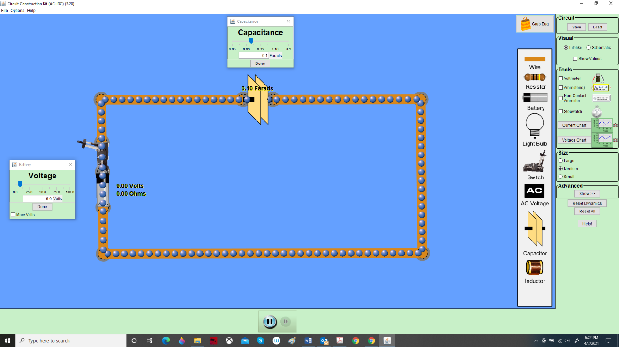

- Now open the switch back up.
  - What do you observe about the capacitor?

  - Does it hold its charge?

- Now disconnect the capacitor, set it off to one side, and install a coil (inductor) in the circuit. Leave the battery in place. Add a ‘current chart’ so you can tell what’s going on with the current. Close the switch and observe what happens with the current. (Point your battery in the direction that makes the current ‘positive’).

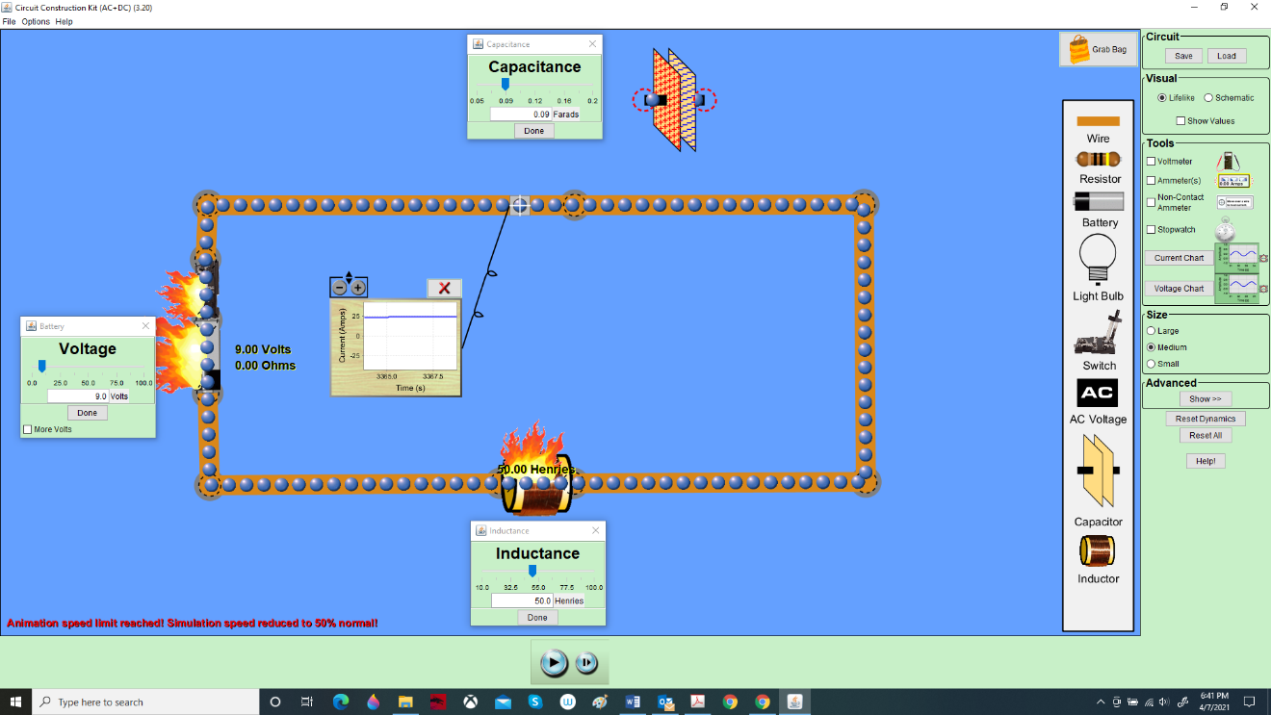

  - Does a coil allow current to flow in a DC circuit?

  - Does the current level-off, or keep climbing?

  - Why?

- Remove the coil and set it off to one side, and connect up the capacitor again. Set the capacitor at 0.09 Farad. Replace the battery with an AC power source (AC Voltage). Set the AC voltage at around 10 volts and the frequency around 0.5 Hz (the exact values aren’t important). Close the switch, hit the play button, and observe:
  - Does a capacitor allow current to flow through an AC circuit?

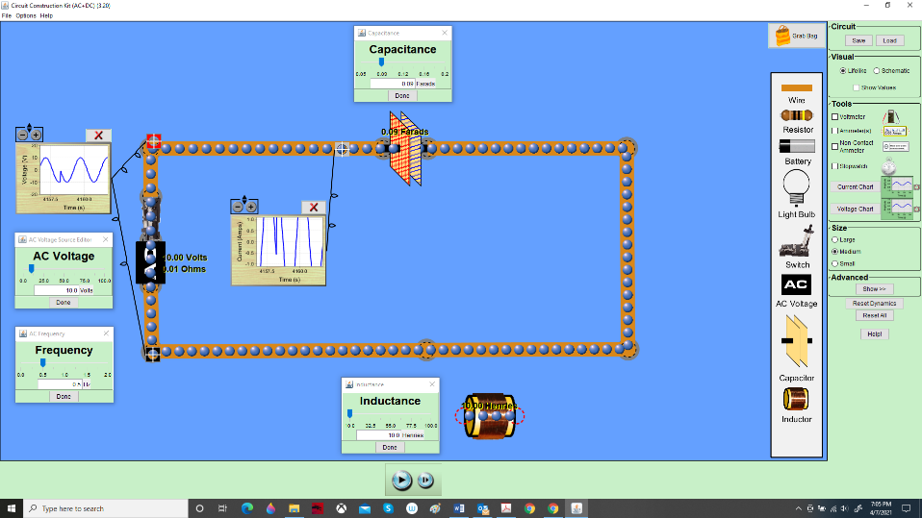

- With your AC power source still in place, charge up the capacitor to the fullest extent, and hit “pause” right when it reaches the maximum charge.

Now carefully disconnect the AC power source from the circuit, being careful to leave the capacitor fully charged (still at 0.09 Farad). Modify your circuit by re-installing the inductor coil set at 10 Henries – with no battery or AC power source. Make sure you still have the current chart on your circuit with the detector over a wire. You may have to adjust the +/- buttons for a good reading.

Your circuit should look like this, with a capacitor, inductor, and switch:

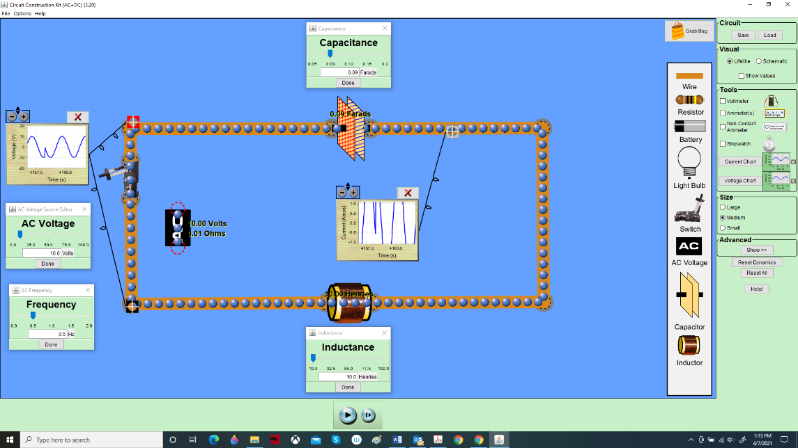

Set the stopwatch to determine the time for one complete cycle (measured in seconds). To minimize starting and stopping error you should measure for several cycles and divide appropriately to find the time for one cycle. Recall that the time for one cycle is called the period (seconds) and the frequency is measured in cycles/second, or 1/period (or seconds⁻¹).

Close the switch, hit the play button, and observe:
  - What is the capacitance C in Farads:

  - What is the inductance L in Henries:

  - Measure the period in seconds (look at the current chart and use the stopwatch to measure it):

  - Therefore, what is the measured frequency in cycles/second or Hz (it’s 1/period):

You have just built a “tank circuit” or resonant LC circuit. It will keep going forever, as long as there’s no resistance in the wire.

- According to equation 22.16 in your book, the natural frequency, f, of a resonant oscillating circuit like the one you just built is given by

  - Plug your values for C and L into the equation. What do you calculate for f in cycles/second?

  - Does your “calculated” frequency agree with your “measured” frequency?

2) Resonance: If this circuit is “hit” with power at its natural frequency, it will resonate, that is, it will oscillate with a large current.

- Put the AC power supply back into your circuit. Set the capacitance to C = 0.09 Farad and the inductance to L = 10 Henries. Right click the power source and set its frequency to a value that is not the natural frequency of this circuit. Wait at least a minute and describe your observations.

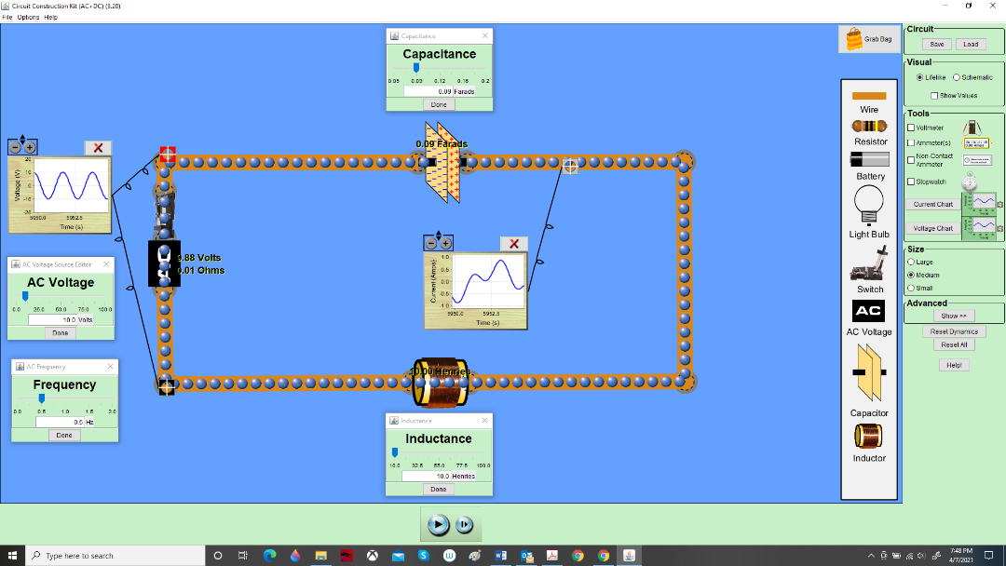

  - Watch the current chart. Is the current smooth or choppy?

  - Does the current gradually increase, or just slosh around in the same range?

- Open the switch and reset the AC frequency so that it is equal to the natural frequency of the circuit (this is the frequency you calculated). Wait at least a minute and describe your observations
  - Does the current increase?

  - Does it reach a maximum?

You have built a resonant, oscillating circuit.

3) Radio Tuners

In a radio tuner resonance is produced by an incoming electromagnetic wave rather than an AC voltage source. The tuner circuit consists of an inductor (inductance coil) and a variable capacitor. Changing the station changes the value of the capacitance. Each radio station transmits electromagnetic waves at a particular frequency and all of these frequencies from the various stations reach the antenna of your radio. Only the frequency corresponding to the natural frequency of the tuner circuit will produce a large enough current to be picked up and then amplified.

Problem:
An FM radio tuner is set to receive a station. The tuner has a 1.400 microHenry (1.400 x 10⁻⁶ H) inductance coil and a variable capacitor that is set to 1.864 picoFarad (1.864 x 10⁻¹² Farad).

- What is the frequency in MHz of the waves emitted by this station? (Hint: FM stations broadcast from 87.5MHz to 107.5 MHz. Recall that 1MHz= 1 x 10⁶ Hz.)

