18. Light Waves homework problems (Physical Science)
Name and date submitted (3 pts):
Instructions: Using this form as a template, create space in the document below and write or type your answers. Turn in your completed work by the due date.
(25 questions, 100 points possible).
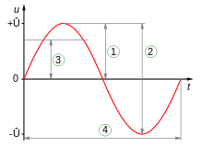
- The wavelength of the wave in Fig. 1 is indicated by which number?

- The amplitude of the wave in Fig. 1 is indicated by which number?

Figure 1
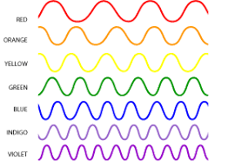

- Which color in Fig. 2 has the longest wavelength?

- Which color in Fig. 2 has the highest frequency?

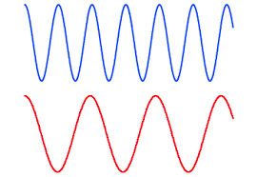
Figure 2

- T/F: Referring to Fig. 3, the blue light wave travels faster through a vacuum than the red light wave because its frequency is higher.

Figure 3

- T/F: Electromagnetic waves travel at the speed of sound.
- T/F: Electromagnetic waves have only an electrical nature.
- T/F: Electromagnetic waves travel through a vacuum.
- T/F: Sunlight consists of all colors.
- T/F: Radio waves can pass through your body without your being aware of them.
- T/F: Microwave ovens heat food by speeding up water molecules.
- T/F: The paint on a red car absorbs light of all colors except red.
- T/F: Violet light has the longest wavelength of visible light.

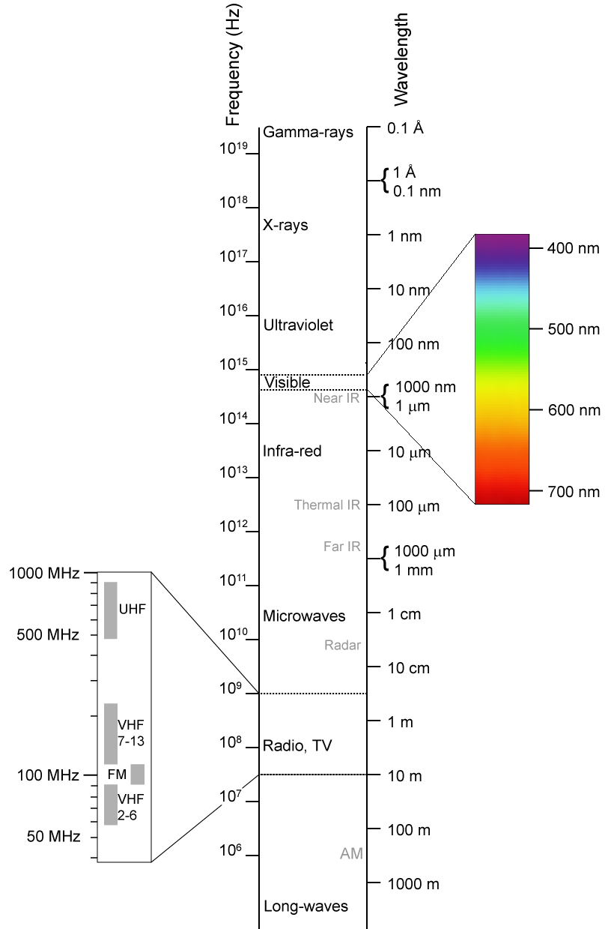
The next 8 questions refer to Figure 4:
- Which electromagnetic waves have the highest frequency? What is their wavelength?
- Which electromagnetic waves have the highest energy?
- Limiting our discussion to the visible-portion of the electromagnetic spectrum, what is the range of wavelengths contained in the visible spectrum?
- Ultraviolet light has (higher frequency)/(lower frequency) than visible light.
- Infrared light has (higher frequency)/(lower frequency) than visible light.
- Radio and TV waves have a (longer)/(shorter) wavelength than visible light.
- What is the wavelength of AM radio waves? (give a range)
- What is the typical wavelength of FM radio waves?

- What does monochromatic light contain?
Figure 4
- A continuous spectrum
- Several colors
- One color
- White light
- The measure of the brightness of a light at a light source is its
- Illumination
- Intensity
- Brilliance
- Light output
- In what way is light different from sound?
- Human senses detect it.
- It travels through a vacuum.
- It is a wave.
- It contains a variety of wavelengths.
- Which of the following are the most energetic?
- Gamma rays
- Microwaves
- Radio waves
- Visible light waves

