18. Metabolism & Nutrition homework questions (Ch. 25)
Name and date submitted (3 pts):
Instructions: Create space in the document below and respond to all questions. Turn in your completed work by the due date.
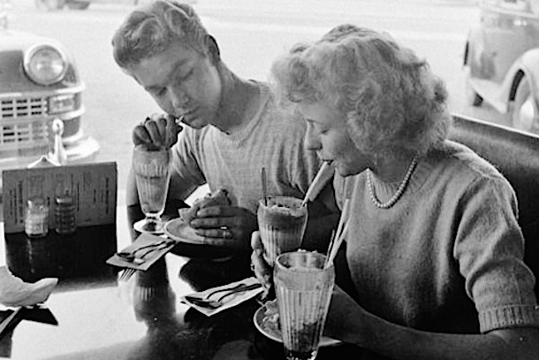(50 questions, average 2 points each, 100 points total)

Metabolic Reactions
- The general term used to describe all the chemical reactions going on in the body is _______

- Chemical reactions in the body that take simple molecules and build-up more complex ones are collectively known as _________________

- Chemical reactions in the body that break down larger, complex molecules into simpler ones are collectively known as _________________

- The molecule ATP functions as the “energy currency” of the body’s cells. It’s the “battery” that powers the cell’s activities. ATP stands for __________________

Energy Transfer
- Chemical reactions in the body are either Oxidation or Reduction reactions.
  - When lactic acid in your muscles is oxidized, it produces what molecule?

  - Specifically what is removed from lactic acid to produce this molecule?

- Two enzymes in your cells, FAD and NAD, are the “electron trucks” which transport hydrogen atoms (and thus electrons) to support other reactions in your cells
  - FAD stands for _____________
  - NAD stands for ______________

Carbohydrate Metabolism
- When you eat carbohydrates, your digestive system ‘hydrolizes’ them into which three sugars?
  - Gl
  - Fr
  - Ga

- Your liver cells (hepatocytes) convert any remaining ‘b’ and ‘c’ (above) into which sugar?

- So the story of carbohydrate metabolism is really the story of ____________ metabolism.

- Glucose movement into cells: Explain how glucose gets from your bloodstream into your cells. In other words, how does it pass from the bloodstream through the cell plasma membrane, into the cytosol of your cells (i.e. your muscle cells, your brain cells, etc)?

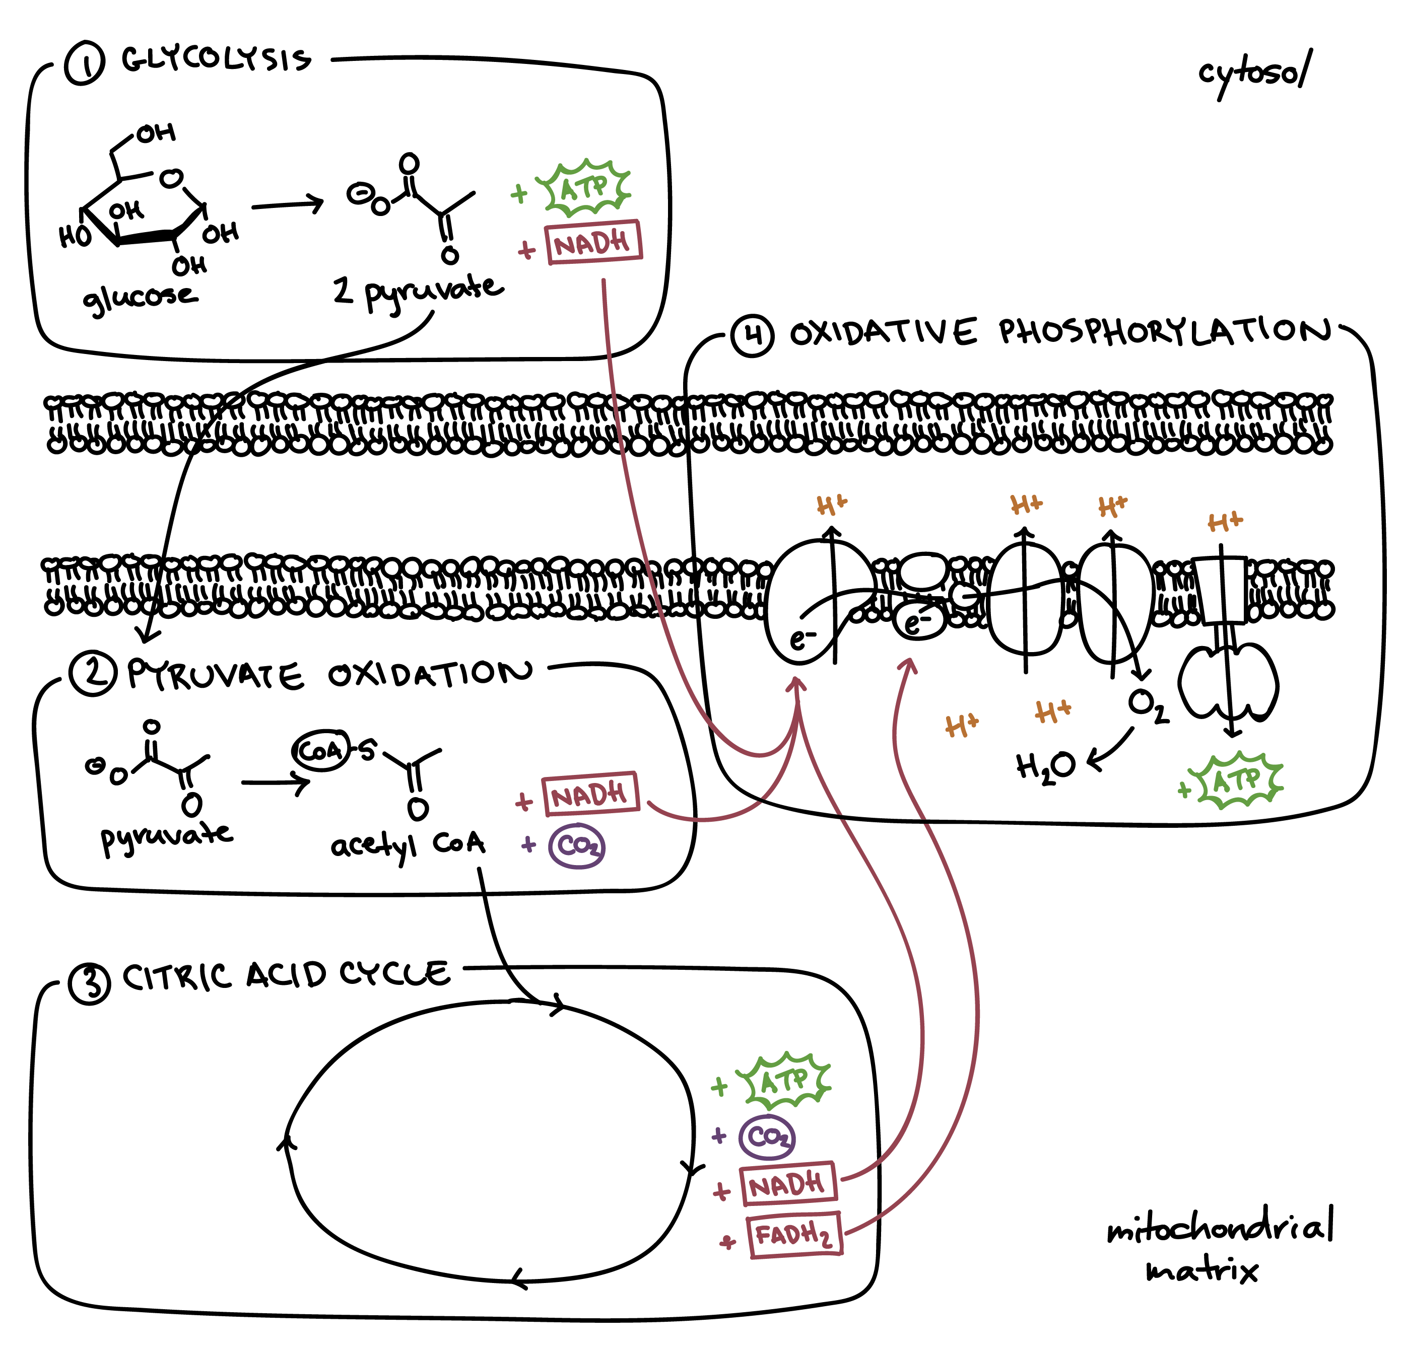

- Step 1 of glucose breakdown – Glycolysis:
  - Once in the cell (muscle cell, brain cell, etc), each glucose molecule is split into two, 3-carbon molecules known as ______________ (two words)

  - This first step requires 2 ATP ‘batteries’, but produces ______ ATP’s, for a net gain of _________ ATP’s for each molecule of glucose.

  - If there is plenty of oxygen (you are breathing okay), the molecule in ‘a’ is converted to “Acetyl __________ ___________”. (3 words)

  - If there is a shortage of oxygen (you are being chased by a mountain lion), the molecule in ‘a’ is converted to an acid that builds up in your muscles, causing a burning sensation. This acid is called “ ___________ ____________ “ (2 words).

- Step 2 of glucose breakdown – The Krebs Cycle:
  - The acetyl CoA produced in step 1 above now enters what is called the Krebs Cycle. This is also called the __________ _____________ __________ (3 words)

  - The chemical reactions in the Krebs Cycle take place in the matrix of which organelle within your cells? M_____________

  - Figure 25.7: There are eight reactions in the Krebs Cycle which break down the acetyl CoA molecule. Supply the missing intermediates: (5 total)
    - Acetyl coenzyme A is broken down to produce

    - Citric acid, which is broken down to produce

    - ________, which is broken down to produce

    - ________, which is broken down to produce

    - Succinyl CoA, which is broken down to produce

    - ________, which is broken down to produce

    - ________, which is broken down to produce

    - Malic acid, which is broken down to produce ________

  - During the eight reactions above, the Krebs Cycle produces more energy, plus six (6) molecules of CO2 (carbon dioxide) per molecule of glucose broken down. How does this CO2 get to the lungs where you breathe it out? (be specific, or no credit granted)

- Step 3 of glucose breakdown – The Electron Transport Chain:
  - This stage of glucose breakdown occurs in the inner _____________ membrane within your cells.

  - The Electron Transport Chain is called the “payoff phase” because an additional _____ to _____ molecules of ATP are generated from each molecule of glucose that is oxidized.
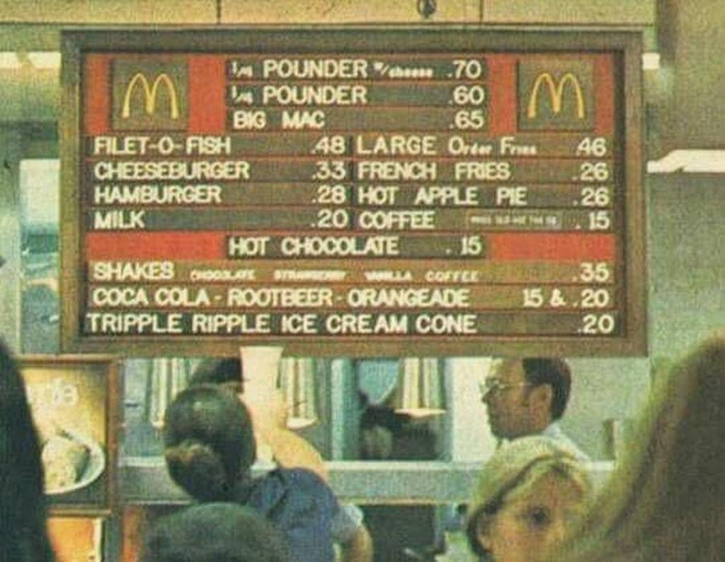

- Glucose Anabolism
  - If glucose is *not* immediately needed for energy production (you are done running from the mountain lion, and are now just sitting around watching TV, eating carbohydrates) the glucose combines with many other molecules of glucose to form the substance known as Gl____________

  - The substance in ‘a’ is stored in your muscle cells (roughly _________%) and your liver (the other ___________%.

  - When you need energy again (you get up from the couch and go for a bike ride and start burning calories) the substance in ‘a’ which has been stored in your muscle cells and liver is broken down again into glucose molecules in a process called G___________.

- Starvation or fasting: If you haven’t eaten, and your liver and muscle cells have already used up their stored glycogen, your body will start breaking down (catabolizing) fats and proteins.
  - This process is known as Gl________________.

  - Around ____% of the amino acids (think proteins, which are made of amino acids) can be used during a starvation scenario

Lipid Metabolism
- Lipids are the fats and oils that you eat. Fats and oils don’t dissolve in water very well, and blood is mostly water. So, in order for lipids to be transported by the bloodstream, they are combined with proteins into packages called L____________.

- The packages (above) are carried by the bloodstream as spherical particles with an outer shell of Pr________, Ph________, and Ch_________, surround an inner core of lipid molecules.

- The four types of lipoproteins running around in your blood
  - Chylomicrons – the lightest density – carry lipids to your fat cells for storage. Fat cells are known as Ad___________ cells.

  - Very low density lipoproteins (VLDL’s) carry lipids made in your liver to your fat cells for storage. Your liver cells are known as H_____________.

  - Low density lipoproteins (LDL’s) deliver cholesterol (a type of lipid) to cells all throughout your body. Cholesterol isn’t “bad”; in fact it is an important ‘structural’ component of all your cells and is necessary for your survival. Describe how excessive LDL’s can result in fatty plaque in your arteries: (Your book gives a short description)

  - High density lipoproteins (HDL’s) remove excessive cholesterol and transport it back to the liver for elimination. HDL’s contain about ______% proteins, ______% triglycerides, ______% phospholipids, and ______% cholesterol

- There are two sources of cholesterol in your body: Some comes from dietary intake (what you eat), but most cholesterol is produced in which organ?

- There are basically three ways to reduce cholesterol in your bloodstream:
  - E

  - Di

  - Dr

- Internet research: Choose one of the cholesterol ‘meds’ listed on p. 991, and write a paragraph explaining how it works, using correct physiological terms.

- Triglyceride Storage:
  - Excess triglycerides are stored in fat cells. Fat cells are more correctly called A_________ cells.

  - The triglycerides stored this way represent ____% of all body energy reserves

- T/F: The triglycerides stored in fat cells are continually being broken down and converted into energy, transported around the bloodstream, and redeposited in other fat cells.

- Lipid breakdown
  - Breakdown of larger molecules into smaller ones – with the release of energy – is known as (Anabolism/ Catabolism).

  - The breakdown of triglycerides is known as Li____________.

  - Two hormones that trigger this breakdown are E__________ and N___________.

  - These hormones are released during something you should do every day, which is called E___________.

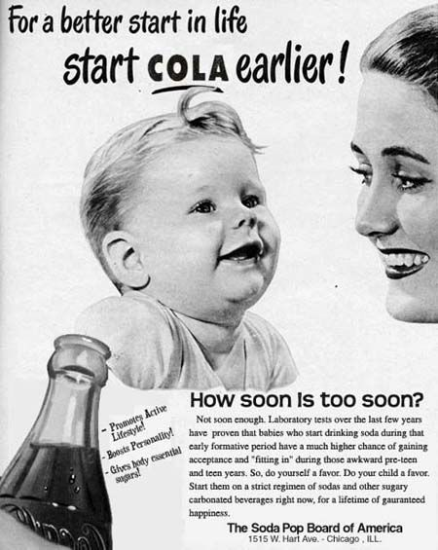

Protein Metabolism
- In your digestive tract (mainly stomach), proteins are broken down into A_______ A_______.

- These are transported into your body’s cells by insulinlike growth factors (IGF’s) and I_____________.

- Once in your cells, they are reassembled back into the proteins your body needs. The numerous

protein molecules in your cells function as E__________, others serve as Ant____________,

hormones like In_______, the muscle fibers Ac__________ and My___________, and the

structural components of the body (Co___________, El_____________, Ke_______________).

- Proteins are built (assembled) in which organelle in your cells? R____________.

- The information (the blueprint, or recipe) to assemble the 100,000-or-so different protein combinations is contained in your nucleic acids, the D___________ and R____________.

- Adequate dietary protein is especially essential during Gr___________, Pr____________, and disease or injury.

- You need 20 different amino acids to function. The 10 which you must eat because they can’t be synthesized in your body are known as ___________ __________ __________ (3 words)

- “Complete proteins” contain all 20 amino acids. Examples are ______________ (list all 5 in your book)

- Clinical Connection box: In “Phenylketonuria”, which amino acid cannot be metabolized? P______________ (1 word)

Metabolic Adaptations
- During the “absorptive state”, ingested nutrients are entering the bloodstream, and there is plenty of glucose available for energy needs. A typical meal requires about ____ hours for complete absorption.

- Assuming no midnight snacks, about ____ hours each night are spent in the postabsorptive state.

- After eating, the digested food reaches the bloodstream mainly as G_________, A________- A__________, and T____________.

- About ____% of the glucose absorbed is taken up by your body’s cells to produce energy

- The glucose that enters the liver cells (known as H________________) is converted to glycogen for storage.

- Any glucose not picked up by the liver cells is converted in fat cells (known as A__________ cells) to triglycerides for storage.

- Overall, about _____% of the glucose absorbed from a meal is converted into triglycerides, and about _____% of the glucose is stored as glycogen in muscle cells and liver cells.

- Most dietary lipids (fat, oils) are stored in the fat cells, also called A_________ tissue.

- Amino acids (from protein digestion) which are not taken up by the liver are used throughout the body’s cells for synthesis of proteins your body needs. Some of these proteins serve as regulatory chemicals such as H___________ and E____________.

- “Metabolism during fasting and starvation”: Your book gives an interesting 4-paragraph description of what happens during fasting. See if you can summarize the important events in your own words. You may use bullet-points if that’s easier.

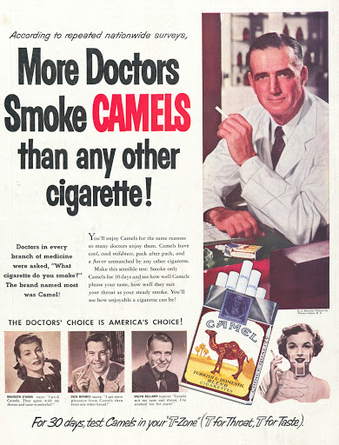
Nutrition
- List the six types of nutrients you need

- Each gram (the weight of a ‘dime’) of protein provides ____ Calories

- Each gram of carbohydrate provides _____ Calories

- Each gram of fat provides _____ Calories

- According to your book (more recent is here https://www.choosemyplate.gov/eathealthy/dietary-guidelines ) the guidelines for healthy eating are to:

- Minerals (Table 25.5): State the role/function of the following minerals in the body (complete sentences are not required, you may abbreviate)
  - Calcium
  - Phosphorus
  - Potassium
  - Sodium
  - Magnesium
  - Iron
  - Iodide
  - Zinc
  - Chromium
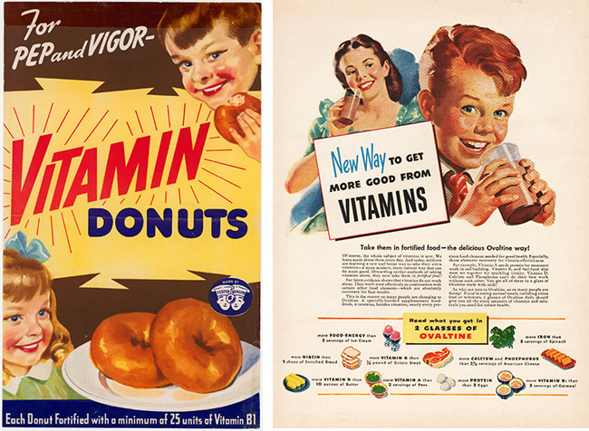

- Vitamins (Table 25.6): State the functions of these vitamins (complete sentences are not required, you may abbreviate)
  - A
  - D
  - E
  - K
  - B2
  - Niacin
  - B6
  - B12
  - C

