Nuclear Fission WebLab

Name and date submitted (3 pts):

Go to the Nuclear Fission simulation https://phet.colorado.edu/en/simulation/nuclear-fission and start the App. (You don’t need to actually download the App unless you want to). This App requires Java in order to run. Java is a free download. Make sure to adjust your browser settings (Google Chrome, etc etc) to allow Java to run this application.

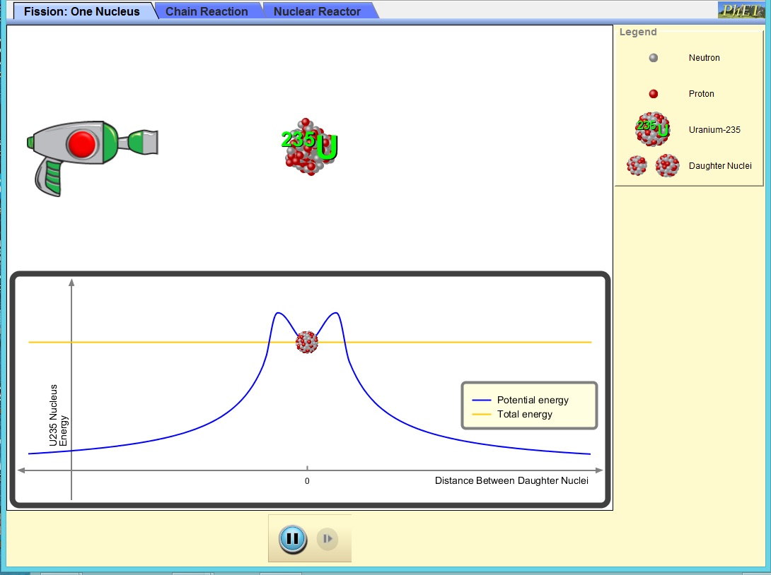

Background: In this simulation, you will be using two isotopes of uranium. Complete the following information about uranium-235 and uranium-238.

- Isotope # protons # neutrons atomic mass
uranium-235

uranium-238

Using the Fission: One Nucleus tab

- Describe how you can trigger a fission reaction in the uranium-235 atom.
- How many neutrons are released when the atom undergoes fission?

Using the Chain Reaction tab

- What happens when you shoot a neutron at a uranium-238 atom?
- What happens when you shoot a neutron at a uranium-239 atom?
- What happens when you have one hundred U-235 (no U-238) atoms and shoot one neutron?
- What happens when you have one hundred U-238 atoms (no U-235) and shoot one neutron?
- We want to know how the percentage of U-235 atoms affects the percentage of U-235 nuclei fissioned. Describe what happens in each of the following situations when you shoot ONE neutron into the field of nuclei on the screen.
Note: When you shoot your neutron, make sure it hits a U-235 atom.
Atoms % U-235 % of Nuclei Fissioned
(#U-235 ÷ Total) (see bottom right corner)
100 U-235
0 U-238
80 U-235
20 U-238
60 U-235
40 U-238
40 U-235
60 U-238
20 U-235
80 U-238
0 U-235
100 U-238

- Determine the variables (look these up on Internet if you don’t remember them)
a. Independent Variable:
b. Dependent Variable:
c. Constant Variable(s):
- Make a line graph of your data. (Use a drawing tool if you want). Remember to:
- Use equally-spaced intervals for both axes.
- Place numbers at a LINE (not between the lines).
- Label both axes with words (the column titles from your data table).

- How does the number of U-235 atoms affect the percentage of U-235 atoms fissioned?
- Using your observations in this simulation, explain why your answer to #11 makes sense.
- Based on your experiment, what isotope of uranium is used in a nuclear reactor? Why must that be the case?
- Use the internet to discover what percentage of natural uranium is U-235. Explain why uranium mines do not start a chain reaction and blow up.
Using the “Nuclear Reactor” tab
- Generate electricity! Adjust the control rods to generate power without letting the temperature get too high. You may need to adjust them as the reaction is taking place.
*In order to maintain a steady power output, do you need to put the control rods farther in or slowly take them out as the fission reaction takes place? Explain why this is the case.

