**2. Acceleration homework problems**

Name and date submitted (3 pts):

Create space in the Word document below, and write or type your answers. Turn in your completed work as an email attachment. Self-check: Hints to the correct answers are given in parentheses.

(7 questions, 100 points possible)

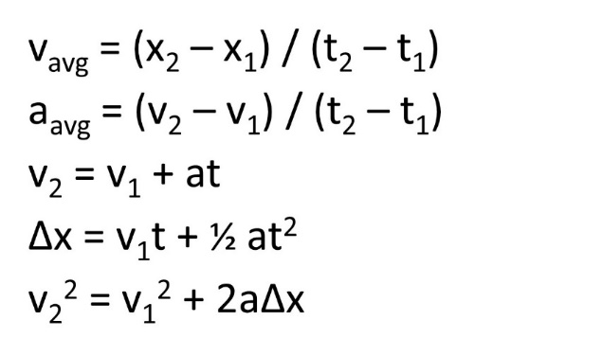Below: For this assignment, you will use the five equations of linear motion:

1. An auto manufacturer boasts that its newest sports car model goes from 0 to 60 mph in 5.00 seconds. There are 1609 meters per mile.
   1. What is the car’s acceleration in m/s2? (5.0-6.0)
   2. How far does it travel in meters as it accelerates from 0.0 mi/h to 60.0 mi/h? (60-70)
2. The Beretta Model 92S (the standard-issue U.S. army pistol) has a barrel 127 mm long. The bullets leave this barrel with a muzzle velocity of 335 m/s. There are 1000 mm per m.



* 1. What is the average acceleration in m/s2 of the bullet while it is in the barrel? (400,000-500,000)
  2. For how long in seconds is the bullet in the barrel? (.0005-.0010)

For the next 3 questions, use 9.8 m/s2 as the acceleration of gravity:

1. A parachutist falls from a plane for 6.0 seconds before opening the parachute. How fast in m/s is he traveling when he opens his parachute? (50-60)
2. A physics student drops a rock off of a cliff. If the rock takes 4.5 seconds to reach the bottom of the cliff, how tall is the cliff in meters? (50-100)
3. A child throws a ball up in the air with an initial velocity of 4.9 m/s. What is the maximum height in m that the ball reaches? (1.0-2.0)

Combined velocity-acceleration problems:



*v*

1. The graph shows the velocity of a motorcycle police officer plotted as a function of time. Find the instantaneous acceleration at the following times
   1. t = 3 s
   2. t = 7 s
   3. t = 11 s
2. A little cat, Bella, walks along a straight line, which we shall call the x axis, with the positive direction to the right. As an observant scientist, you make measurements of her motion and construct a graph of the little feline’s velocity as a function of time.
   1. Find Bella’s velocity at
3. t = 4.0 s
4. t = 7.0 s
   1. What is her acceleration at
5. t = 3.0 s
6. t = 6.0 s
7. t = 7.0 s

Extra credit: 10 points

1. One popular theory for the origin of life on earth is that we were transplanted by an alien civilization. The theory – called *Panspermia* – says that the seeds arrived here in tiny spores from a distant planet. Of course, any life in such spores would have to survive a long journey through the frigid near vacuum of outer space. If these spores originated from a nearby star system – say 20 light years away – and travelled at a constant 1000 km/s (about 600 miles per second), how many years would it take for them to make the journey here? (the light year is the distance light travels in 1 year) (6000-7000 yrs)