**2. “DNA Double Helix” homework questions**

Name and date submitted (3 pts):

Refer to the reading assignment “The DNA Double Helix” on the class website - to answer the following questions. Put the answers in your own words (cut-and-paste is not allowed).

(16 questions, 100 points possible)

1. (p. 16) In the 1920’s, Phoebus Levene at the Rockefeller Institute began studying the chemistry of DNA and RNA. Where did Levene get the DNA & RNA he used in his studies? He used 2 sources:

i.

ii.

1. (p. 16-17) According to Levene’s research, DNA was comprised of what 3 fundamental components?

i.

ii.

iii.

1. (p. 17 and Fig 2.1) In DNA, the four most common bases are

i.

ii.

iii.

iv.

1. (Fig 2.2) This figure shows how one of the nucleotide units are built. Which one of the four bases from question #3 are depicted in this particular nucleotide unit?
2. (Fig 2.4) What function do the phosphate groups perform in the building of each strand of DNA?
3. (p. 20) By 1949, Erwin Chargaff’s experiments revealed new, important information about DNA. What did Chargaff discover about the amounts of adenine (A) versus thymine (T), and of cytosine (C) versus guanine (G), regardless of the source of the DNA?
4. (p. 20, bottom of column 1) Read this carefully. What did Chargaff’s discovery tell us about DNA that we didn’t know previously?
5. (Table 2.1) Test Chargaff’s findings for yourself…

Look at the results for *Homo sapiens* (you and me).

1. Does human DNA have pretty much the same percentage of adenine and thymine? What are the percentages?
2. How about the percentages of guanine and cytosine? What are the percentages?

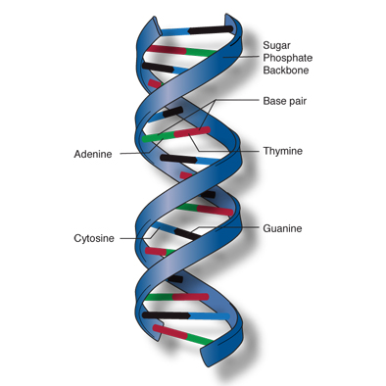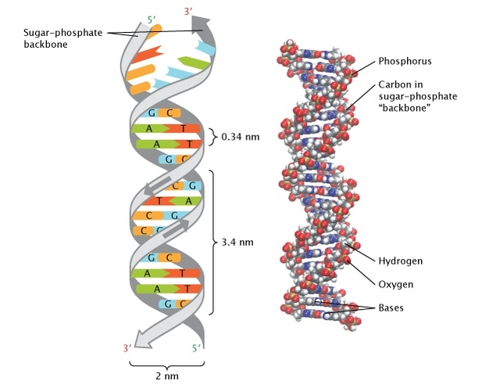

Now look at *Drosophila melanogaster* (fruit flies).

1. Does fruit fly DNA have the same percentage of adenine and thymine? What are the percentages?
2. How about guanine and cytosine? What are the percentages?
3. (p. 20, column 2) Leading up to the 1950’s:
4. Prior to the 1950’s, did we know the helical arrangement of DNA and the functions of DNA?
5. What did many scientists think that DNA did?
6. (p. 20) The contributions of Watson and Crick at Cambridge University:
7. Watson and Crick had the amazing ability to do what?
8. What unique method did these 2 men basically use to build their famous model of DNA?
9. (p. 21-22, Box 2.1) One of the most “famous mistakes” in 20th century science:

Linus Pauling at Cal Tech was probably the most famous chemist in the world at that time. He didn’t get along with Chargaff, however, and missed an important clue. Briefly describe Pauling’s mistaken model for the DNA molecule.



1. (p. 22) Rosalind Franklin’s contribution:

Some feel that Rosalind Franklin’s research was basically stolen from her by her partner, Maurice Wilkins (i.e. the now-famous “photograph 51”) without giving her due credit. Briefly outline what happened…



1. (p. 21 last sentence and p. 22) Explain how Rosalind Franklin’s x-ray diffraction studies helped to determine the structure of DNA.
2. (p. 23 and Fig. 2.10) According to Franklin’s measurements,
3. What was the distance (nm) between each nucleotide on the DNA strand?
4. What was the distance (nm) in each ‘turn’ of the DNA helix?
5. What was the diameter (nm) of the DNA helix?
6. (p. 24 last sentence and p. 25) Given the base sequence of one strand in the DNA helix, explain how you can figure out the base sequence of the opposite DNA strand. Be specific! (p. 24-25)
7. The four bases that make up DNA are A, T, C, and G (Mnemonic: **A**ll **T**igers **C**an **G**rowl). A’s bond to T’s (the ‘pointy’ letters pair) and C’s bond to G’s (the ‘curvy’ letters pair).

Draw diagrams of two sets of nucleotide bases: one with A bonding to T, and the other with C bonding to G. In other words, one diagram will depict a sugar-phosphate-base ‘A’ bonded to a sugar-phosphate-base ‘T’; and the other diagram will depict a sugar-phosphate-base ‘C’ bonded to a sugar-phosphate-base ‘G’. Using pencil and regular paper is fine. Label the components so they are easily identifiable. Hint: you can search for “dna nucleotide diagram” for ideas.

Do a professional-looking drawing, please!