**Food tests for starch, sugars, proteins, and lipids**

**Starch Test using Iodine Solution**

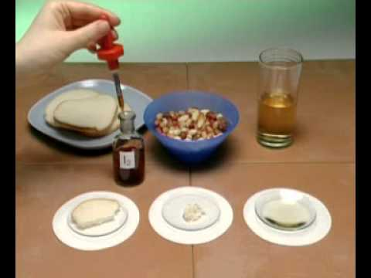

In this test, food samples are prepared by dissolving them in a few milliliters of water or mashing/grinding in a mortar & pestle. In some cases the food sample may need to be boiled to extract any starch. Then a few drops of Iodine solution (Tincture of Iodine) are added to the sample. If the starch molecule is present, the food will immediately turn blue-black to purple in color. Other carbohydrates – fructose, pectin, cellulose, or sucrose for example – will not change color; only starch. Mechanism: the iodine complex (I3-) slips in between the amylose starch rings and changes the electron configuration and thus the color.

Try these:

1. Compare a potato slice vs. apple slice
2. Bread, pasta
3. Crackers mixed with saliva for varying amounts of time
4. Corn starch
5. Rice
6. Try milk
7. A leaf which has been scraped open to expose the starch (proves photosynthesis)

**Sugar Test using Benedict’s Reagent**

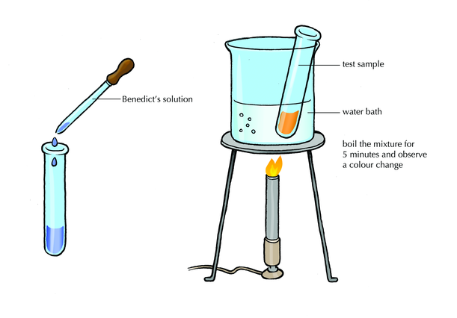In this test, a small sample of food (~1ml) to be tested is placed in a test tube with several drops (~2ml) of Benedict’s Reagent, and gently heated in a water bath for about 3-5 minutes. If reducing sugars (glucose, fructose, lactose) are present, the color changes per the chart below. Sucrose (table sugar) is not a reducing sugar and does not change color. Mechanism: The blue cupric (Cu+2) ion in the Benedict’s Reagent is changed to the red cuprous (Cu+1) ion when reducing sugars are present.

Final color:

Blue = no reducing sugar present (or only sucrose, perhaps)

Green = 0.1-0.5% sugar (fructose, glucose, lactose, etc)

Yellow = 0.5-1.0%

Orange = 1.0-1.5%

Red = 1.5-2.0%

Brick red = >2.0%

Try these:

1. Corn syrup (low fructose variety)
2. Pancake syrup
3. Molasses
4. Honey
5. Grapes
6. Apple juice
7. Milk
8. Saltine crackers which have been mixed with saliva for 10 minutes

You can also break down sucrose into glucose: dissolve 1g table sugar in 10 ml water, add 10 drops HCl acid. Heat gently in water bath for a few minutes. The sucrose molecules are broken down into glucose and fructose. Now test it for glucose using Benedict’s Reagent.

Make sugar candy: dissolve ½ cup sugar in 2 tbsp water and 2 tbsp light syrup. Stir over low heat until completely dissolved. Continue heating without stirring until a sample dropped in cold water forms a brittle thread. Spoon out candy-size globs onto greased aluminum foil, insert stick, remove when cold.

**Protein Test using Biuret’s Reagent**

In this test, a small sample (~5 ml) of food to be tested is placed in a dish or test tube. Add 5 ml of 10% NaOH, and 2 drops of 2% CuSO4 (1 g in 50 ml water). If protein is present in the food, the liquid will turn a violet-pink color after 3-5 minutes. Mechanism: Peptide groups on the amino acids in protein react with the Cu+2 ion to form the violet/pink color. A chelate complex forms using the exposed electrons on the N atoms and the Cu+2 ion.

Try these:

1. Gelatin (the stuff that’s in Jello)
2. Milk
3. Egg whites
4. Rice
5. Hair
6. Finger nails
7. Feathers

Albumin is the protein in eggs (both yolk and white): try denaturing it with heat, boiling water, alcohol, acid. Try redissolving white coagulant in 10% NaOH by heating.

Casein is the protein in milk: add vinegar to ½ cup warm milk; casein separates into white curds. Squeeze it out and rinse it using cheese cloth. Let dry into cheese. Or – take a lump of casein and mix with a CaO slurry, stir into a smooth paste suitable for paper or wood ‘casein glue’.

Collagen is the protein in bones: soak a cleaned chicken bone in medium-strength HCl for 2-3 days (can also use vinegar). The HCl dissolves the calcium, leaving flexible bone collagen – called ‘ossein’. You can extract ‘gelatin’ by boiling the ossein in water. Remove the bone, and the water will become jelly-like as it cools.

**Lipid Test (fats and oils) with grease spot**

Place a drop of test-material on brown-bag paper, or filter paper. If lipids are present, a translucent spot forms which is visible when held up to light. Hasten drying with hair dryer if needed.

If necessary, adding 5 ml of acetone will help extract the fat; after a few minutes for extraction, drop the acetone mixture on the brown paper/filter paper.

Try these:

1. Chocolate
2. Peanuts
3. Greasy chips
4. Beef or chicken fat
5. Milk, butter
6. Olive oil

Test for glycerol: combine 1 ml H2SO4 to 1 ml vegetable oil and heat gently. Waft the irritating odor towards you and sniff cautiously. The smell is from acrolein which is produced by breaking down the glycerin in the fat. [the acid sets the glycerol free and then destroys it, turning it into ill smelling acrolein].

Test for fatty acids: dissolve ½ tsp soap powder or flakes in 50 ml warm water. Add 10 ml HCl. You will get lumps of the fatty acids of which soap is the sodium salt – mainly stearic and palmitic acids. Stearic acid is added to paraffin to make candles.