Lipids Biochemistry lab (make tallow soap & study lipids)
The soap reaction is called “saponification”, or “Alkaline hydrolysis of triglycerides”
Team members: ____________________________ Date: ______________________
- List the four (4) groups of biomolecules

- Triglyceride molecule:

  - Where do we find this molecule in the body?
  - Circle and label the glycerol group
  - Circle and label the 3 carboxylic acid groups
  - Circle and label the 3 lipid (fatty) tails

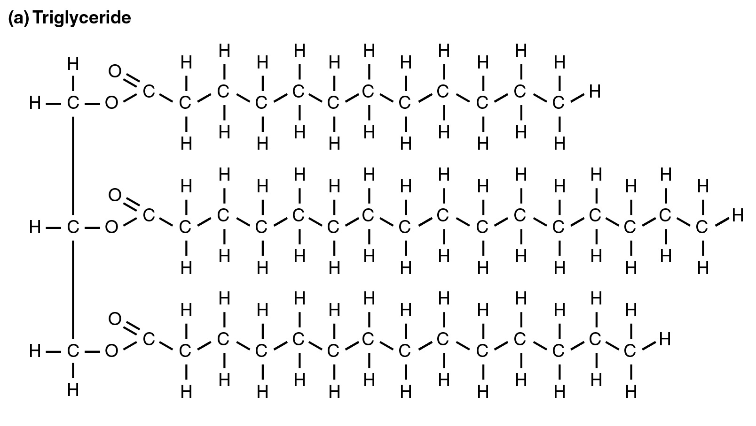

- Why is this called a “fatty acid”?

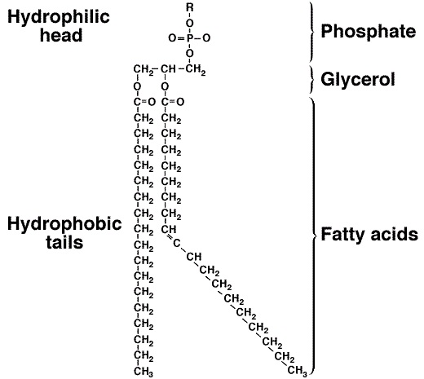
- Phospholipid molecule:
  - Where do we find this molecule in a cell?

  - How does this differ from a triglyceride?

  - Which end is polar?

  - Which end is non-polar?

  - What do we call the cell membrane? Phospho__________ Bi_______________

- Cell membrane:
  - Circle a single phospholipid molecule.
  - Label the ‘inside’ of the cell, and the ‘outside’ of the cell.
  - What is meant by “extracellular fluid”?

  - What is meant by “cytoplasm”?

  - Circle a cholesterol molecule.
  - 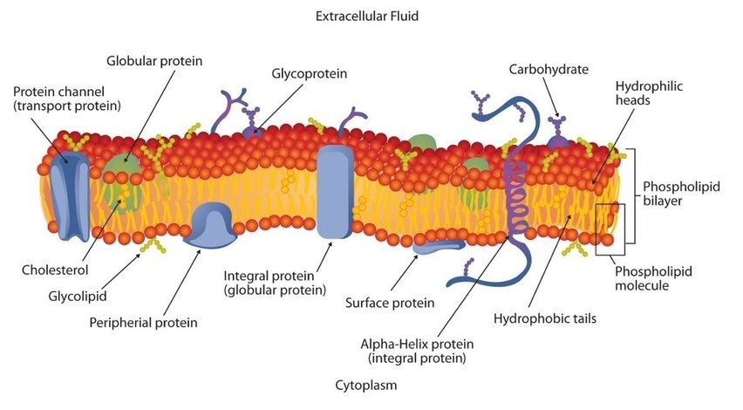Circle 4 proteins.

- Saponification reaction:
  - Identify this triglyceride with 16-carbons (including the carboxylic acid).
Stearic acid? Palmitic acid? Linoleic acid?
  - What is the NaOH called?

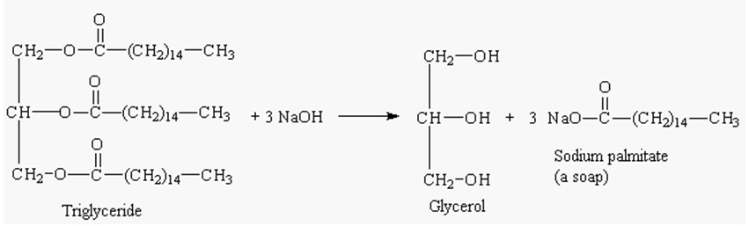

- Beef tallow:
- List the 3 main fatty acids in tallow, in order:

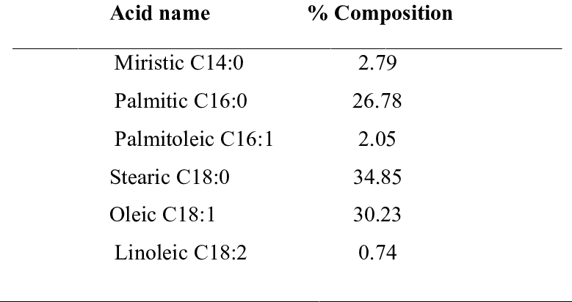

- Procedure:
    - Put on safety glasses and lab coats!
    - Pre-heat a large pan of water to 40-50⁰C
    - Measure 7 g tallow, 3 g vegetable oil, and 1/8 tsp stearic acid into 250 ml beaker. The amounts are not “precise”, and you can experiment with different fats, oils, and waxes.
    - Fill a larger, 500 ml beaker ¼-full with 40⁰C water. Carefully insert the 250 ml beaker into the larger beaker to make a hot water bath. Heat the fats gently, stirring SLOWLY, until the mixture has a smooth consistency.
    - Add 6 ml of 25% NaOH. (6ml of 25% NaOH = 7.8 g) (25% NaOH = 6M).
    - Continue heating at 40⁰C and stirring SLOWLY for 5 minutes to let the reaction run its course. Change-out the hot water as necessary. DO NOT OVER-WHIP THE MIXTURE. Stir very slowly! You should have a slightly-thickened paste now.
    - (Optional): This would be the time to add fragrance or color.
    - Remove the 250ml beaker to cool down. Add 1 ice cube directly to the paste. Stir SLOWLY for a few minutes to thicken the soap curds. DON’T OVER-STIR. This is very important! Add another ice cube if needed. The melted water won’t hurt anything.
    - Rinse the curds 2-3 times with distilled water until pH comes down to 6-10. Move-around the curds GENTLY, like making butter. Do not whip them around! Decant-off each batch of distilled water into a waste beaker. The curds should increasingly agglomerate together.
    - Pour the soap into molds. Cover with cheese cloth to keep away insects. Dry for several days.
    - Perform soap tests using grease, hard water, etc.

