2. Measurement homework problems (Chemistry)
Name and date submitted (3 pts):
Create space in the Word document below, and write or type your answers.
(25 questions, 100 points possible)
Metric system and exponential notation:
- The basic metric unit for volume is the
- The basic metric unit for length is the
- The basic metric unit for mass is the
- The abbreviation g stands for
- The abbreviation m stands for
- The abbreviation L stands for
- One kilometer equals ___________ meters.
- A thousand grams equals ____________ kilogram(s).
- One thousand meters equals ____________ km.
- One thousandth of a liter is one ________.
- One milligram is ____________ gram.
- One thousandth of a meter is called _____________.
- One hundredth of a meter is called _______________.
- Write these numbers in exponential notation
- 12.45
- 3,040,000
- 6,100.5
- 0.001234

- Convert these into decimal form
- 6 x 10⁶
- 3.04 x 10⁻³
- 1.56 x 10³
- 4.5 x 10⁻²
Conversions:
- Convert the following temperatures from the scale given to the scale indicated. Report your answer to the nearest tenth of a degree. YOU MUST SHOW YOUR CALCULATIONS TO RECEIVE CREDIT.
- 300.0 K = ________ °C
- -115.53 °C = ________ °K
- 100.0 °K = __________°C
- 38.5 °C = ___________°K
- 212.0 °F = ___________ °C

- Convert the following quantities of energy from the unit given to the unit indicated in parentheses. You can consult the Appendix in your book (or the inside book cover) for the necessary conversion factors. YOU MUST SHOW YOUR CALCULATIONS TO RECEIVE CREDIT. You may check your answers using the Internet.
- 157 J = __________ cal
- 3700 BTU = __________ J
- 153 cal = ___________ J
- 7.89 x 10⁸ J = ____________ BTU

- Congratulations! You and your spouse are the proud parents of a new baby, born while you are studying in a country that uses the metric system. The nurse has informed you that the baby weighs 3.91 kg and measures 51.4 cm. Convert your baby’s weight to pounds and ounces (for example “8 pounds, 2 ounces”), and her length to inches (rounded to the nearest quarter inch.)

- The circumference of the earth is 25,000 mi at the equator.
- What is the circumference in kilometers?

- In meters?

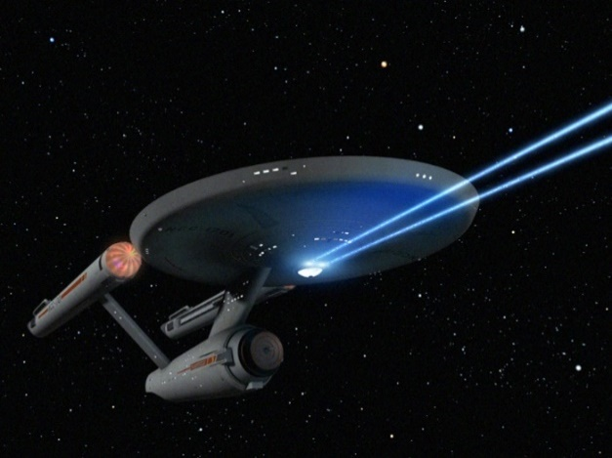
- If the starship U.S.S. Enterprise is traveling at warp factor 1.71, what is its speed in miles per hour? (Warp 1.71 is equal to 5.00 times the speed of light; speed of light = 3.00 x 10⁸ m/s).
SHOW ALL YOUR WORK. If you have never watched a Star Trek movie, the speed of the Enterprise is always given as “Warp speed”.

Next 4 questions: “Derived Units” – Density, Volume, and Area
- The formula for Density can be written as D = m/V (density = mass ÷ volume). Therefore, the units of ‘Density’ can be expressed as (choose the best answer…)
- grams/liter
- kg/liter
- mg/milliliter
- A & B only
- A & B & C
- None of the above

- For each of the following, decide which block is more dense: the orange block, the blue block, or it cannot be determined.
- Top left:
- Top right:
- Bottom left:
- Bottom right:

Next 3 questions: Unit Conversions
- 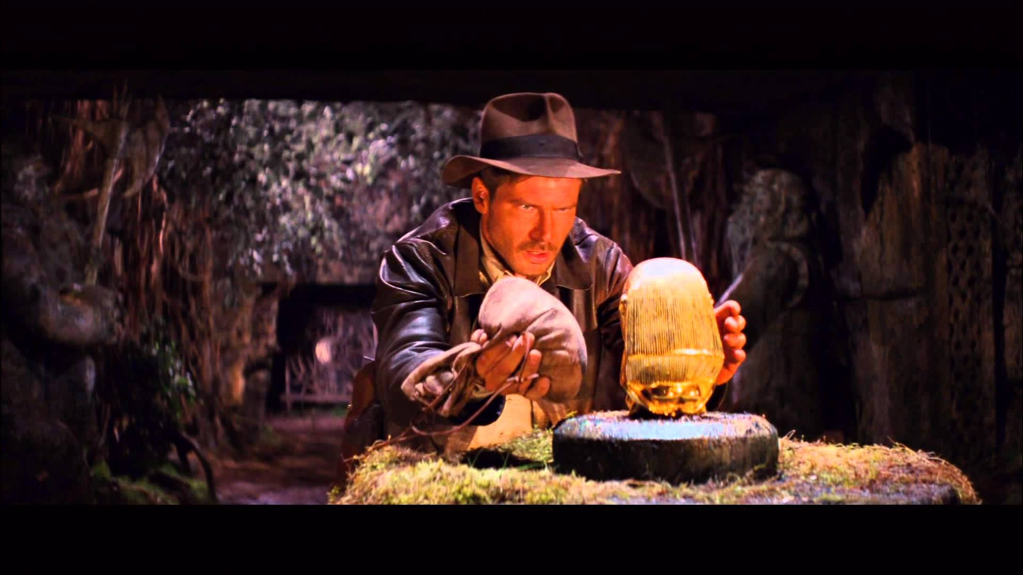In Raiders of the Lost Ark, Indiana Jones tries to remove a gold idol from a booby-trapped pedestal. He replaces the idol with a bag of sand of approximately the same volume. (Density of gold = 19 g/cm³; density of sand = 2 g/cm³)
- Did he have a reasonable chance of not activating the booby trap? Explain, using the information given. Be specific.

- In a later scene, he and another character play catch with the gold idol. Assume that the idol is about 1.0 L.
- If it were solid gold, what mass would the idol have? (hint: there are 1,000 cm³ in 1 L). SHOW ALL CALCULATIONS. Be sure to check your answer for reasonableness!
- Is playing catch with it possible? Elaborate.

- Would a car traveling at a constant speed of 65 km/h violate a 40 mi/h speed limit?

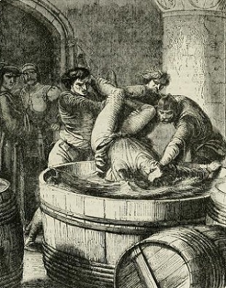
- In Shakespeare’s Richard III, the First Murderer says:

“Take that, and that! (Stabs Clarence)
If that is not enough, I’ll drown you in a malmsey butt within!”

Given that 1 butt = 126 gal, in how many liters of malmsey (a foul brew similar to mead) was the unfortunate Clarence about to be drowned?

