2. Properties of Matter homework problems (Phys Science)
Name and date submitted (3 pts):
Create space in the Word document below, and write or type your answers. Turn in your completed work as an email attachment.
15 questions, 100 points possible. 1 extra credit question, 10 points possible.
- States of Matter:
Write the correct description next to each phase change in ‘a – e’ below. Choose from this list:
Condensation
Evaporation
Freezing
Melting
Sublimation

- Solid to liquid
- Liquid to gas
- Solid to gas
- Gas to liquid
- Liquid to solid

- Determine if each description is 1) a chemical change, or 2) a physical change.
- Iron rusts
- Molten aluminum solidifies
- Sugar dissolves
- Water freezes
- Water is split into hydrogen and oxygen
- Wood burns
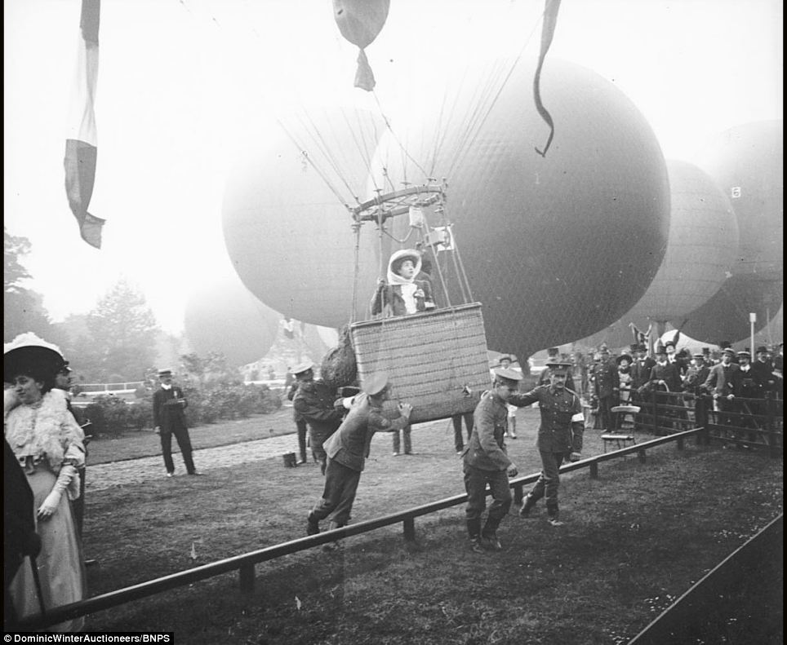
The next 3 are short essay questions. Research the chapter and the Internet and write 2 paragraphs on each question, below. USE COMPLETE SENTENCES.
- Man’s first flying machine was the hot air balloon. Explain how a hot air balloon works. Why does a helium balloon rise even though the gas is not hot?

- Why is the cooking time for some foods dependent upon elevation?

- What is the difference between evaporation and boiling?

Multiple choice questions:
- Which of the following is a chemical property?
- Color
- Ease of rusting
- Hardness
- Texture
- Only solids have
- High compressibility
- Low density
- Definite shape
- High-speed particles
- The kinetic energy of a particle (atom or molecule for example) is directly related to its
- Density
- Temperature
- Volume
- Pressure
- What happens to the pressure of a gas when it is heated?
- Decreases
- Increases
- Remains the same
- Depends on which gas
- Whey do solids keep their shape?
- The molecules move too fast
- The molecules are locked in place
- The molecules are still touching
- The molecules diffuse
- The thickness of a liquid is its
- Density
- Viscosity
- Liquidity
- Mass
- How does the thickness of most liquids change as they heat up?
- Less thick
- More thick
- No change

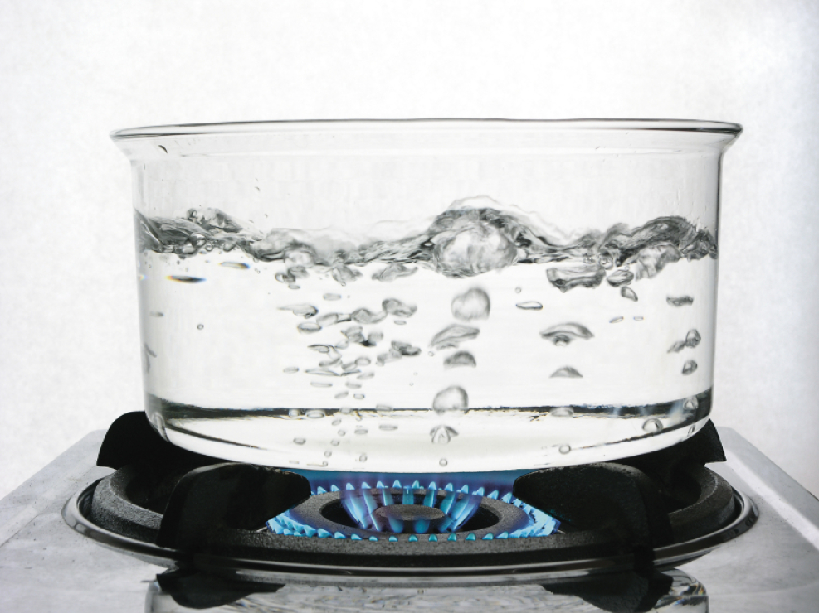
- You may have noticed that when water boils, you can see bubbles that rise to the surface of the water. What is inside these bubbles?
- Air
- Hydrogen and oxygen gas from the H₂O
- Oxygen gas from the H₂O
- Water vapor
- Carbon dioxide gas
The next 2 are review questions. SHOW ALL YOUR WORK.
- Congratulations! You and your spouse are the proud parents of a new baby, born while you are studying in a country that uses the metric system. The nurse has informed you that the baby weighs 3.91 kg and measures 51.4 cm. Convert your baby’s weight to pounds and ounces and her length to inches (rounded to the nearest quarter inch.)

- The circumference of the earth is 25,000 mi at the equator.
- What is the circumference in kilometers?
- In meters?
Extra credit:
- If the starship U.S.S. Enterprise is traveling at warp factor 1.71, what is its speed in miles per hour? (Warp 1.71 = 5.00 times the speed of light; speed of light = 3.00 x 10⁸ m/s).
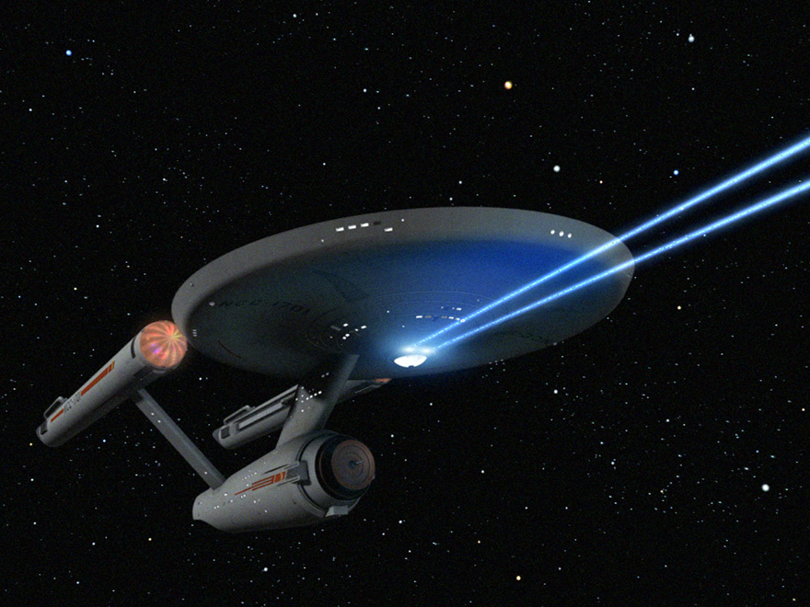SHOW ALL YOUR WORK.

