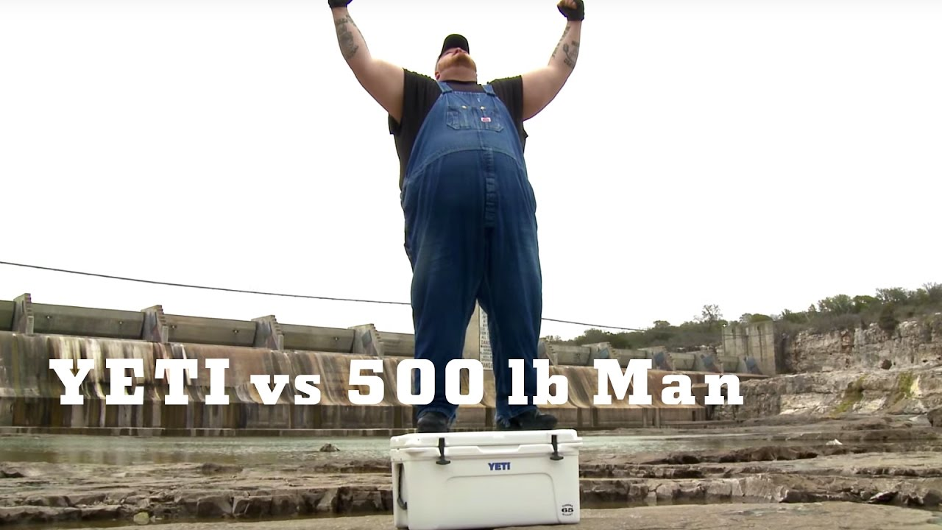YETI Coolers assignment
Name and date submitted (3 pts):
Instructions: Create space in the document below, and type or write your answers. When you are done, submit your work as an email attachment.
(10 questions, 100 possible points).
YETI Cooler assignment
YETI Coolers www.yeti.com was started 10 years ago by brothers Roy & Ryan Seiders. Their market growth has been phenomenal, and the Wall Street Journal just announced (see below) their company was valued at $5 Billion through an IPO! (we will discuss "IPO's" later on - it means their company is worth that much).
Assignment: Do Internet research and read the Wall St. Journal article posted on the class page, and answer the following questions. Submit as a Word document.

- What are YETI's products?

- How would you describe their market? (young, old, male, female, rich, poor, etc). Be as specific and descriptive as possible.

- How do they create demand for their product, given that there are so many cooler companies? Look at their website and advertising, and go into this in some detail.
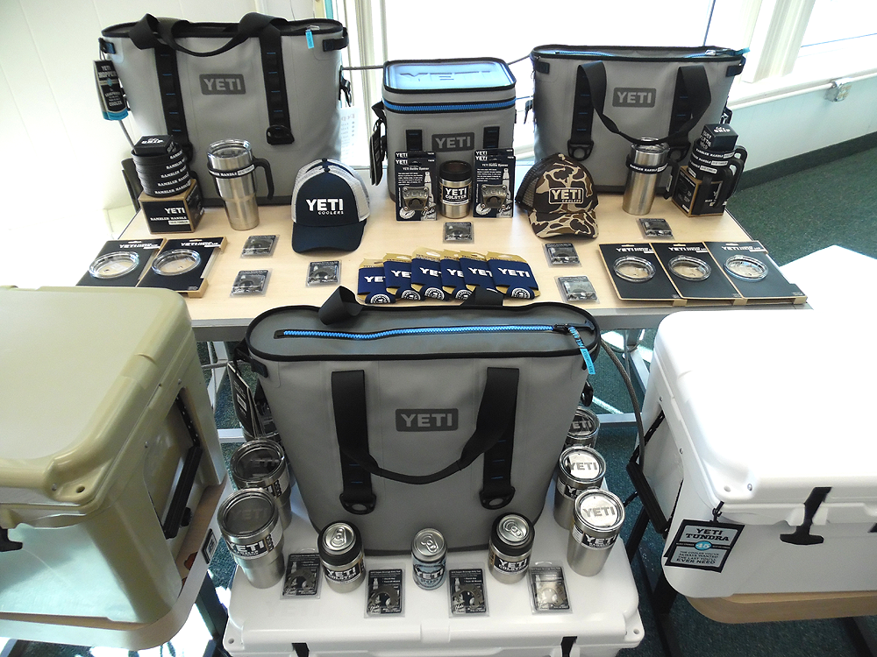
- What is their most expensive product? What is their cheapest?

- Who are their major competitors in this industry? List them. There are several.

- How do you think YETI differentiates their product line from their competitors? Think carefully about this, and look at the advertising of YETI and their competitors.

- Why do you think YETI has done so well in an otherwise crowded market of coolers and insulated mugs? Again, browse their website and think about the reasons, and write a thoughtful response.

- Factors of Production: What are examples of each of the 4 Factors of Production (Land, Labor, Capital, Technology) needed to manufacture YETI coolers?

- Refer to the Wall Street Journal article and answer the following questions:
- Who did Roy & Ryan Seiders sell coolers to at first, when they started the company a decade ago?
- What percentage of their sales is now comprised of soft coolers and drinkware (mugs)?
- What modern marketing tool increased demand for their stainless steel mugs during the Christmas season, 2015?
- Apparently, their largest cooler "can hold multiple elk". What are they trying to accomplish by publishing that obscure information? Think carefully.

- According to the article:
- What was their sales revenue in 2015?
- If their average product (let's say a cooler) sold for $400, how many coolers would that represent in one year?
- What does the company say is partly responsible for its "widespread publicity" and "explosive growth"?
- According to one YETI distributor (Mr. Hyde), what are the "real questions" concerning whether the company will continue to grow? Please state this in your own words, don't just cut and paste!
- How have Igloo and Coleman changed their own strategies in response to this new threat?

