**2-D Motion problems**

(Crosswinds & Projectile Motion)

Name and date submitted (3 pts):

Create space in the Word document below, and write or type your answers. Turn in your completed work as an email attachment. YOU MUST SHOW ALL YOUR WORK to get credit.

(8 questions, 100 points)

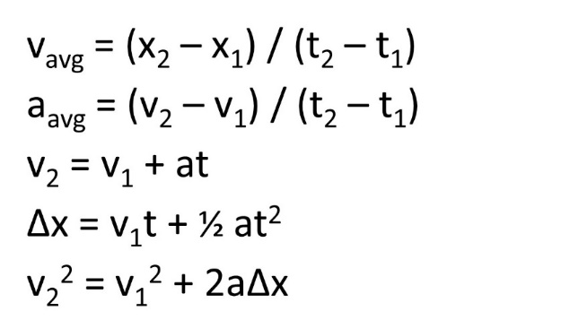For convenience, here are the five equations of linear motion:

1. True/False: A change in velocity is always an acceleration.
2. True/False: In projectile motion problems, the horizontal and vertical components of an object’s motion can be analyzed independently of each other.
3. True/False: Ignoring air resistance, a 45° firing angle (from the horizontal) will give a projectile its maximum range.
4. Crossing the river: A river flows due south with a speed of 2.0 m/s. You are steering a motorboat across the river to deliver food, water, and medical supplies to hurricane victims on the other side; your velocity relative to the water is 4.2 m/s due east. The river is 800 m wide.
   1. How much time is required for you to cross the river?
   2. How far south of your starting point will you reach the opposite bank?
5. A marksman fires a .22-caliber rifle horizontally at a target; the bullet has a muzzle velocity with magnitude 750 ft/s. How much does the bullet drop in flight if the target is
   1. 50.0 yd away
   2. 150.0 yd away
6. You are flying an airplane to deliver supplies to a remote village. You intend to drop-deliver a cargo container attached to a parachute. The aircraft is flying at 165 km/h due east as your crew drops the 100. kg crate. The parachute fails to open and the crate crashes to the ground 4.5 s after it was released.
   1. What is the crate’s vertical speed just before it hits the ground?
   2. How high was the plane when the container was released?
   3. Your plane was 0.5 km west of a lake when the crate was released. Did the crate land in the lake?
7. Don’t do this: A daring 510 N swimmer dives off a cliff with a running horizontal leap, as shown in the figure. What must his minimum speed be just as he leaves the top of the cliff so that he will miss the ledge at the bottom, which is 1.75 m wide and 9.00 m below the top of the cliff?
8. Your spaceship lands on an unknown planet. To determine the local value of ‘g’, you ask a crew member to kick a stone, and you find that if she kicks it at 17.6 m/s at 45° from the horizontal, it has a range of 33.8 m.



* 1. What is ‘g’ on this planet?
  2. How long was the stone in the air?
  3. How high above the ground did the stone go?