Projectile Motion Simulation
Name and date submitted (3 pts):
Create space in the Word document below, and write or type your answers. Turn in your completed work as an email attachment.
(13 questions, 100 points possible)
Go to https://phet.colorado.edu/ and find the “Projectile Motion” simulation. At the time of writing, it was located here https://phet.colorado.edu/en/simulation/projectile-motion
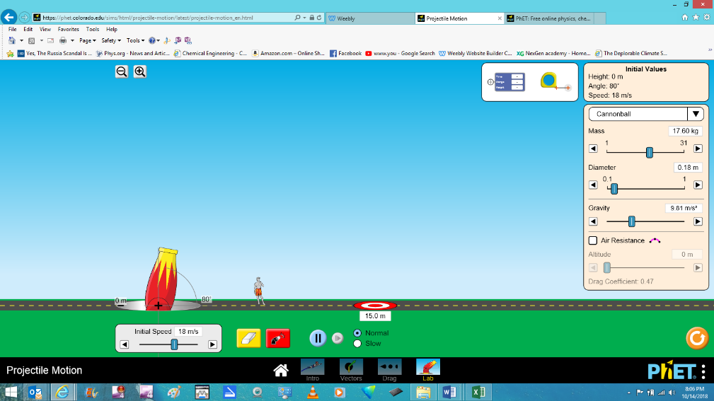
Hit the “play” button (you don’t need to download the app) and select the “Lab” option.

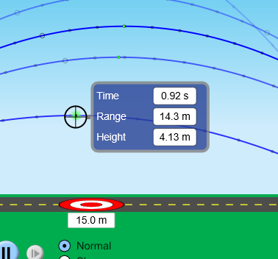
Keep the initial values at 18 m/s initial speed, 17.6 kg mass, 0.18 m diameter, 9.81 m/s² gravity, and zero air resistance.

Experiment 1: How does firing angle affect projectile motion?
- Use the blue “range finder” tool (shown in the picture above) to fill out the following table:
Firing angle | Maximum height reached | Range
80°
70°
60°
50°
45°
40°
30°

- What angle results in the maximum range?

- What angle results in the maximum height?

- Plot the angles vs. ranges on the graph below. List the angles on the ‘y’ axis, and the ranges on the ‘x’ axis. (You will end up with a curve plotted on the graph).

- Use your graph to estimate the required firing angle needed for a range of 30.0 meters. What is it?

- Test your prediction above, using the simulation. Were you correct? Explain…

Experiment 2: How does initial speed affect projectile motion?
On the simulation, clear the results and start over. Use the eraser icon to clear the screen.
- Keep all the constraints the same as the first experiment. Same mass, diameter, and so forth. Set the firing angle at 70°. Using the blue “range finder” tool, fill out the following table. Use the +/- buttons to resize your screen if necessary:

Initial speed | Range
5 m/s
10 m/s
15 m/s
18 m/s
20 m/s

- Plot the ranges vs. initial speeds on the graph below. List the initial speeds on the ‘y’ axis, and the ranges on the ‘x’ axis. (You will end up with a curve plotted on the graph).

- Use your graph to estimate the required initial speed needed for a range of 20.0 meters. What is it?

- Test your prediction above, using the simulation. Were you correct? Explain…

Experiment 3: How does the projectile mass affect the range?
On the simulation, clear the results and start over. Use the eraser icon to clear the screen.
- Keep all the variables the same. Select a firing angle and initial speed (for example 70° and 20 m/s, but you may use whatever you want). Fire several cannonballs with different masses. (Vary the mass of the projectile!). What do you observe? Does the mass of the projectile affect the maximum height or the range, as long as there is no wind resistance?

Experiment 4: How does gravity affect projectile motion?
- Now experiment with the “gravity” slider button. Fire the projectile several times, varying the acceleration of gravity over the whole range, from 5 m/s² to 20 m/s². What conclusions can you make? Write a paragraph explaining what you observe with respect to height, range, and gravitational acceleration.

Experiment 5: How does air resistance affect projectile motion?
- Now experiment with the “air resistance” slider and the “diameter” slider. Fire the projectile several times, varying the diameter and air resistance over their whole ranges, from 0.1 to 1.0 meter, and from 0 to 5000 meters. What conclusions can you make? Write a paragraph explaining what you observe with respect to maximum height and range.

