Henrietta Lacks case study
Name and date submitted (3 pts):
Learning objectives
Cell division, mitosis, cancer
Instructions
Using this handout as a TEMPLATE, create space between the questions and write or type your answers. Turn in your completed work as an email attachment.
(37 questions, 100 points)
Background Henrietta Lacks, 1920-1951
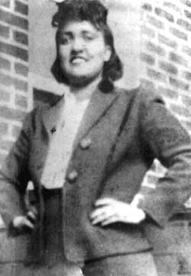HeLa cells are cervical cancer cells isolated from a woman named Henrietta Lacks. Her cells have been cultured since 1951 and used in numerous scientific experiments. Henrietta Lacks died from her cancer not long after her cells were isolated. Lacks' cancer cells are unique in that they have a mutation on Chromosome 11 – caused by the HPV virus which infected Mrs. Lacks – which causes them to multiply without end, i.e. they are an “immortal cell line”. This makes them extremely valuable for research purposes. HeLa cells have been used in medical research for 60+ years, and have been instrumental in finding cures for many diseases. When the Lacks family found out some years after her death how her cells were being propagated and used, it presented a moral/ethical dilemma in that her family had apparently never been informed that her cells would be used for research purposes. In addition, they had never been compensated for the use of her tissue, and claimed they should have been.
Cancer
Cancer is caused by cells that multiply out-of-control. The normal “check points” in the cell cycle have been damaged and can’t regulate cell division like they should; therefore, the affected cells continue to replicate out-of-control and result in a tumor (there are no ‘brakes’ on the cell cycle). Since we are studying cells and tissues, this is an excellent launching pad for exploring these topics.
Watch “Immortal Cells Turn 96” posted on student portal:
- Describe Henrietta Lacks’ background. Where from? Birth date? What was her occupation? How did she die? How old at death? (0:00-0:20)
- Where did she go for treatment? Why there? What did the physician do? According to this video, did she give him consent? (roughly 0:30-0:60)
- How many times can most human cells divide? (1:00)
- What was unique about Lacks’ tumor cells? (around 1:10 and following)
- What is meant by an “immortal cell line”? (around 1:20)
- Before HeLa cells were available, how did researchers study Polio? (2:19 and following)
- How did HeLa cells help Jonas Salk find a vaccine for Polio? (2:19 and following)
- How many HeLa cells have been grown to date? (2:40 and following)
- What treatments have been developed by using HeLa cells for research purposes? (beginning at 2:50)
- How many research papers have been written using HeLa cells? (around 3:00)
- What caused Mrs. Lacks’ cervical cancer? (3:12 and following)
- In 2013, researchers at the University of Washington sequenced her genome and found out what caused her tumor cells to continue dividing. What was it? Try to summarize it in your own words. (3:46-4:10)
Watch “The Immortal Cells of Henrietta Lacks” posted on student portal:
- Why do we grow/culture human cells? Three reasons are given… (0:25)
- Why do we need huge populations of identical cells to carry out research? (0:35)
- What was the main problem before 1951, before HeLa cells became available? (0:45)
- Describe the tissue sample given to Dr. George Gey. (0:54)
- What was unique about the tissue? (1:03)
- Normal cells divide about how many times before they self-destruct? (1:52)
- What does Apoptosis (the self-destruct mechanism) prevent in a healthy organism? (2:00)
- How do cancer cells differ from normal cells? (2:08-2:12)
- When Dr. Gey realized he had discovered the first human ‘immortal cell line’, what did he do with the tissue? (2:22)
- At first, what do you think was Dr. Gey’s motive in doing this? Was it a good motive?... an evil motive? Think about this for a while and comment/elaborate in a thoughtful way…
- As the years went by, why did it appear more and more that an injustice had been done and/or was continuing to be done? (2:38-2:50)
- Besides Polio, what are some other diseases that have been studied using HeLa cells? (3:00)
- Thanks to HeLa cells, we discovered that cervical cancer is caused by what? (3:34)
- And now there’s a ___________ (3:42)
- To summarize, what is Henrietta Lacks’ legacy to medicine? (4:05)
Wikipedia “Henrietta Lacks” https://en.wikipedia.org/wiki/Henrietta_Lacks
- Mrs. Lacks had a pretty tough life by today’s standards. Read the “Personal Life” section. Summarize her life experience in a few sentences….
- Read the “Diagnosis and Treatment” section. Summarize her symptoms, what her diagnosis was, and what procedures were done at Johns Hopkins.
- Read the “Medical and Scientific Research” section.
- Summarize what Dr. Gey and Mary Kubicek did to produce the cell line.
- How was Henrietta Lacks’ family finally made aware of Mrs. Lacks’ cell line? How many years had passed?
- Read “Consent Issues and Privacy Concerns”.
- Why didn’t Johns Hopkins obtain permission from her family before harvesting/culturing her cell tissue?
- Did they have to?
- According to the California Supreme Court, do you “own” your discarded tissues, and can they be used by others for commercial purposes?
- In 2013, the DNA of HeLa cells was sequenced and published.
- Why would you/should you be concerned if your mother’s or grandmother’s DNA sequencing was published for the whole world to see?
- What agreement was reached with the family members to provide some degree of privacy?
Privacy and Medical Ethics
On February 6, 1951, Henrietta Lacks signed the following consent form:
"I hereby give consent to the staff of The Johns Hopkins Hospital to perform any operative procedures and under any anesthetic either local or general that they may deem necessary in the proper surgical care and treatment of: _______________________."﻿
This was a widely accepted consent form in 1951. In addition, the removal of tissue cells from a cancer patient (called a “Biopsy”) and analyzing them in a pathology lab was (and is) standard procedure. And at the time, permission was not required to use a patients cells in research.
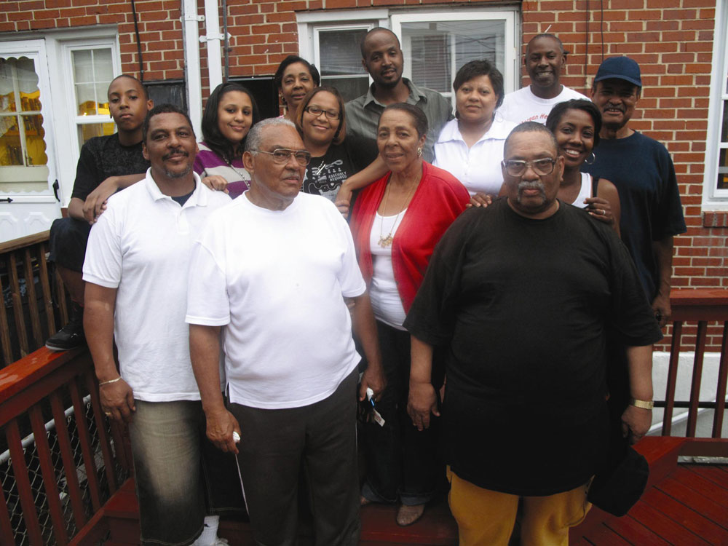
In 1990, the California Supreme Court ruled that a hospital patient's discarded blood and tissue samples are not his personal property and that individuals do not have rights to a share in the profits earned from commercial products or research derived from their cells. (Moore v. Regents of University of California)

Lacks family to sue Johns Hopkins:
In 2017, Henrietta's family (pictured) prepared to sue Johns Hopkins for the unauthorized use of her cells in research. Source: “Henrietta Lackss family wants compensation for her cells”, Washington Post, 2/14/2017. [Updated June 25, 2018 “Can the immortal cells of Henrietta Lacks sue for their own rights?”, Washington Post] At the time of her treatment and death, her family actually played a relatively small role in her medical decisions. In fact, Henrietta herself did not inform her family of her condition for a significant amount of time ("She simply went on with her day as if nothing had happened, which was just like her--no sense upsetting anyone over something she could deal with herself." (Skloot, 31)). The role of Henrietta's family in her medical decision-making only became clear near and after her death--David Lacks (Henrietta's husband) authorized Johns Hopkins to perform an autopsy. However, this was done informally ("I didn't sign no papers. I just told them they could do a topsy. Nothin else. Them doctors never said nuthin about keepin her alive in no tubes or growin no cells. All they told me was they wanted to do a topsy see if they could help my children." (Source: Skloot, 164)) https://helabriere.weebly.com/
In defense of Johns Hopkins:
On the one hand, Mrs. Lacks received free medical treatment at one of the best hospitals in the world. Johns Hopkins has not profited from the cells. Her cells have helped to cure ancient diseases and have saved many lives. Johns Hopkins didn’t violate any laws or customs in place at the time, and she did sign a standard consent form. Her family didn’t seem that concerned until many years later. In addition, her family has been recognized and honored at many national events.
In defense of the Lacks family:
On the other hand, since her death in 1951, numerous private companies and individuals have profited from tissues which were taken from her. Johns Hopkins claims they never patented her cell line and have never profited from it (see Washington Post article above), but many other institutions and individuals have profited from it. Why should numerous careers and fortunes be made by others, while Henrietta’s own family continues to struggle?
Give this dilemma some serious thought and respond to the following questions. Use complete sentences and give thoughtful answers! There is no “right or wrong” answers; I’m looking for you to think about it and justify your opinions.
- Should her family be compensated?
- How would you do that? Who would pay?
- If you compensated her family, who among her many children and grandchildren would be paid? How would you split it?
- How much is fair?
- Tissues, cells, and blood are removed all the time. Living and dead people even donate entire body organs. How would you compensate the multitude of other people who would then claim they are owed money?

