4. Newton’s Laws homework problems
Name and date submitted (3 pts):
Create space in the Word document below, and write or type your answers. Turn in your completed work as an email attachment. YOU MUST SHOW ALL YOUR WORK to get credit.
(9 questions; 100 points)
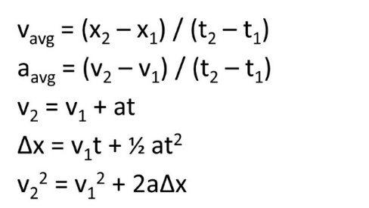
Tip: You will need to use Newton’s 2nd Law, F=ma, and the equations of linear motion:

- A father is teaching his young daughter to surf by pulling her across the water with a short rope. If the girl (whose mass is 30 kg) starts to accelerate at 0.40 m/s², with what force in Newtons is the father pulling her? (Ignore friction and water resistance)

- 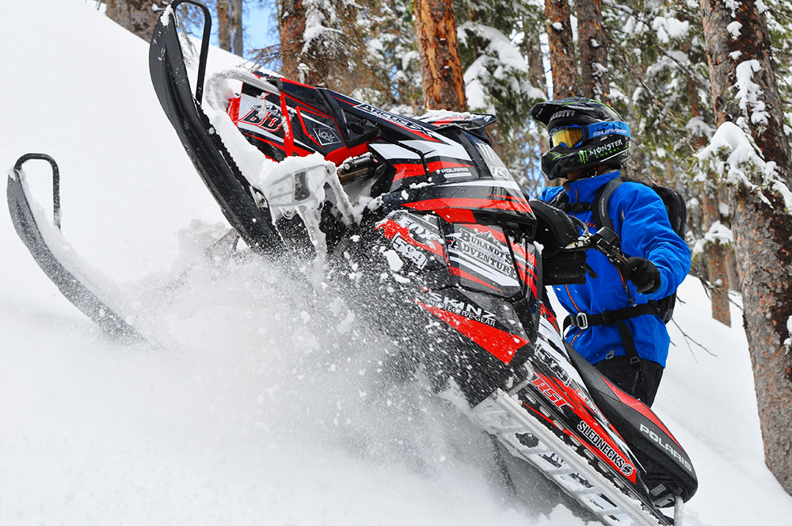U.S. standard system: Your 601-lb Polaris snowmobile has run out of gas while crossing a frozen river. If you push it with a force of 20 lbs, how fast will it accelerate in ft/s²? (ignore friction between the machine and the ice, and assume the ice surface is level). In the U.S. system, gravitational acceleration is 32 ft/s², and mass is reported in “slugs”. One lb_{f} will accelerate a mass of one slug at a rate of 1 ft/s².

- In the last problem, I asked you to assume that there is no friction between the snowmobile and the ice. You do, however, have to assume that there is friction between your boots and the ice. Why? Which of Newton’s Laws pertains? Explain/elaborate.

- With a full gas tank, your Polaris snowmobile weighs 640 lbs (on Earth, at sea level).
  - What is its mass in slugs?
  - What is its weight on the Moon in lbs (g_{moon} = 5.3 ft/s²)

- The reason you were crossing the frozen river, above, is because you were towing a 750-lb sled loaded with emergency food and medical supplies to a remote village in Alaska. What is the minimum force in lbs. required to get the sled moving again from a dead stop? (μ_{s} = 0.30, μ_{k} = 0.14)

- Once you get the sled moving, you can tow with a force of 350 lbs. In other words, you can exert 350 lbs force on the tow rope. Assume level ice, no obstacles, etc. (μ_{s} = 0.30, μ_{k} = 0.14)
  - With that amount of force, how fast will the sled accelerate in ft/s²? Remember to factor in the mass of the snowmobile with full gas tank.
  - With what force in lbs. must you pull the sled in order to keep it moving at a constant velocity once it’s broken loose from the frozen surface?

- A hunting bow imparts an acceleration of 5100 m/s² to a 28.3 g arrow at an angle of 15.0° to the horizontal. What is the horizontal component of the force exerted by the bow on the arrow?

- 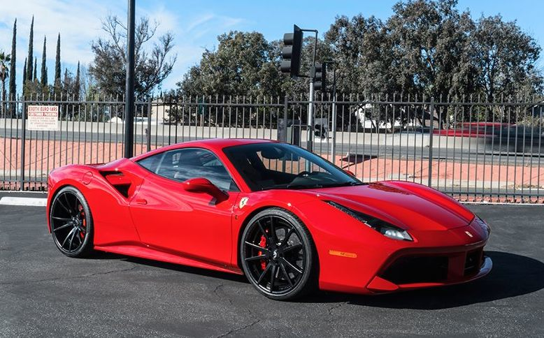Some Physics students were test-driving a Ferrari as part of a laboratory exercise. They found that the 1,370-kg car accelerated from 0 to 60 mi/hr (0 to 97.0 km/hr) in 2.7 seconds along a level stretch of track. Assuming that the acceleration is constant, solve the following:
  - Calculate the magnitude of the net force in Newtons that produces the acceleration.
  - Calculate the distance in meters the car covers during 2.7 seconds.

- ‘Uncharted Planet’
When venturing forth on an uncharted planet, you throw a 6.24 kg rock upward at 14.0 m/s and find that it returns to the same level 1.61 seconds later. What does the rock weigh on this planet, in Newtons?

