Rutherford’s Gold Foil Experiment (Physical Science)

Name and date submitted (3 pts):

Create space in the Word document below, and write or type your answers. Turn in your completed work as an email attachment.
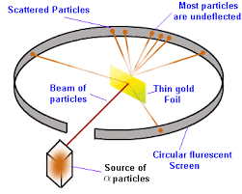

Instructions: Go to phet.colorado.edu. Find the “Rutherford Scattering” simulation. It should be here https://phet.colorado.edu/en/simulation/rutherford-scattering Click on the play button to open the simulation. You don’t need to download it unless you want to. You can run it directly off the PhET website.

Once the simulation opens, click on the Rutherford Atom. Once open, set the number of protons to 20 (you are setting the nucleus of each “foil” atom to have 20 protons) and click on the “Alpha Particles” blue button to start firing Alpha particles towards the gold foil.

Part 1: Rutherford’s ‘Nuclear’ or ‘Planetary’ Atom
Rutherford’s model of the atom (1911) was a heavy, positively-charged nucleus surrounded by light-weight, negatively-charged electrons that balance out the charge of the atom.

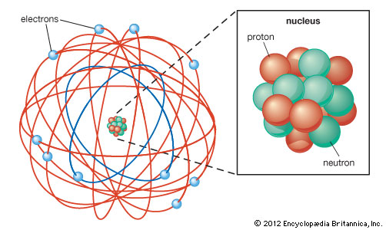

Alpha Particles
Rutherford bombarded gold foil with alpha particles he obtained from Radium, and watched how they scattered. Radium is radioactive and emits alpha particles in the process of radioactive decay; thus, it is an excellent source of these massive, positively-charged particles. Alpha particles are basically Helium atoms stripped of their electrons; thus, they are a large particle consisting of 2 protons and 2 neutrons. They are a Helium nucleus, technically. They carry a positive (+2) charge.

- Place a ‘check’ in the Traces box. Observe for a while. How would you describe the paths of most of the alpha particles?

- Increase the number of protons to 60. (now you’re allowing the nucleus of each “foil” atom to have 60 protons) Observe for a while. How does this change how the alpha particles move? Explain/elaborate. Why the difference?

- Now, increase the number of protons to 100. How does this increase change how the alpha particles move through the gold foil as compared to when you started? Why do you think this change occurred? Explain/elaborate.

- Repeat the above steps, but vary how many neutrons are present with the protons. Run the simulation with 20 neutrons and with 150 neutrons. Does the number of neutrons in the “gold foil” change how the Alpha particles travel? Why or why not? Explain!

- Now zoom in and observe just one (1) ‘gold foil’ atom. Click on the red/gray sphere in the upper left of the Sim (looks sort of like a golf ball) and reset the number of protons to 20 and the number of neutrons to 100. Watch and describe how the alpha particles move in relationship to the nucleus. Make a sketch of the motion.

- Now increase the number of protons to 100. Watch and describe how the alpha particles move in relationship to the nucleus. Make a sketch of the motion.

- How are the situations in #6 and #7 different? Why do you think this is? Explain!

Part 2: J.J. Thomson’s Plum-Pudding Atom
Now we compare the earlier Thomson ‘Plum Pudding’ model (1904) to the Rutherford ‘Nuclear’ model (1911).
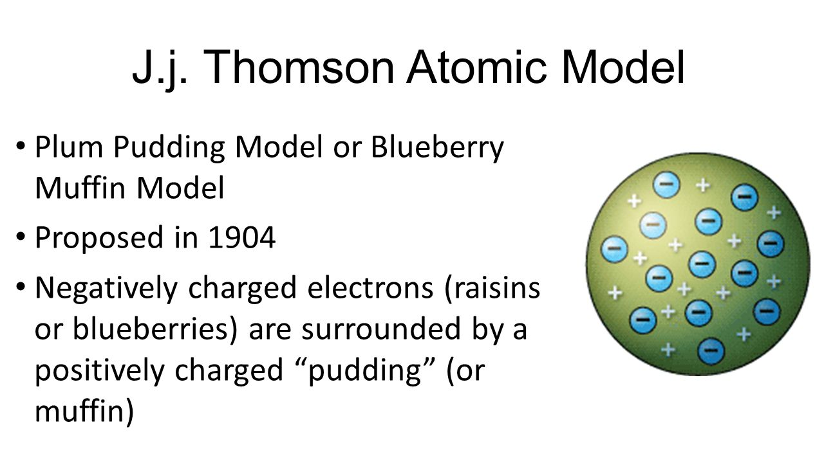

Before Rutherford came along, we had the J.J. Thomson ‘Plum Pudding Atom’. In this earlier model, the negatively-charged electrons were distributed throughout the atom, sort of like chocolate chips are distributed throughout cookie dough. In other words, Thomson didn’t know about the positively-charged nucleus.

- Switch the simulation to the Plum-Pudding Atom (down at the bottom of the screen). Once the simulation opens, place a ‘check’ in the Traces box. Click on the blue button on the Alpha Particle gun to turn on the Alpha particles. What type of path do the Alpha particles take?

- How is this different than the Rutherford model of the atom? Give a thoughtful answer and explain!

Conclusion

- What did Rutherford’s gold foil experiment (1911) show us that the Thomson Plum Pudding model (1904) couldn’t? Explain! Give a thoughtful answer.

- Why were the Alpha particles deflected by the gold foil nuclei and not attracted to them?

