4. The Elements homework (Chemistry)
Name and date submitted (3 pts):
Instructions: Create space in the Word document below, and write or type your answers. Turn in your completed work as an email attachment.
(20 questions, 100 points possible).
Questions 1-6: The Periodic Table. You will need to use the Internet and your textbook to research these questions.

- Lavoisier, in 1793, produced a list of thirty substances that he declared could not be broken down into simpler substances. He called them “elements”. What did he do wrong?

- Dalton, in 1803, produced his own list of elements, some of which were wrong. What is the story behind that?

- Dobereiner, in 1829, arranged his elements by atomic mass, grouping them in “triads”. Some didn’t hold up. Give the story…

- Newlands, in 1864, arranged the elements in octaves (groups of 8), and saw a connection with the musical “octave”. What was the reasoning behind this?

- 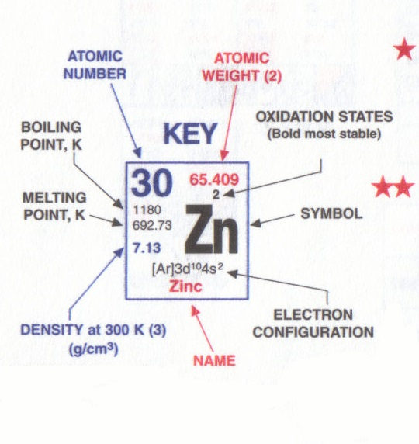Mendeleev, in 1869, arranged his elements by atomic mass. Elements with the same chemical properties were placed in the same “Groups” or columns.
- Why did he leave some empty spaces in his table? Explain.
- What did his Periodic Law state? Summarize.

- State the modern ‘Periodic Law’. Be careful, it differs slightly from Mendeleev’s version.

- What does the atomic number “Z” of an element tell us?

- What does the atomic mass “A” (also known as ‘atomic weight’) tell us about an element?
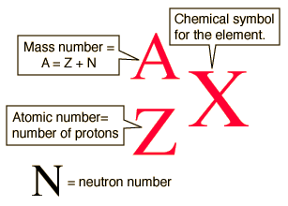
- What are the general physical properties of metals? In other words, why do we call some elements on the Periodic Table, “metals”?

- What are the general physical properties of non-metals? In other words, why do we call some elements on the Periodic Table, “non-metals”?

- Explain the term “metalloids”.

- Atomic radius
- In general, atomic radii (increase) / (decrease) in size as you move from left to right across a given row.
- Why is this the case? Explain in some detail.

- Ionization energy
- Ionization energy of an atom is the energy we need to supply in order to remove _____________.
- Ionization energies generally (increase) / (decrease) as we move from left to right across a given row.
- Explain why this is the case. I’m looking for 2-3 well-written sentences.

- Electron affinity
- Electron affinity is the amount of energy released or given-off when we add ___________.
- In general, electron affinity (increases) / (decreases) as we move from left to right across a row.
- Explain why.

- Electronegativity
- Electronegativity is a term developed by the brilliant U.S. chemist named _______________.
- Explain the concept of “electronegativity”.
- List the top 3 elements in order of their electronegativity. Your Sargent-Welch Periodic Table has this information on the back.

- How many elements are on the modern Periodic Table?

- Alkali metals (Group 1)
- Show the symbols of the first 4 alkali metals. (Hint: lithium, sodium, potassium, rubidium). For each one, give the number of protons, neutrons, and electrons in the neutral atom. (The above figure may help with this). Arrange this information in a nice, neat table here.
- Davy isolated the alkali metals in what year?
- What are their physical properties?
- What are their chemical properties?
- Where do we get the term, “alkali metals”? (will require Internet research)

- Alkaline-earth metals (Group 2)
- Show the symbols of the first 5 alkaline-earth metals. (Hint: start with Beryllium). For each one, give the number of protons, neutrons, and electrons in the neutral atom. Arrange this information in a nice, neat table here.
- What are their physical properties?
- What are their chemical properties?
- Where do we get the term, “alkaline-earth metals”? (may require Internet research)

- Oxygen family (Group 16)
- Show the symbols of the first 3 elements in the Oxygen family. (Hint: start with Oxygen). For each one, give the number of protons, neutrons, and electrons in the neutral atom. Arrange this information in a nice, neat table here.
- Oxygen itself was discovered by the famous chemist/clergyman named _____________ in 1774.
- How did he discover oxygen? Describe his process.
- The chemical properties of Oxygen and Sulfur are similar. Summarize what they are.
- What are some of the many uses for Selenium? (may require Internet research)

- Halogen family (Group 17)
- Show the symbols of the first 4 elements in the Halogen family. (Hint: start with Fluorine). For each one, give the number of protons, neutrons, and electrons in the neutral atom. Arrange this information in a nice, neat table here.
- How was Chlorine discovered/recognized in 1771? Describe the process.
- How was Iodine discovered/recognized in 1811? Describe the process.
- Try to summarize the chemical properties of the halogen group.

