**5. Applying Newton’s Laws homework problems**

Name and date submitted (3 pts):

Create space in the Word document below, and write or type your answers. Turn in your completed work as an email attachment. YOU MUST SHOW ALL YOUR WORK to get credit.

(6 questions; 100 points + 5 points extra credit)

Newton’s 2nd Law: F=ma

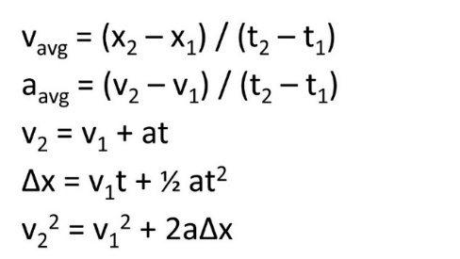Five equations of linear motion:

1. Two weights are hanging as shown in the figure at right.
   1. Find the tension in Newtons in cable A.
   2. Find the tension in cables B and C.
2. An adventurous physics student crosses between two rock cliffs by slowly going hand over hand along a rope stretched between the cliffs. He stops to rest at the middle of the rope. The rope will break if the tension in it exceeds 2.50 x 104 N. The student’s mass is 100.0 kg.

If the angle θ is 10.0°, find the tension in the rope in Newtons. Will the rope break? Start with a free-body diagram of the student.



1. A 1130-kg car is held in place by a cable on a frictionless ramp. The cable makes an angle of 31.0° above the surface of the ramp, and the ramp itself rises at 25.0° above the horizontal.

Find the tension in the cable in Newtons.

1. Some careless construction workers have rigged a system whereby they suspend a 22.0 kg bucket of mortar-mix over the side of a building by tying it off to a 375 N crate of roofing materials. Assume there is no friction in the pulley.
   1. The coefficient of static friction, μs, between the crate and the roof is 0.60. Do the calculations to show that the bucket won’t fall under this scenario.
   2. Predictably, some other workers who weren’t notified removed some of the roofing materials from the crate, reducing its weight to just 200 N. How fast does the bucket begin to accelerate while the crate slides across the roof? μk = 0.30.
   3. How fast is the bucket moving after it has fallen 2.00 m, assuming the crate hasn’t reached the edge of the roof?
2. Two boxes are connected by a rope that passes over a frictionless pulley. One box rests on a frictionless ramp that rises at 30.0° above the horizontal, and the system is released from rest.

Find the acceleration of each box in m/s2.



1. The construction workers mentioned above still haven’t learned their lesson. This time they have suspended a pallet of bricks from the side of the building to make their job “easier”. A rope is attached to a couple of heavy crates on the roof as shown. The coefficient of static friction, μs, between the lower crate and the roof is 0.600.
   1. What is the weight in pounds of the heaviest pallet of bricks that can be supported this way?
   2. Overnight it rains, and the coefficient of static friction on the roof is reduced so the bricks suddenly begin to fall. At that moment, μk = 0.30, and the bricks weigh 200 lbs. How fast will the bricks accelerate?

5-POINTS EXTRA CREDIT: The coefficient of static friction, μs, between the upper crate and the lower crate is only 0.300. Will the suddenly-accelerating bricks cause the upper crate to slide off the lower crate? Show your work.