Thermodynamics homework (POE)

Name and date submitted (3 pts):

Using this handout as a template, respond to all questions below. KEEP THE SAME NUMBERING. Turn in you completed work on Canvas. (20 questions, average 5 pts each, 100 points total)

Hint: This material is explained in your book and in the PowerPoint slides.

- Define Thermodynamics

- Define potential energy and list 4 examples

- Define kinetic energy and list 5 examples

- Define the term ‘heat’

- Explain the concept of ‘conduction’

- Explain the concept of ‘convection’

- Explain the concept of ‘radiation’

- Fill in the table below with the correct scale and unit.

Scale | Freezing point of water | Boiling point of water
Celsius
Fahrenheit
Kelvin

- Explain what “BTU” stands for, and how 1 BTU is defined

- Explain what a “Joule” is, and how 1 Joule is defined

- Explain what a “calorie” is, and how it is defined

- How is “Power” defined in terms of energy and time?

- What is the definition of 1 “Watt”?

- Define the Zeroth Law of Thermodynamics.

- Define the 1st Law of Thermodynamics.

- Define the 2nd Law of Thermodynamics, including the concept of “Entropy”.

- Define the 3rd Law of Thermodynamics

- A 1.00kg piece of aluminum metal at 90.0°C is placed in 4.00 liters (=4.00 kg) of water at 25.0°C. Determine the final temperature (Tf).

Formula: Q = mc∆T
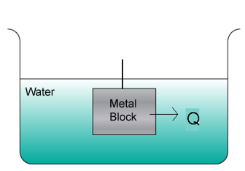
Define the variables:
Q =

m =

c =

∆T =

Solve the problem:

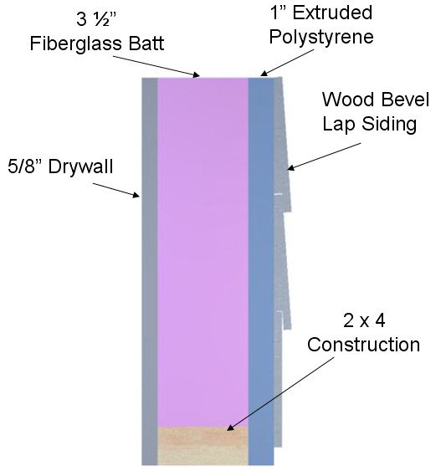
- Use the R-value chart (attached) to calculate the R- value of the wall cavity shown, and the R-value at the stud location.

R is the thermal resistance of a material. You look it up in a table, then you total it for all the materials. R_{tot} = R₁ + R₂ + R₃….

a. Wall cavity R-value

b. R-value at stud location

- A student travels on a school bus in the middle of winter from home to school. The school bus temperature is 58.0 ℉. The student’s skin temperature is 91.4 ℉. Determine the net energy transfer in Joules from the student’s body during the 20.00 min ride to school due to electromagnetic radiation. Note: Skin emissivity is 0.90, and the surface area of the student is 1.50 m².

Stefan’s Law: P = σAe(T₂⁴ – T₁⁴)

Define the variables:

P =

σ = Stefan’s constant = 5.6696 x 10⁻⁸ W/m²-K⁴

A =

e =

T₁ = initial temperature in Kelvin

T₂ =

Solve the problem:

R-Value Chart (R has units of °F-hr/BTU-ft²)
Construction Material | R-Value
½ in. Drywall | 0.45
5/8 in. Drywall | 0.56
Particle Board – ½ in. | 0.63
Particle Board – ¾ in. | 0.94
Fiberboard ½ in. | 1.32
Extruded Polystyrene 1 in. | 4.00
Extruded Polystyrene 1 ½ in. | 6.00
Foil-faced Polyisocyanurate 1 in. | 7.20
2 x 4 | 4.38
2 x 6 | 6.88
Hardwood | 0.90
Masonry Systems | R-Value
Brick 4 in. common | 0.80
Brick 4 in. face | 0.44
Concrete Block – Normal wt. 12 in. empty core | 1.23
Concrete Block – Light wt. 12 in. empty core | 2.60 - 2.30
Cement Mortar | 0.20
Sand and Gravel | 0.60
Stucco | 0.20
Roofing | R-Value
Asphalt Roll | 0.15
Asphalt Shingle | 0.44
Slate | 0.05
Wood | 0.94
Siding | R-Value
Wood Shingles | 0.87
Wood Drop | 0.79
Wood Bevel Lapped | 0.80
Aluminum/Steel – Hollow | 0.61
Aluminum/Steel – with 3/8 in. Backer | 1.82
Insulation | R-Value per in.
Fiberglass Batt | 3.142
Blankets – Rock Wool | 3.0 - 3.8
Loose Fill – Cellulose | 2.8 - 3.7
Loose Fill – Fiberglass 0.7 lb/cu.ft | 2.2 - 4.0
Loose Fill – Rock Wool | 3.1
Loose Fill – Vermiculite | 2.2
Extruded Polystyrene | 4.00

